Course syllabus

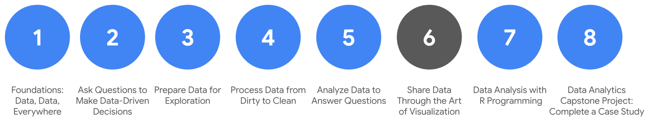

**C​ourse Overview**

1. [Foundations: Data, Data, Everywhere](https://www.coursera.org/learn/foundations-data/home/welcome)
2. [Ask Questions to Make Data-Driven Decisions](https://www.coursera.org/learn/ask-questions-make-decisions/home/welcome)
3. [Prepare Data for Exploration](https://www.coursera.org/learn/data-preparation/home/welcome)
4. [Process Data from Dirty to Clean](https://www.coursera.org/learn/process-data/home/welcome)
5. [Analyze Data to Answer Questions](https://www.coursera.org/learn/analyze-data/home/welcome)
6. **Share Data Through the Art of Visualization** *(this course)*
7. [Data Analysis with R Programming](https://coursera.org/learn/data-analysis-r/home/welcome)
8. [G​oogle Data Analytics Capstone: Complete a Case Study](https://coursera.org/learn/google-data-analytics-capstone/home/welcome)

Welcome to the sixth course in the Google Data Analytics Certificate! In the previous course, you learned how to organize and prepare data for analysis by sorting, formatting, converting, and merging it. You also worked with spreadsheet functions and calculations. And, you wrapped it up by learning how to sort data and perform calculations using SQL queries and temporary tables. In summary, you learned to use basic tools of the trade. A cook who has basic knife skills is prepared to work in the kitchen. A data analyst who can “slice and dice” data using spreadsheets and SQL queries is prepared to work in business.

In this course, you will learn how to create data visualizations. Everyone enjoys a good story. Visualizations along with good data storytelling will help you communicate the meaning of a dataset to your audience. Sharing the results of an analysis is actually one of the most important parts of an analyst’s job. Do you want the results of your analysis to just show up, or do you want the results to show off?

You too can become a talented data storyteller! You will learn basic principles and best practices for data visualization in spreadsheets. You will also gain hands-on experience with data visualizations in Tableau, a specialized data visualization tool. You will also learn how to apply pro tips to create exciting visualizations, presentations, and talking points about your data. And finally, you will learn to prepare and deliver great presentations. You will be ready to get through tough questions about your data analysis with confidence.

**Course content**

Course 6 – Share Data Through the Art of Visualization

1. **Data visualization:** Data visualization is in many ways the culmination of the data analysis process. In this part of the course, you will be introduced to the concepts involved in data visualization. You will learn about accessibility, design thinking, and other factors that play a role in visualizing the data in your analysis.
2. **Data visualizations with Tableau:** Tableau is a tool that can help analysts create effective data visualizations. In this part of the course, you will learn all about Tableau and its uses. You will also explore the importance of creativity and clarity while visualizing your findings appropriately.
3. **Stories about your data:** Connecting your objective with your data through insights is essential to good data storytelling. In this part of the course, you will learn about data-driven stories and their attributes. You will also gain an understanding of how to use Tableau to create dashboards and dashboard filters.
4. **Developing presentations and slideshows:** In this part of the course, you will discover how to give an effective presentation about your data analysis. You will consider all aspects of your analysis when creating a presentation and learn how to use multiple data sources in the data visualizations you will share. In addition, you will learn how to anticipate potential limitations and questions that might arise and how to provide useful answers to stakeholders.
5. **Course Challenge:** At the end of this course, you will be able to put everything you have learned into practice with the Course Challenge. The Course Challenge will ask you questions about key principles you have been learning about and then give you an opportunity to apply those principles in two scenarios.

**What to expect**

You can expect to finish this course in about five to six weeks. Be prepared to spend a lot more of your time practicing and working with the tools introduced. Not only will you understand the features of the tools, you will use them for specific tasks–just as you would if you were on the job as a data analyst.

You will be on track to earn the certificate after completing all of the prescribed activities, which include:

* **V​ideos** of instructors teaching new concepts and demonstrating the use of tools
* **In-video questions** that pop up during or at the end of a video to check your learning
* **Readings** to introduce new ideas and build on the concepts from the videos
* [**Discussion forums**](https://www.coursera.org/learn/visualize-data/discussions) to discuss, explore, and reinforce new ideas for better understanding
* **D​iscussion prompts** to promote thinking and engagement in the discussion forums
* **Qwiklabs** to introduce real-world situations and tasks that might pop up on the job
* **Practice quizzes** to prepare you for the graded quizzes
* **Hands-on activities** to reinforce the skills you have learned in specific tools
* **Graded quizzes** to measure your course progress and give you valuable feedback as a learner

Hands-on activities promote additional opportunities to build your skills. Try to get as much out of them as possible. Assessments are based on the approach taken by the course to offer a wide variety of learning materials and activities that reinforce important skills. Graded and ungraded quizzes will  help the content sink in. Ungraded practice quizzes are a chance for you to prepare for the graded quizzes, and both types of quizzes can be taken more than one time.

As a quick reminder, this course is designed for all types of learners, with no degree or prior experience required. Everyone learns differently, so the Google Data Analytics Certificate has been designed with that in mind. Personalized deadlines are just a guide, so feel free to work at your own pace. There is no penalty for late assignments. If you prefer, you can extend your deadlines by returning to **Overview** in the navigation pane and clicking **Switch Sessions**. If you already missed previous deadlines, click **Reset my deadlines** instead.

If you would like to review previous content or get a sneak peek of upcoming content, you can use the navigation links at the top of this page to go to another course in the program. When you pass all the required assignments, you will be on track to earn your certificate.

**Tips**

* Try to complete all items in order. All new information builds on previous lessons.
* Treat every task as if it is real-world experience. Have a mindset that you are working at a company or in an organization as a data analyst. This will help you apply what you learn in this program to the real world.
* Repeat demonstrated tasks on your own for extra practice and speed.
* Even though they aren’t graded, it is important to complete all practice items. They will help you build a strong foundation as a data analyst and prepare you for the graded assessments.
* Take advantage of all of the additional resources provided, including discussion forums and links to external articles for more information.
* W​hen you encounter useful links in the course, remember to bookmark them so you can refer to the information later for study or review.
* Additional resources are free, but some sites place limits on how many articles you can access for free each month. Sometimes you can register on the site for full access, but you can always bookmark a resource and come back to view it later.
* Create a notebook or electronic journal to keep track of things to remember about using Tableau. This will become a handy and personalized reference that you can use when you need it.

# Effective data visualizations

A data visualization, sometimes referred to as a “data viz,” allows analysts to properly interpret data. A good way to think of data visualization is that it can be the difference between utter confusion and really grasping an issue. Creating effective data visualizations is a complex task; there is a lot of advice out there, and it can be difficult to grasp it all. In this reading, you are going to learn some tips and tricks for creating effective data visualizations. First, you'll review two frameworks that are useful for thinking about how you can organize the information in your visualization. Second, you'll explore pre-attentive attributes and how they can be used to affect the way people think about your visualizations. From there, you'll do a quick review of the design principles that you should keep in mind when creating your visualization. You will end the reading by reviewing some practices that you can use to avoid creating misleading or inaccurate visualizations.

## Frameworks for organizing your thoughts about visualization

Frameworks can help you organize your thoughts about data visualization and give you a useful checklist to reference. Here are two frameworks that may be useful for you as you create your own data viz:

**1)** [**The McCandless Method**](https://www.informationisbeautiful.net/visualizations/what-makes-a-good-data-visualization/)

You learned about the David McCandless method in the first lesson on effective data visualizations, but as a refresher, the McCandless Method lists four elements of good data visualization:

1. **Information**: the data you are working with
2. **Story**: a clear and compelling narrative or concept
3. **Goal**: a specific objective or function for the visual
4. **Visual form**: an effective use of metaphor or visual expression

Note: One useful way of approaching this framework is to notice the parts of the graphic where there is incomplete overlap between all four elements. For example, visual form without a goal, story, or data could be a sketch or even art. Data plus visual form without a goal or function is eye candy. Data with a goal but no story or visual form is boring. All four elements need to be at work to create an effective visual.

**2)** [**Kaiser Fung’s Junk Charts Trifecta Checkup**](https://junkcharts.typepad.com/junk_charts/junk-charts-trifecta-checkup-the-definitive-guide.html)

This approach is a useful set of questions that can help consumers of data visualization critique what they are consuming and determine how effective it is. The Checkup has three questions:

1. What is the practical question?
2. What does the data say?
3. What does the visual say?

Note: This checklist helps you think about your data viz from the perspective of your audience and decide if your visual is communicating your data effectively to them or not. In addition to these frameworks, there are some other building blocks that can help you construct your data visualizations.

## Pre-attentive attributes: marks and channels

Creating effective visuals means leveraging what we know about how the brain works, and then using specific visual elements to communicate the information effectively. **Pre-attentive attributes** are the elements of a data visualization that people recognize automatically without conscious effort. The essential, basic building blocks that make visuals immediately understandable are called marks and channels.

### **Marks**

**M​arks** are basic visual objects like points, lines, and shapes. Every mark can be broken down into four qualities:

1. **Position** - Where a specific mark is in space in relation to a scale or to other marks

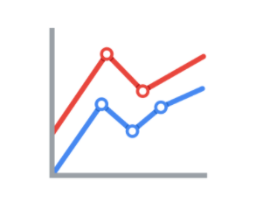

2. **Size** - How big, small, long, or tall a mark is

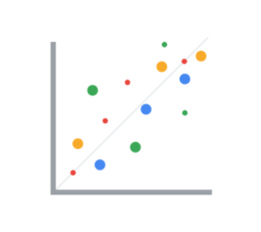

3. **Shape** - Whether a specific object is given a shape that communicates something about it

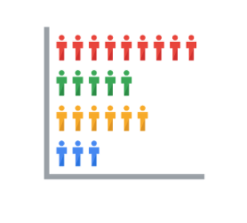

4. **Color** - What color the mark is

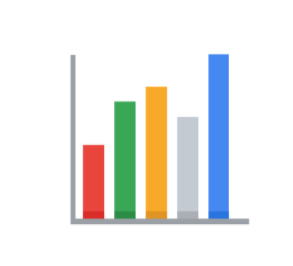

### **Channels**

**C​hannels** are visual aspects or variables that represent characteristics of the data. Channels are basically marks that have been used to visualize data. Channels will vary in terms of how effective they are at communicating data based on three elements:

1. **Accuracy** - Are the channels helpful in accurately estimating the values being represented?

For example, color is very accurate when communicating categorical differences, like apples and oranges. But it is much less effective when distinguishing quantitative data like 5 from 5.5.

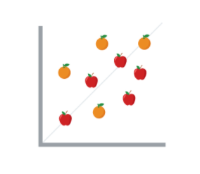

2. **Popout** - How easy is it to distinguish certain values from others?

There are many ways of drawing attention to specific parts of a visual, and many of them leverage pre-attentive attributes like line length, size, line width, shape, enclosure, hue, and intensity.

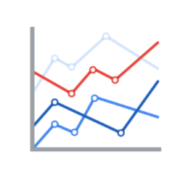

3. **Grouping** - How good is a channel at communicating groups that exist in the data?

Consider the proximity, similarity, enclosure, connectedness, and continuity of the channel.

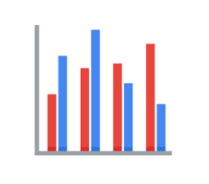

But, remember: the more you emphasize different things, the less that emphasis counts. The more you emphasize one single thing, the more that counts.

## Design principles

Once you understand the pre-attentive attributes of data visualization, you can go on to design principles for creating effective visuals. These design principles are important to your work as a data analyst because they help you make sure that you are creating visualizations that communicate your data effectively to your audience. By keeping these rules in mind, you can plan and evaluate your data visualizations to decide if they are working for you and your goals. And, if they aren’t, you can adjust them!

| **Principle** | **Description** |
| --- | --- |
| Choose the right visual | One of the first things you have to decide is which visual will be the most effective for your audience. Sometimes, a simple table is the best visualization. Other times, you need a more complex visualization to illustrate your point. |
| Optimize the data-ink ratio | The data-ink entails focusing on the part of the visual that is essential to understanding the point of the chart. Try to minimize non-data ink like boxes around legends or shadows to optimize the data-ink ratio. |
| Use orientation effectively | Make sure the written components of the visual, like the labels on a bar chart, are easy to read. You can change the orientation of your visual to make it easier to read and understand. |
| Color | There are a lot of important considerations when thinking about using color in your visuals. These include using color consciously and meaningfully, staying consistent throughout your visuals, being considerate of what colors mean to different people, and using inclusive color scales that make sense for everyone viewing them. |
| Numbers of things | Think about how many elements you include in any visual. If your visualization uses lines, try to plot five or fewer. If that isn’t possible, use color or hue to emphasize important lines. Also, when using visuals like pie charts, try to keep the number of segments to less than seven since too many elements can be distracting. |

## Avoiding misleading or deceptive charts



As you are considering what kind of visualization to create and how to design it, you will want to be sure that you are not creating misleading or deceptive charts. As you have been learning, data analysis provides people with insights and knowledge they can use to make decisions. So, it is important that the visualizations you create are communicating your data accurately and truthfully. Here are some common errors to avoid so that your visualizations aren’t accidentally misleading:

| **What to avoid** | **Why** |
| --- | --- |
| Cutting off the y-axis | Changing the scale on the y-axis can make the differences between different groups in your data seem more dramatic, even if the difference is actually quite small. |
| Misleading use of a dual y-axis | Using a dual y-axis without clearly labeling it in your data visualization can create extremely misleading charts. |
| Artificially limiting the scope of the data | If you only consider the part of the data that confirms your analysis, your visualizations will be misleading because they don’t take all of the data into account. |
| Problematic choices in how data is binned or grouped | It is important to make sure that the way you are grouping data isn’t misleading or misrepresenting your data and disguising important trends and insights. |
| Using part-to-whole visuals when the totals do not sum up appropriately | If you are using a part-to-whole visual like a pie chart to explain your data, the individual parts should add up to equal 100%. If they don’t, your data visualization will be misleading. |
| Hiding trends in cumulative charts | Creating a cumulative chart can disguise more insightful trends by making the scale of the visualization too large to track any changes over time. |
| Artificially smoothing trends | Adding smooth trend lines between points in a scatter plot can make it easier to read that plot, but replacing the points with just the line can actually make it appear that the point is more connected over time than it actually was. |

Finally, keep in mind that data visualization is an art form, and it takes time to develop these skills. Over your career as a data analyst, you will not only learn how to design good data visualizations, but you will also learn how to evaluate good data visualizations. Use these tips to think critically about data visualization—both as a creator and as an audience member.

## Further reading

* [The beauty of data visualization](https://www.ted.com/talks/david_mccandless_the_beauty_of_data_visualization?language=en#t-150183): In this video, David McCandless explains the need for design to not just be beautiful, but for it to be meaningful as well. Data visualization must be able to balance function and form for it to be relevant to your audience.
* [‘The McCandless Method’ of data presentation](https://artscience.blog/home/the-mccandless-method-of-data-presentation): At first glance, this blog appears to be written by a David McCandless fan, and it is. However, it contains very useful information and provides an in-depth look at the 5-step process that McCandless uses to present his data.
* [Information is beautiful](https://informationisbeautiful.net/): Founded by McCandless himself, this site serves as a hub of sample visualizations that make use of the McCandless method. Explore data from the news, science, the economy, and so much more and learn how to make visual decisions based on facts from all kinds of sources.
* [Beautiful daily news](https://informationisbeautiful.net/beautifulnews/): In this McCandless collection, explore uplifting trends and statistics that are beautifully visualized for your creative enjoyment. A new chart is released every day so be sure to visit often to absorb the amazing things happening all over the world.
* [The Wall Street Journal Guide to Information Graphics: The Dos and Don'ts of Presenting Data, Facts, and Figures](https://www.amazon.com/Street-Journal-Guide-Information-Graphics/dp/0393072959): This is a comprehensive guide to data visualization, including chapters on basic data visualization principles and how to create useful data visualizations even when you find yourself in a tricky situation. This is a useful book to add to your data visualization library, and you can reference it over and over again.

The beauty of visualizing

You will find that organizing your data and communicating your results are significant parts of a data analyst’s role. In this reading, you are going to navigate different resources for effective data visualization that will allow you to choose the best model to present your data.

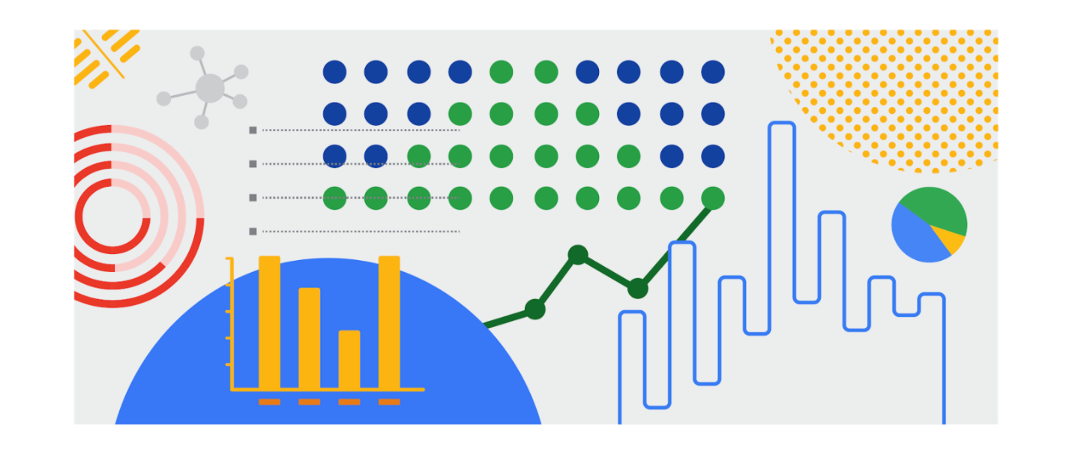

**Inspiration is in the air**

**Data visualization** is the graphical representation of data. But why should data analysts care about data visualization? Well your audience won’t always have the ability to interpret or understand the complex information that you relay to them so your job is to inform them of your analysis in a way that is meaningful, engaging, and easy to understand. Part of why data visualization is so effective is because people’s eyes are drawn to colors, shapes, and patterns, which makes those visual elements perfect for telling a story that goes beyond just the numbers.

Of course, one of the best ways to understand the importance of data visualization is to go through different examples of it. As a junior data analyst, you want to have several visualization options for your creative process whenever you need. Below is a list of resources that can inspire your next data-driven decisions, as well as teach you how to make your data more accessible to your audience:

* [The data visualization catalogue](https://datavizcatalogue.com/#google_vignette): Not sure where to start with data visualization? This catalogue features a range of different diagrams, charts, and graphs to help you find the best fit for your project. As you navigate each category, you will get a detailed description of each visualization as well as its function and a list of similar visuals.
* [The 25 best data visualizations](https://visme.co/blog/best-data-visualizations/): In this collection of images, explore the best examples of data that gets made into a stunning visual. Simply click on the link below each image to get an in-depth view of each project, and learn why making data visually appealing is so important.
* [10 data visualization blogs](https://www.tableau.com/learn/articles/best-data-visualization-blogs): Each link will lead you to a blog that is a fountain of information on everything from data storytelling to graphic data. Get your next great idea or just browse through some visual inspiration.
* [Information is beautiful](https://informationisbeautiful.net/wdvp/gallery-2019/): Founded by David McCandless, this gallery is dedicated to helping you make clearer, more informed visual decisions based on facts and data. These projects are made by students, designers, and even data analysts to help you gain insight into how they have taken their own data and turned it into visual storytelling.
* [Data studio gallery](https://datastudio.google.com/gallery?category=visualization): Information is vital, but information presented in a digestible way is even more useful. Browse through this interactive gallery and find examples of different types of data communicated visually. You can even use the data studio tool to create your own data-driven visual.

**Engage your audience**

Remember: an important component of being a data analyst is the ability to communicate your findings in a way that will appeal to your audience. Data visualization has the ability to make complex (and even monotonous) information easily understood, and knowing how to utilize data visualization is a valuable skill to have. Your goal is always to help the audience have a conversation with the data so your visuals draw them into the conversation. This is especially true when you have to help your audience engage with a large amount of data, such as the flow of goods from one country to other parts of the world.

# Correlation and causation

In this reading, you will examine correlation and causation in more detail. Let’s review the definitions of these terms:

* **Correlation** in statistics is the measure of the degree to which two variables move in relationship to each other. An example of correlation is the idea that “As the temperature goes up, ice cream sales also go up.” It is important to remember that correlation doesn’t mean that one event causes another. But, it does indicate that they have a pattern with or a relationship to each other. If one variable goes up and the other variable also goes up, it is a positive correlation. If one variable goes up and the other variable goes down, it is a negative or inverse correlation. If one variable goes up and the other variable stays about the same, there is no correlation.
* **Causation** refers to the idea that an event leads to a specific outcome. For example, when lightning strikes, we hear the thunder (sound wave) caused by the air heating and cooling from the lightning strike. Lightning causes thunder.

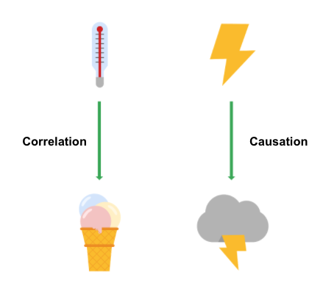

## Why is differentiating between correlation and causation important?

When you make conclusions from data analysis, you need to make sure that you don’t assume a causal relationship between elements of your data when there is only a correlation. When your data shows that outdoor temperature and ice cream consumption both go up at the same time, it might be tempting to conclude that hot weather **causes** people to eat ice cream. But, a closer examination of the data would reveal that every change in temperature doesn’t lead to a change in ice cream purchases. In addition, there might have been a sale on ice cream at the same time that the data was collected, which might not have been considered in your analysis.

Knowing the difference between correlation and causation is important when you make conclusions from your data since the stakes could be high. The next two examples illustrate the high stakes to health and human services.

### **Cause of disease**

For example, pellagra is a disease with symptoms of dizziness, sores, vomiting, and diarrhea. In the early 1900s, people thought that the disease was caused by unsanitary living conditions. Most people who got pellagra also lived in unsanitary environments. But, a closer examination of the data showed that pellagra was the result of a lack of niacin (Vitamin B3). Unsanitary conditions were related to pellagra because most people who couldn’t afford to purchase niacin-rich foods also couldn’t afford to live in more sanitary conditions. But, dirty living conditions turned out to be a correlation only.

### **Distribution of aid**

Here is another example. Suppose you are working for a government agency that provides food stamps. You noticed from the agency’s Google Analytics that people who qualify for food stamps are browsing the official website, but they are leaving the site without signing up for benefits. You think that the people visiting the site are leaving because they aren’t finding the information they need to sign up for food stamps. Google Analytics can help you find clues (correlations), like the same people coming back many times or how quickly people leave the page. One of those correlations might lead you to the actual cause, but you will need to collect additional data, like in a survey, to know exactly why people coming to the site aren’t signing up for food stamps. Only then can you figure out how to increase the sign-up rate.

## Key takeaways

In your data analysis, remember to:

* Critically analyze any correlations that you find
* Examine the data’s context to determine if a causation makes sense (and can be supported by all of the data)
* Understand the limitations of the tools that you use for analysis

## Further information

You can explore the following article and training for more information about correlation and causation:

* [**Correlation is not causation**](https://towardsdatascience.com/correlation-is-not-causation-ae05d03c1f53)**:** This article describes the impact to a business when correlation and causation are confused.
* [**Correlation and causation**](https://www.khanacademy.org/test-prep/praxis-math/praxis-math-lessons/gtp--praxis-math--lessons--statistics-and-probability/a/gtp--praxis-math--article--correlation-and-causation--lesson) **(Khan Academy lesson):** This lesson describes correlation and causation along with a working example. Follow the examples of the analysis and notice if there is a positive correlation between frostbite and sledding accidents.

The wonderful world of visualizations

As a data analyst, you will often be tasked with relaying information and data that your audience might not readily understand. Presenting your data visually is an effective way to communicate complex information and engage your stakeholders. One question to ask yourself is: “what is the best way to tell the story within my data?” This reading includes several options for you to choose from (although there are many more).

**Line chart**

A **line chart** is used to track changes over short and long periods of time. When smaller changes exist, line charts are better to use than bar graphs. Line charts can also be used to compare changes over the same period of time for more than one group.

Let’s say you want to present the graduation frequency for a particular high school between the years 2008-2012. You would input your data in a table like this:

| **Year** | **Graduation rate** |
| --- | --- |
| 2008 | 87 |
| 2009 | 89 |
| 2010 | 92 |
| 2011 | 92 |
| 2012 | 96 |

From this table, you are able to present your data in a line chart like this:

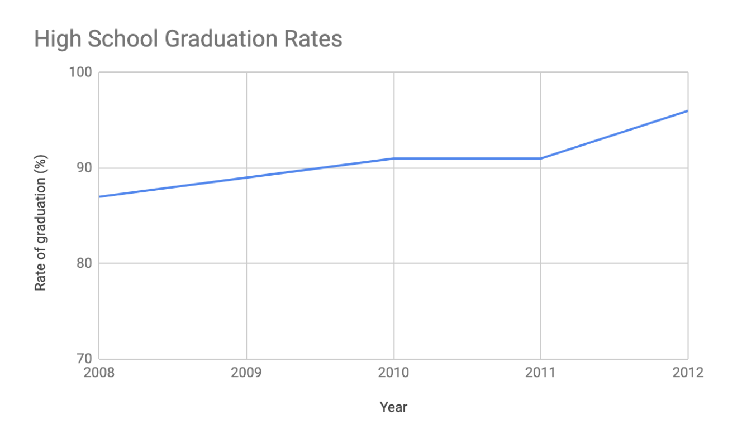

Maybe your data is more specific than above. For example, let’s say you are tasked with presenting the difference of graduation rates between male and female students. Then your chart would resemble something like this:

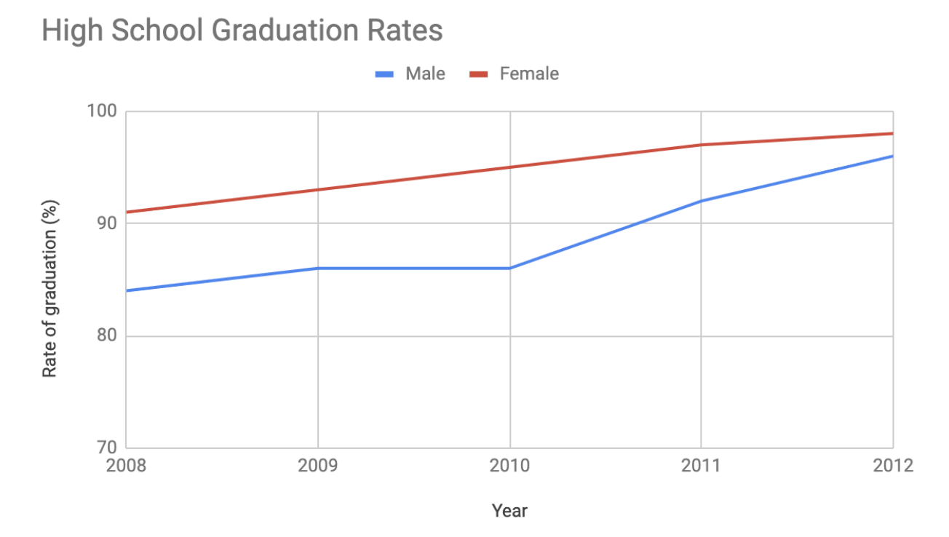

**Column chart**

**Column charts** use size to contrast and compare two or more values, using height or lengths to represent the specific values.

The below is example data concerning sales of vehicles over the course of 5 months:

| **Month** | **Vehicles sold** |
| --- | --- |
| August | 2,800 |
| September | 3,700 |
| October | 3,750 |
| November | 4,300 |
| December | 4,600 |

Visually, it would resemble something like this:

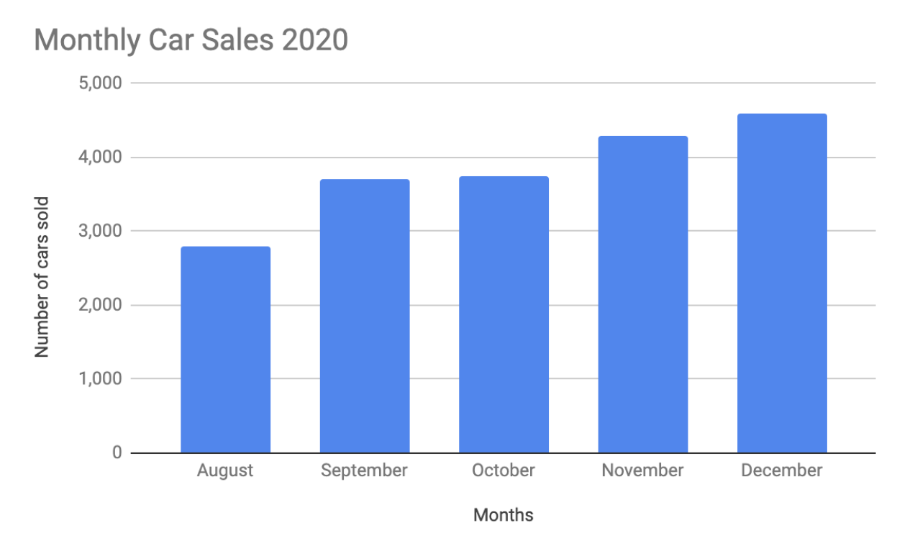

What would this column chart entail if we wanted to add the sales data for a competing car brand?

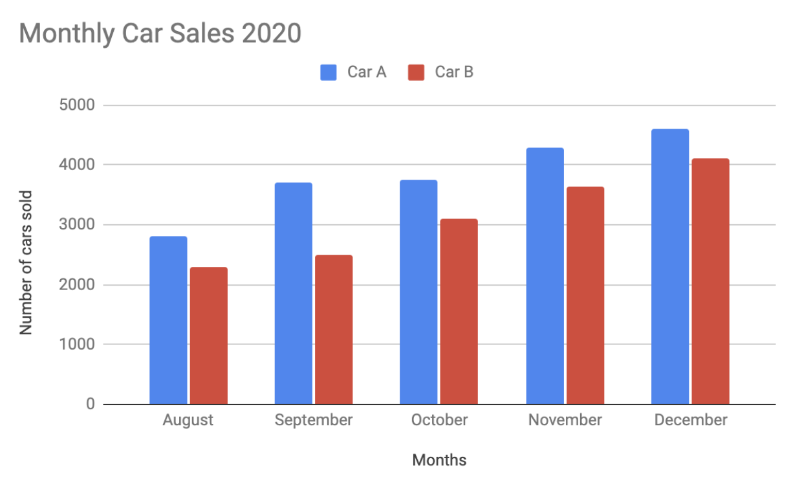

**Heatmap**

Similar to bar charts, **heatmaps** also use color to compare categories in a data set. They are mainly used to show relationships between two variables and use a system of color-coding to represent different values. The following heatmap plots temperature changes for each city during the hottest and coldest months of the year.

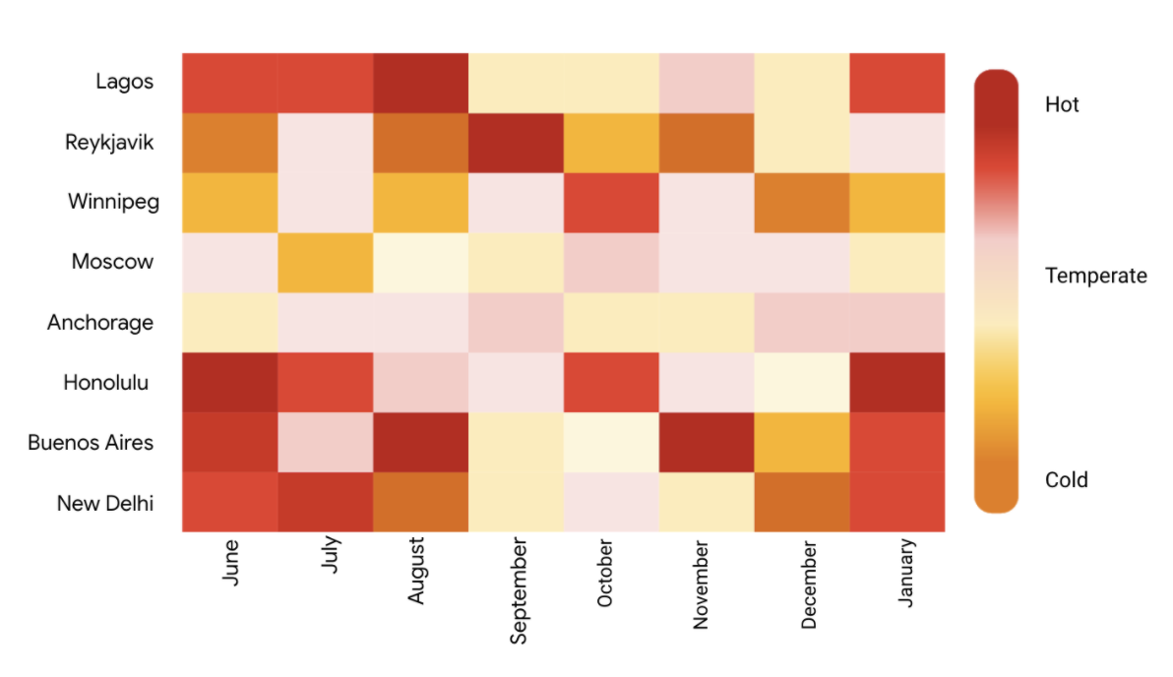

**Pie chart**

The **pie chart** is a circular graph that is divided into segments representing proportions corresponding to the quantity it represents, especially when dealing with parts of a whole.

For example, let’s say you are determining favorite movie categories among avid movie watchers. You have gathered the following data:

| **Movie category** | **Preference** |
| --- | --- |
| Comedy | 41% |
| Drama | 11% |
| Sci-fi | 3% |
| Romance | 17% |
| Action | 28% |

Visually, it would resemble something like this:

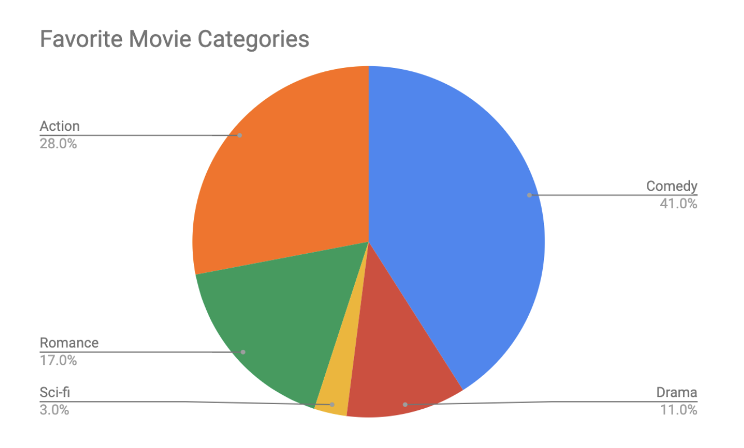Action- 28% Comedy- 41% Romance- 17% Sci-fi- 3% Drama- 11%

**Scatter plot**

**Scatter plots** show relationships between different variables. Scatter plots are typically used for two variables for a set of data, although additional variables can be displayed.

For example, you might want to show data of the relationship between temperature changes and ice cream sales. It would resemble something like this:

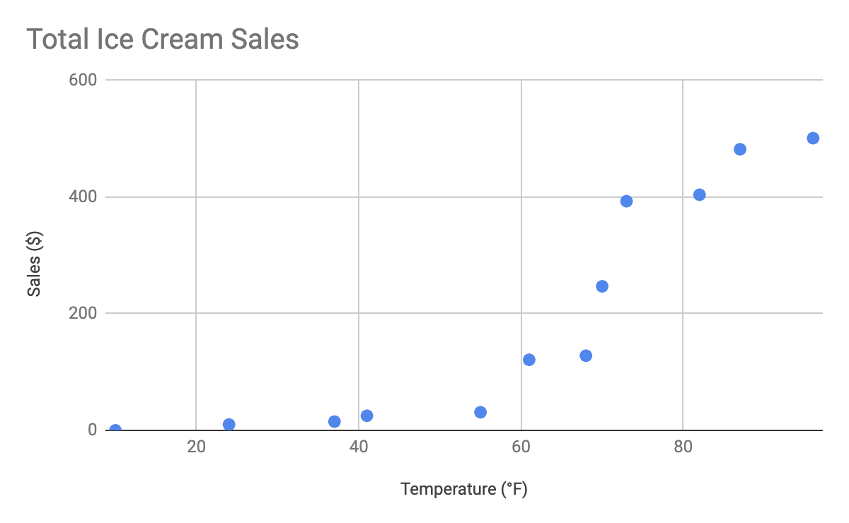

As you may notice, the higher the temperature got, the more demand there was for ice cream – so the scatter plot is great for showing the relationship between the two variables.

**Distribution graph**

A **distribution graph** displays the spread of various outcomes in a dataset.

Let’s apply this to real data. To account for its supplies, a brand new coffee shop owner wants to measure how many cups of coffee their customers consume, and they want to know if that information is dependent on the days and times of the week. That distribution graph would resemble something like this:

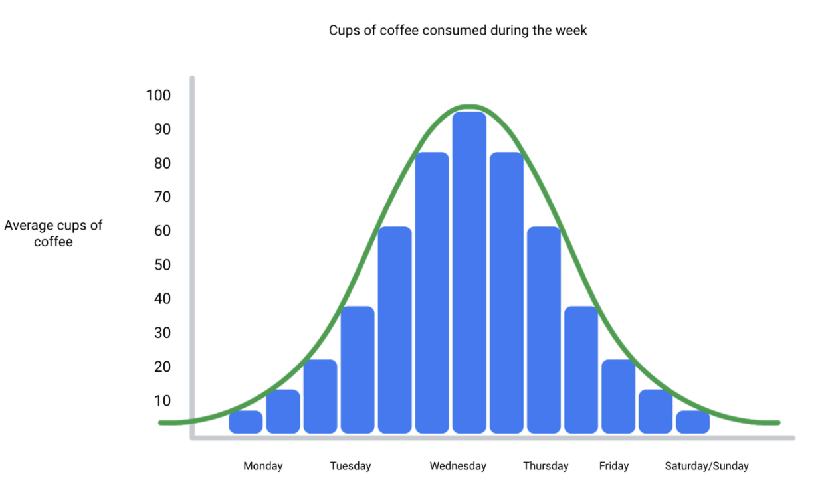

From this distribution graph, you may notice that the amount of coffee sales steadily increases from the beginning of the week, reaching the highest point mid-week, and then decreases towards the end of the week.

If outcomes are categorized on the x-axis by distinct numeric values (or ranges of numeric values), the distribution becomes a **histogram**. If data is collected from a customer rewards program, they could categorize how many customers consume between one and ten cups of coffee per week. The histogram would have ten columns representing the number of cups, and the height of the columns would indicate the number of customers drinking that many cups of coffee per week.

Reviewing each of these visual examples, where do you notice that they fit in relation to your type of data? One way to answer this is by evaluating patterns in data. Meaningful patterns can take many forms, such as:

* **Change:** This is a trend or instance of observations that become different over time. A great way to measure change in data is through a line or column chart.
* **Clustering:** A collection of data points with similar or different values. This is best represented through a distribution graph.
* **Relativity:** These are observations considered in relation or in proportion to something else. You have probably seen examples of relativity data in a pie chart.
* **Ranking:** This is a position in a scale of achievement or status. Data that requires ranking is best represented by a column chart.
* **Correlation:** This shows a mutual relationship or connection between two or more things. A scatter plot is an excellent way to represent this type of data pattern.

**Studying your data**

Data analysts are tasked with collecting and interpreting data as well as displaying data in a meaningful and digestible way. Determining how to visualize your data will require studying your data’s patterns and converting it using visual cues. Feel free to practice your own charts and data in spreadsheets. Simply input your data in the spreadsheet, highlight it, then insert any chart type and view how your data can be visualized based on what you choose.

Data grows on decision trees

With so many visualization options out there for you to choose from, how do you decide what is the best way to represent your data?

A **decision tree** is a decision-making tool that allows you, the data analyst, to make decisions based on key questions that you can ask yourself. Each question in the visualization decision tree will help you make a decision about critical features for your visualization. Below is an example of a basic decision tree to guide you towards making a data-driven decision about which visualization is the best way to tell your story. Please note that there are many different types of decision trees that vary in complexity, and can provide more in-depth decisions.

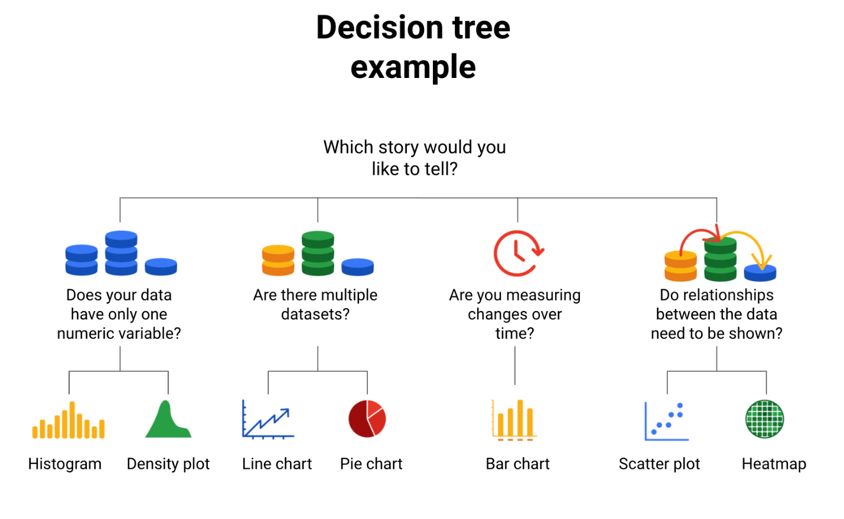-Does your data have only one numeric variable? Histogram or Density plot -Are there multiple data sets?  Line chart or pie chart -Are you measuring changes over time? Bar chart -Do relationships between the data need to be shown? Scatter plot or heatmap

**Begin with your story**

Start off by evaluating the type of data you have and go through a series of questions to determine the best visual source:

* **Does your data have only one numeric variable?** If you have data that has one, continuous, numerical variable, then a histogram or density plot are the best methods of plotting your categorical data. Depending on your type of data, a bar chart can even be appropriate in this case. For example, if you have data pertaining to the height of a group of students, you will want to use a histogram to visualize how many students there are in each height range:

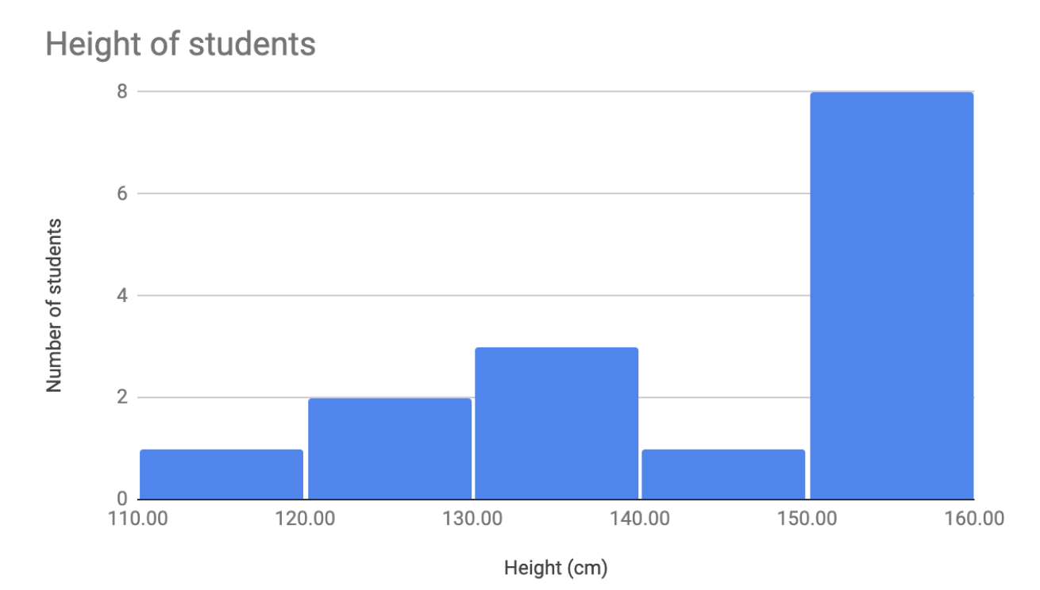

* **Are there multiple datasets?**For cases dealing with more than one set of data, consider a line or pie chart for accurate representation of your data. A line chart will connect multiple data sets over a single, continuous line, showing how numbers have changed over time. A pie chart is good for dividing a whole into multiple categories or parts. An example of this is when you are measuring quarterly sales figures of your company. Below are examples of this data plotted on both a line and pie chart.

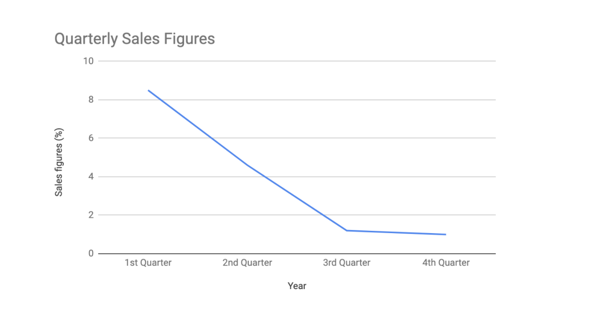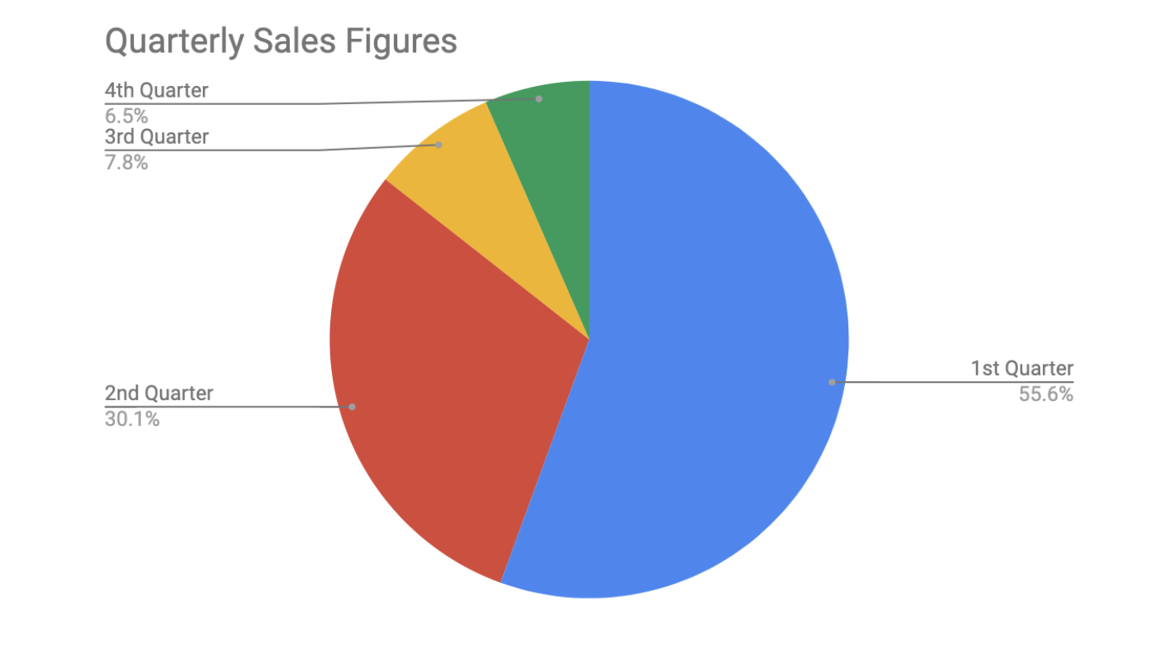

* **Are you measuring changes over time?** A line chart is usually adequate for plotting trends over time. However, when the changes are larger, a bar chart is the better option. If, for example, you are measuring the number of visitors to NYC over the past 6 months, the data would look like this:

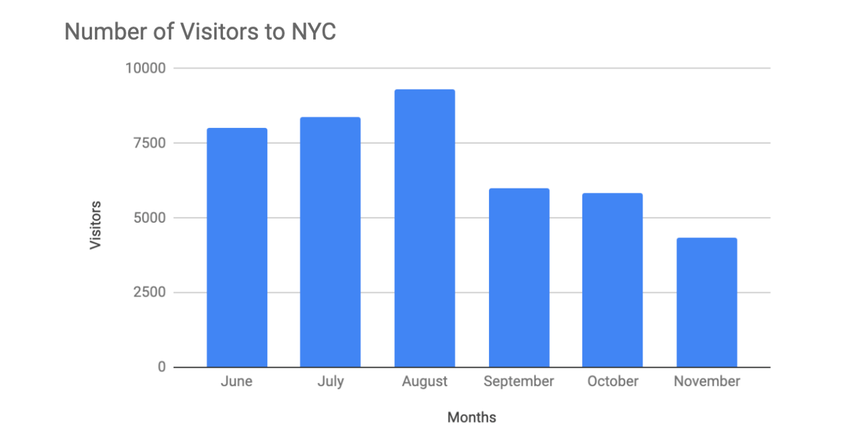

* **Do relationships between the data need to be shown?** When you have two variables for one set of data, it is important to point out how one affects the other. Variables that pair well together are best plotted on a scatter plot. However, if there are too many data points, the relationship between variables can be obscured so a heat map can be a better representation in that case. If you are measuring the population of people across all 50 states in the United States, your data points would consist of millions so you would use a heat map. If you are simply trying to show the relationship between the number of hours spent studying and its effects on grades, your data would look like this:

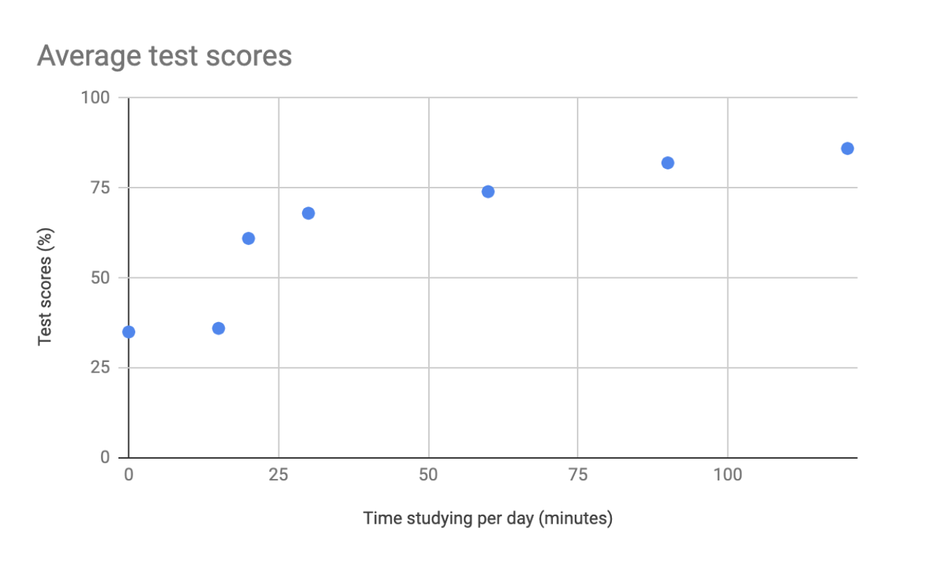

**A​dditional resources**

The decision tree example used in this reading is one of many. There are multiple decision trees out there with varying levels of details that you can use to help guide your visual decisions. If you want more in-depth insight into more visual options, explore the following resources:

* [From data to visualization](https://www.data-to-viz.com/): This is an excellent analysis of a larger decision tree. With this comprehensive selection, you can search based on the kind of data you have or click on each  graphic example for a definition and proper usage.
* [Selecting the best chart](https://www.youtube.com/watch?v=C07k0euBpr8): This two-part YouTube video can help take the guesswork out of data chart selection. Depending on the type of data you are aiming to illustrate, you will be guided through when to use, when to avoid, and several examples of best practices. [Part 2](https://www.youtube.com/watch?v=qGaIB-bRn-A) of this video provides even more examples of different charts, ensuring that there is a chart for every type of data out there.

## Self-Reflection: Choosing your visualization

**Total points**1

### 1.

**Question 1**



## Overview



Now that you have been introduced to decision trees, you can pause for a moment and think about what you are learning. In this self-reflection, you will review a scenario, consider your thoughts about choosing a data visualization, and respond to brief questions.

This self-reflection will help you develop insights into your own learning and prepare you to make a decision tree for your next visualization. As you answer questions—and come up with questions of your own—you will consider concepts, practices, and principles to help refine your understanding and reinforce your learning. You’ve done the hard work, so make sure to get the most out of it: This reflection will help your knowledge stick!

## Use a decision tree to choose a visualization



Choosing a data visualization to communicate your message may seem more like an art than a science. Fortunately, a **decision tree** can help you select the best visualization. To construct a decision tree, you simply need a basic understanding of design principles and the necessary knowledge of your data, message, and audience. This process will help add some structure to your decision making process, making it easier to pick the right data visualization.

First, take a moment to review some of the design concepts and best practices you’ve learned so far.

### **Create successful data visualizations**



Recall that there are four elements of successful data visualization:

* **Information:** reflects the conclusion you’ve drawn from the data, which you will communicate with visualization
* **Story:** adds meaning to the data and makes it interesting
* **Goals:** makes the data usable and useful
* **Visual form:** creates both beauty and structure

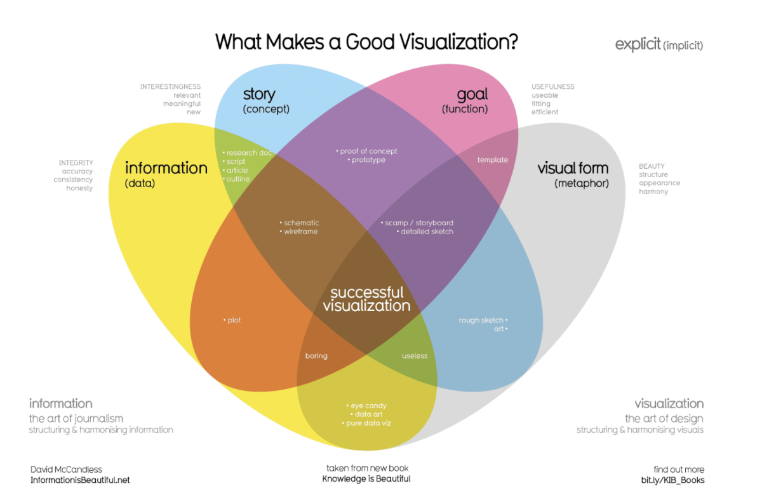Where just two or three ovals overlap, there are different types of incomplete data visualization. At the center, where all four overlap, contains the words “successful visualization”. This visualization stresses the idea that all four elements are necessary to create a successful data visualization.

Keep these elements in mind as you review the scenario below. This will help you make better data visualizations by helping you connect the information you want to communicate with your audience and your goals.

Here are additional best practices that are helpful to keep in mind:

* Your audience should know what they are observing within five seconds of being shown a data visualization. Visuals should be clear and easy to follow.
* In the five seconds after that, your audience should understand the conclusion your visualization is making—even if they aren’t familiar with your research.
* As long as it’s not misleading, you should visually represent only the data that your audience needs in order to understand your findings. Including irrelevant data may confuse, distract, or overwhelm your audience.

These rules will guide you as you create your visualizations and you can apply them as you consider the following scenario.

### **The scenario**



Imagine you are a junior data analyst at a local company. In your current data analysis project, you’ve been exploring sales data for all of your company’s products, including the top products and sales trends for the last year. You need to present the results of this analysis to the company executives. Your goal for this presentation is to demonstrate how sales of the company’s products have changed over the last 12 months. Your findings about the two top-selling products include:

| **Product name** | **Units sold** | **Time period with highest sales** |
| --- | --- | --- |
| Product A | 2.5 million | 70% of total annual sales occur in October, November, and December |
| Product B | 1.9 million | Mostly consistent sales year-round, with a slight increase in November, December, and January |

Your audience is made up of the chief marketing officer (CMO) and marketing department vice presidents (VPs), not other data analysts or engineers. The audience will use the information you present to make decisions on how to allocate the advertising budget for each product for the coming year.

### **Use a decision tree**



A **decision tree** is a flowchart that you can use to help frame larger decisions as a series of smaller yes/no decisions. These are very useful when trying to choose the best data visualization to communicate a given message to your audience. Since different visualizations have different strengths and weaknesses, a decision tree can help you pick the best visualization for your given information and audience.

Observe the following decision tree. Consider what you know about the type of data you have and the kind of relationships you are trying to communicate. Use this to navigate the flowchart and determine what kind of visualizations are most appropriate.

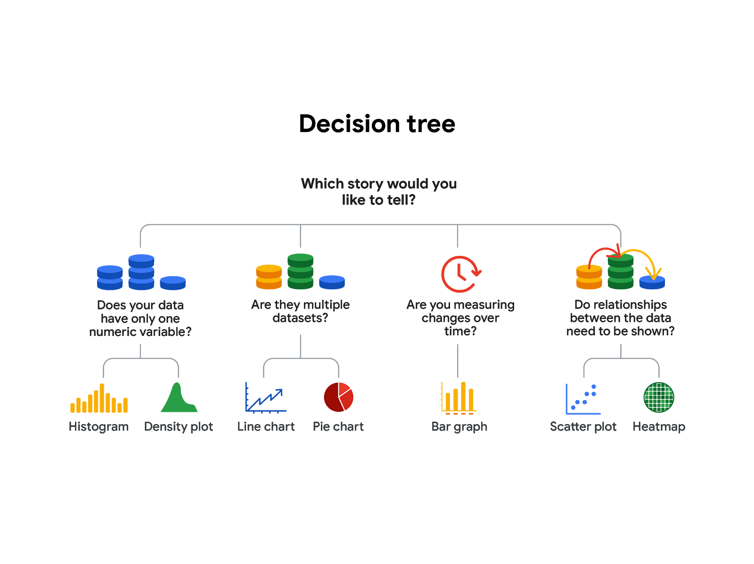-Does your data have only one numeric variable? Histogram or Density plot -Are there multiple data sets?  Line chart or pie chart -Are you measuring changes over time? Bar chart -Do relationships between the data need to be shown? Scatter plot or heatmap

Based on how you want to represent the sales data, there are several good choices here. You could frame this by using a comparison of different categories using a bar graph, or by showing how the composition of total sales changes month-to-month as a line chart with lines for each product.

Either of these would be a good choice. Combined with effective use of design principles, either could accurately communicate the message you need to convey to company leadership. This message being: sales for Product A are extremely seasonal, so they may want to consider reducing their advertising spend for this product when it’s out of season.

# Principles of design

In this reading, you are going to learn more about using the elements of art and principles of design to create effective visualizations. So far, we have learned that communicating data visually is a form of art. Now, it's time to explore the nine design principles for creating beautiful and effective data visualizations that can be informative and appeal to all audiences.

After we go through the various design principles, spend some time examining the visual examples to ensure that you have a thorough understanding of how the principle is put into practice. Let’s get into it!

## Nine basic principles of design

There are ninebasic **principles of design** that data analysts should think about when building their visualizations.

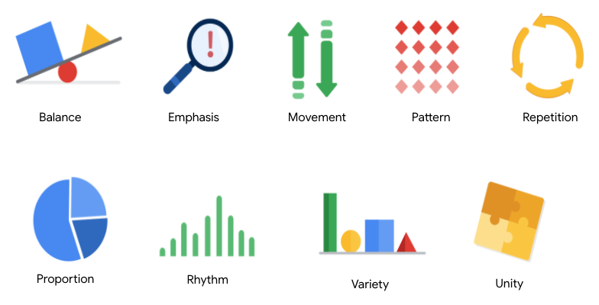

**1. Balance**: The design of a data visualization is balanced when the key visual elements, like color and shape, are distributed evenly. This doesn’t mean that you need complete symmetry, but your visualization shouldn’t have one side distracting from the other. If your data visualization is balanced, this could mean that the lines used to create the graphics are similar in length on both sides, or that the space between objects is equal. For example, [**this column chart**](https://developers.google.com/chart/interactive/docs/gallery/columnchart) (also shown below) is balanced; even though the columns are different heights and the chart isn’t symmetrical, the colors, width, and spacing of the columns keep this data visualization balanced. The colors provide sufficient contrast to each other so that you can pay attention to both the motivation level and the energy level displayed.

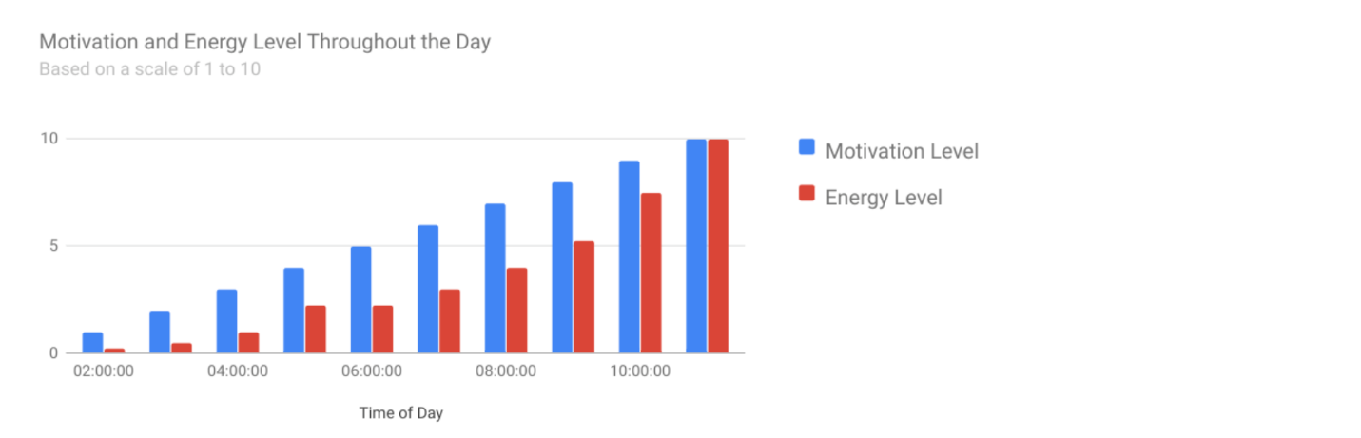

**2. Emphasis:** Your data visualization should have a focal point, so that your audience knows where to concentrate. In other words, your visualizations should emphasize the most important data so that users recognize it first. Using color and value is one effective way to make this happen. By using contrasting colors, you can make certain that graphic elements—and the data shown in those elements—stand out.

For example, you will notice a heat map data visualization below from [**The Pudding’s “Where Slang Comes From"**](https://pudding.cool/2017/02/new-slang/)article. This heat map uses colors and value intensity to emphasize the states where search interest is highest. You can visually identify the increase in the search over time from low interest to high interest. This way, you are able to quickly grasp the key idea being presented without knowing the specific data values.

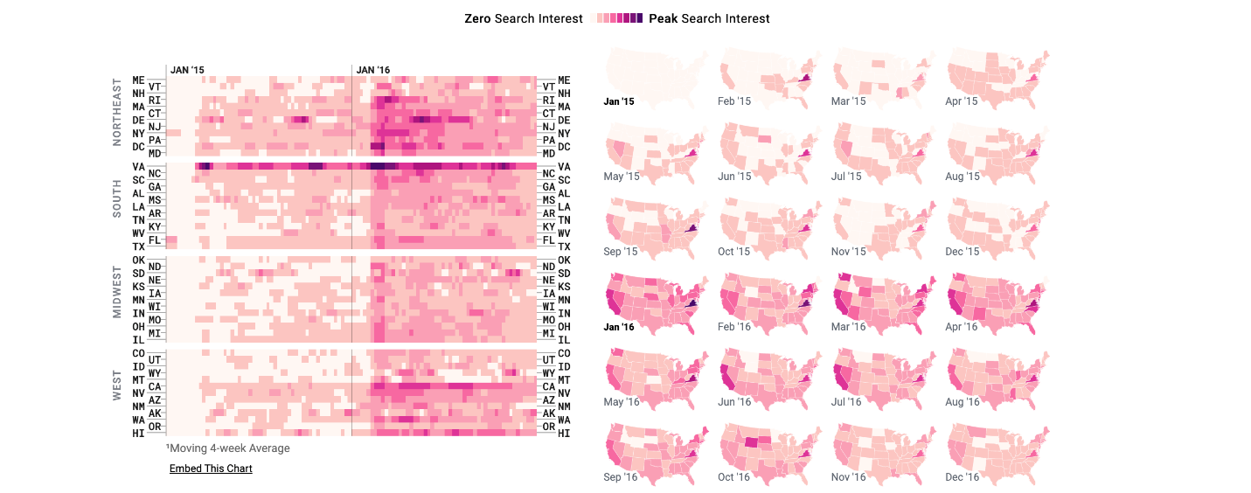

**3. Movement:** Movement can refer to the path the viewer’s eye travels as they look at a data visualization, or literal movement created by animations. Movement in data visualization should mimic the way people usually read. You can use lines and colors to pull the viewer’s attention across the page.

For example, notice how the average line in [**this combo chart**](https://developers.google.com/chart/interactive/docs/gallery/combochart) (also shown below) draws your attention from left to right. Even though this example isn’t moving, it still uses the movement principle to guide viewers’ understanding of the data.

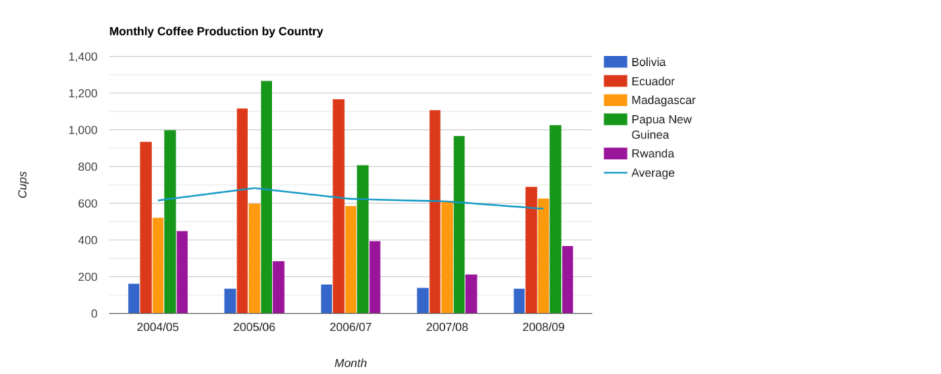

**4. Pattern:** You can use similar shapes and colors to create patterns in your data visualization. This can be useful in a lot of different ways. For example, you can use patterns to highlight similarities between different data sets, or break up a pattern with a unique shape, color, or line to create more emphasis.

In the example below, the different colored categories of [**this stacked column chart**](https://developers.google.com/chart/interactive/docs/gallery/barchart)(also shown below)are a consistent pattern that makes it easier to compare book sales by genre in each column. Notice in the chart that the Fantasy & Sci Fi category (royal blue) is increasing over time even as the general category (green) is staying about the same.

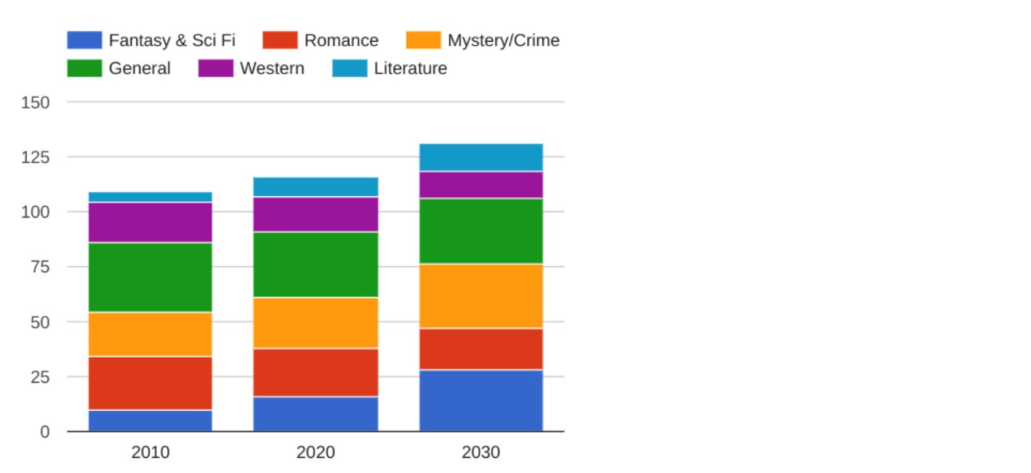

**5. Repetition:** Repeating chart types, shapes, or colors adds to the effectiveness of your visualization. Think about the book sales chart from the previous example: the repetition of the colors helps the audience understand that there are distinct sets of data. You may notice this repetition in all of the examples we have reviewed so far. Take some time to review each of the previous examples and notice the elements that are repeated to create a meaningful visual story.

**6. Proportion:** Proportion is another way that you can demonstrate the importance of certain data. Using various colors and sizes helps demonstrate that you are calling attention to a specific visual over others. If you make one chart in a dashboard larger than the others, then you are calling attention to it. It is important to make sure that each chart accurately reflects and visualizes the relationship among the values in it. In [**this dashboard**](https://developers.google.com/chart/interactive/docs/gallery/controls) (also shown below), the slice sizes and colors of the pie chart compared to the data in the table help make the number of donuts eaten by each person the focal point.

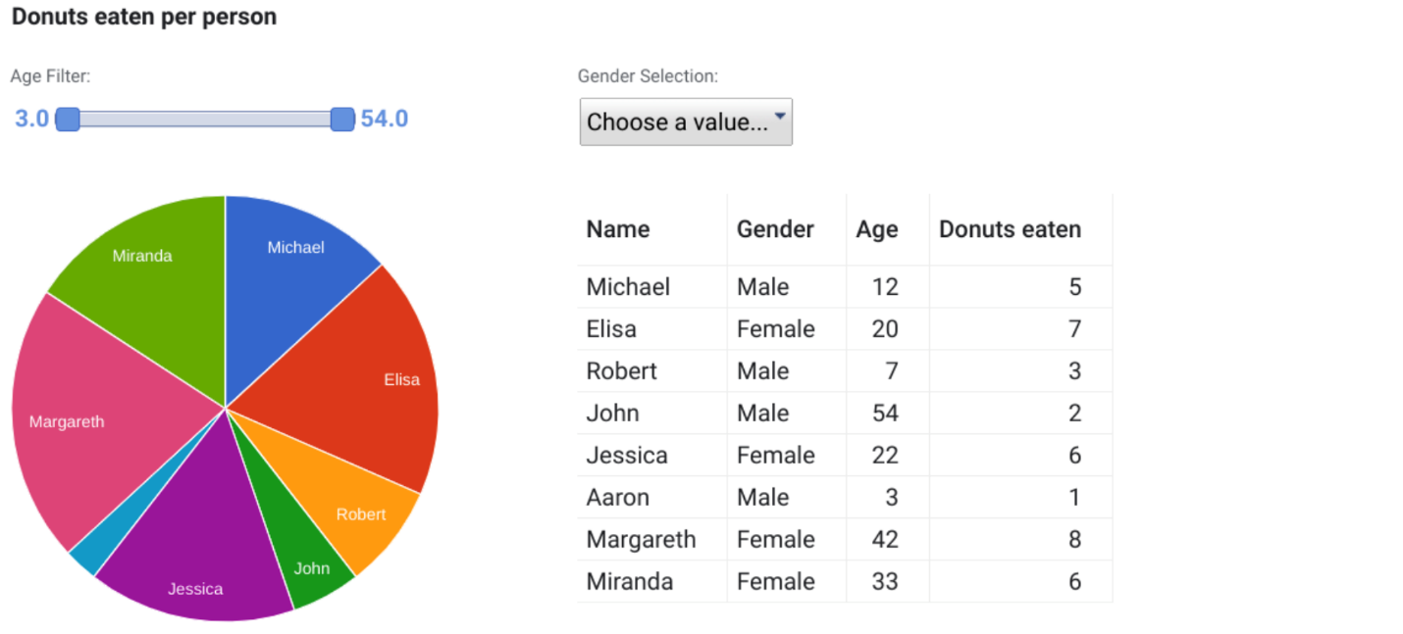

These first six principles of design are key considerations that you can make while you are creating your data visualization. These next three principles are useful checks once your data visualization is finished. If you have applied the initial six principles thoughtfully, then you will probably recognize these next three principles within your visualizations already.

**7. Rhythm:** This refers to creating a sense of movement or flow in your visualization. Rhythm is closely tied to the movement principle. If your finished design doesn’t successfully create a flow, you might want to rearrange some of the elements to improve the rhythm.

**8. Variety:** Your visualizations should have some variety in the chart types, lines, shapes, colors, and values you use. Variety keeps the audience engaged. But it is good to find balance since too much variety can confuse people. The variety you include should make your dashboards and other visualizations feel interesting and unified.

**9. Unity:** The last principle is unity. This means that your final data visualization should be cohesive. If the visual is disjointed or not well organized, it will be confusing and overwhelming.

Being a data analyst means learning to think in a lot of different ways. These nine principles of design can help guide you as you create effective and interesting visualizations.

# Data is beautiful

At this point, you might be asking yourself: What makes a good visualization? Is it the data you use? Or maybe it is the story that it tells? In this reading, you are going to learn more about what makes data visualizations successful by exploring David McCandless’ elements of successful data visualization and evaluating three examples based on those elements. Data visualization can change our perspective and allow us to notice data in new, beautiful ways. A picture is worth a thousand words—that’s true in data too! You will have the option to save all of the data visualization examples that are used throughout this reading; these are great examples of successful data visualization that you can use for future inspiration.

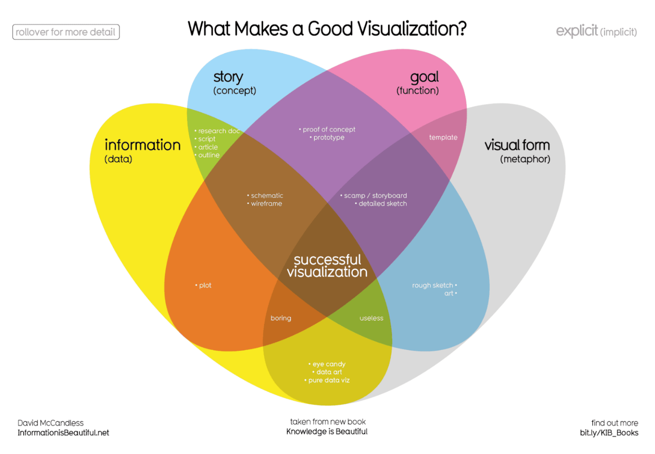Where just two or three ovals overlap, there are different types of incomplete data visualization. At the center, where all four overlap, contains the words “successful visualization”. This visualization stresses the idea that all four elements are necessary to create a successful data visualization

You can also access a PDF version of this visualization and save it for your own reference by clicking the file below:

**WEB\_What-Makes-a-Good-Infoviz.pdf**PDF File

[Open file](https://d3c33hcgiwev3.cloudfront.net/P5sik46MQMmbIpOOjGDJ0g_6ccbbc544b41477883b63dd5f37dbbf5_WEB_What-Makes-a-Good-Infoviz.pdf?Expires=1648080000&Signature=VtUMuM2IOgp6Er87pQumOKTcXJnkfCoLoMAIAxjoOKDTi3RE1NqLSMzDDAlIyv9BsVa-J91KQseHtfxJQTa7m5pvzYJiAsbzAznQgzTKZNdyJ6tmc7PRebkRyJAhQ2qKuiq03StNX5Yu4OH5aJ8W3-M8oR7FHaGHjdmCCcuYvbs_&Key-Pair-Id=APKAJLTNE6QMUY6HBC5A" \t "_blank)

## Four elements of successful visualizations

The Venn diagram by David McCandless identifies four elements of successful visualizations:

* **Information (data):** The information or data that you are trying to convey is a key building block for your data visualization. Without information or data, you cannot communicate your findings successfully.
* **Story (concept):** Story allows you to share your data in meaningful and interesting ways. Without a story, your visualization is informative, but not really inspiring.
* **Goal (function):** The goal of your data visualization makes the data useful and usable. This is what you are trying to achieve with your visualization. Without a goal, your visualization might still be informative, but can’t generate actionable insights.
* **Visual form (metaphor):** The visual form element is what gives your data visualization structure and makes it beautiful. Without visual form, your data is not visualized yet.

All four of these elements are important on their own, but a successful data visualization balances all four. For example, if your data visualization has only two elements, like the information and story, you have a rough outline. This can be really useful in your early planning stages, but is not polished or informative enough to share. Even three elements are not quite enough— you need to consider all four to create a successful data visualization.

In the next part of this reading, you will use these elements to examine two data visualization examples and evaluate why they are successful.

## Example 1: Visualization of dog breed comparison

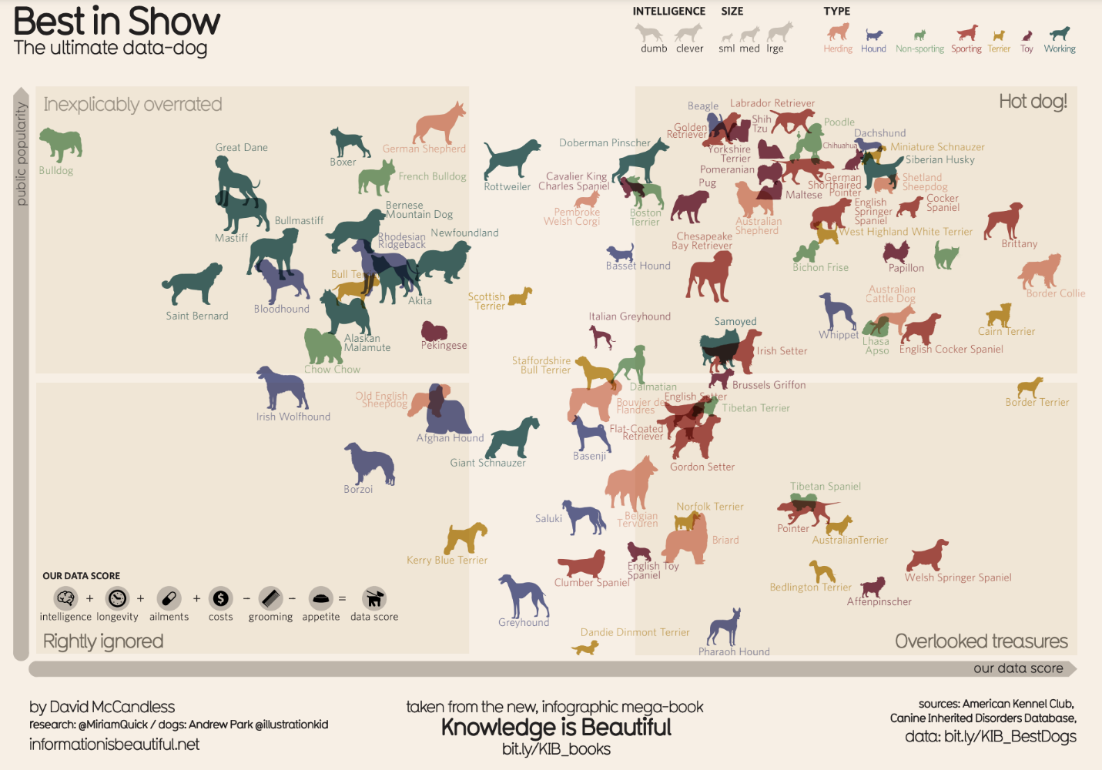It uses two axes, popularity and data score, to place different dog breeds on a four-square chart. The squares are labelled “Inexplicably Overrated,” “The Rightly Ignored,” “Hot Dogs!,” and “Overlooked Treasures.” Different dog breeds, visualized with plotted points shaped like dogs, are distributed on the chart based on their popularity and their data score.

Save this data visualization as a PDF by clicking the file below:

**IIB-LICENSED\_Best-in-Show.pdf**PDF File

[Open file](https://d3c33hcgiwev3.cloudfront.net/9_ukt6X2QOu7pLel9tDrfw_359529dc0bd647de843a11274ca5ace9_IIB-LICENSED_Best-in-Show.pdf?Expires=1648080000&Signature=VI4CBSFhhcAOsaOu90Kb44aF3KQQxXwwZHoT2tfh7zRsZvzSyhmJBBrYp1ZBrzu31kdKWgancQfBy-n4miYWhyPR33PvV9CrimPvitzRGBxH3OGr8iNaLTw5Xau9I~Z38uJ4BXwpt6gaU9RnLfT2QxUNlMGB45ba9G~ccUH4DOs_&Key-Pair-Id=APKAJLTNE6QMUY6HBC5A" \t "_blank)

### **View the data**

The Best in Show visualization uses data about different dog breeds from the American Kennel Club. The data has been compiled in a spreadsheet. Click the link below and select "Use Template" to view the data.

Link to the template: [KIB - Best in Show](https://docs.google.com/spreadsheets/d/1l_HfF5EaN-QgnLc2UYdCc7L2CVrk0p3VdGB1godOyhk/template/preview)

Or, if you don't have a Google account, download the file below.

**KIB - Best in Show (public)**XLSX File

[Download file](https://d3c33hcgiwev3.cloudfront.net/-tlQpnbgR2-ZUKZ24GdvPg_5754482a15824030bab88668386dde06_KIB---Best-in-Show-public-.xlsx?Expires=1648080000&Signature=N~U3wSsskz4wgssWM-4K26tOkNAuplu37oVKqIxbabgUxIDbfXLASV31P-TeE80kSchk5KIxIALr-Jt6AGF~01B1el7EXuNagt4QMP7MH1HkcsSwzMIU-rS-YTXIx4FmOTPmIJ4u7Be-DD0x1Uemb5HdECfHPqbZSjT~qsLkjMU_&Key-Pair-Id=APKAJLTNE6QMUY6HBC5A" \t "_blank)

### **Examine the four elements**

This visualization compares the popularity of different dog breeds to a more objective data score. Consider how it uses the elements of successful data visualization:

* **Information (data):** If you view the data, you can explore the metrics being illustrated in the visualization.
* **Story (concept):** The visualization shows which dogs are overrated, which are rightly ignored, and those that are really hot dogs! And, the visualization reveals some overlooked treasures you may not have known about previously.
* **Goal (function):** The visualization is interested in exploring the relationship between popularity and the objective data scores for different dog breeds. By comparing these data points, you can learn more about how different dog breeds are perceived.
* **Visual form (metaphor):** In addition to the actual four-square structure of this visualization, other visual cues are used to communicate information about the dataset. The most obvious is that the data points are represented as dog symbols. Further, the size of a dog symbol and the direction the dog symbol faces communicate other details about the data.

## Example 2: Visualization of rising sea levels

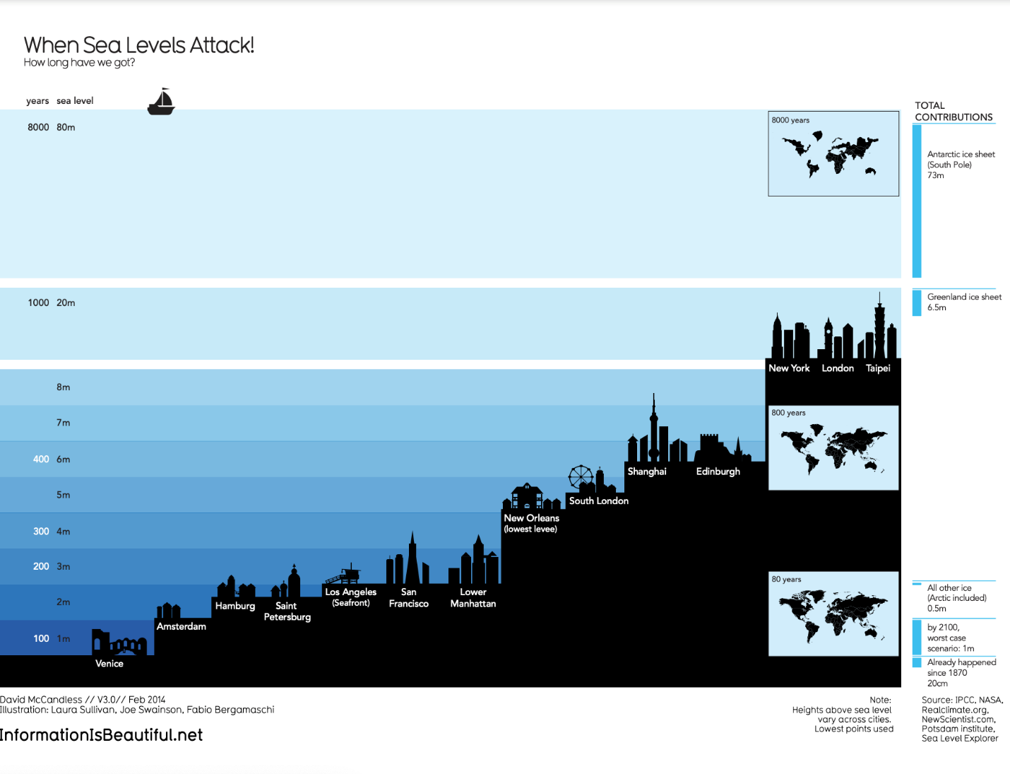demonstrates how much sea levels are projected to rise over the course of 8,000 years. On the y-axis, it lists both the number of years and the sea level in meters. From right to left, starting with the lowest sea level, the chart includes silhouettes of different cities around the world to demonstrate how long it would take for most of the world to be underwater. It also includes inset maps of the continents and how they would appear at different times as sea levels continue to rise.

Save this data visualization as a PDF by clicking the file below:

**IIB-LICENSED\_Sea-Levels.pdf**PDF File

[Open file](https://d3c33hcgiwev3.cloudfront.net/5eB5YE1QSPSgeWBNUKj0MQ_64cb4212fa57404a9a1d0274cc8ae8ba_IIB-LICENSED_Sea-Levels.pdf?Expires=1648080000&Signature=jGHlf-kpQmVgiSfyPllh1o1XwlyYeqdiyZHY7hWb2r6-1DgiKXzRUPSLgm2tL~uolZsprRjCrhXmT-CxBY4krP0RGwU9ALkWHab4CC9iA7k4UbYXEmmujQ3d5zTQcHIPpMHSbJwHZWmbgzJfQg~wqVB7PAMdU9MgrkNH-3NB97k_&Key-Pair-Id=APKAJLTNE6QMUY6HBC5A" \t "_blank)

### **Examine the four elements**

This When Sea Levels Attack visualization illustrates how much sea levels are projected to rise over the course of 8,000 years. The silhouettes of different cities with different sea levels, rising from right to left, helps to drive home how much of the world will be affected as sea levels continue to rise. Here is how this data visualization stacks up using the four elements of successful visualization:

* **Information (data):** This visualization uses climate data on rising sea levels from a variety of sources, including NASA and the Intergovernmental Panel on Climate Change. In addition to that data, it also uses recorded sea levels from around the world to help illustrate how much rising sea levels will affect the world.
* **Story (concept):** The visualization tells a very clear story: Over the course of 8,000 years, much of the world as we know it will be underwater.
* **Goal (function):** The goal of this project is to demonstrate how soon rising sea levels are going to affect us on a global scale. Using both data and the visual form, this visualization makes rising sea levels feel more real to the audience.
* **Visual form (metaphor):** The city silhouettes in this visualization are a beautiful way to drive home the point of the visualization. It gives the audience a metaphor for how rising sea levels will affect the world around them in a way that showing just the raw numbers can’t do. And for a more global perspective, the visualization also uses inset maps.

## Key takeaways

Notice how each of these visualizations balance all four elements of successful visualization. They clearly incorporate data, use storytelling to make that data meaningful, focus on a specific goal, and structure the data with visual forms to make it beautiful and communicative. The more you practice thinking about these elements, the more you will be able to include them in your own data visualizations.

# Design thinking for visualization improvement

Design thinking for data visualization involves five phases:

1. **Empathize:** Thinking about the emotions and needs of the target audience for the data visualization
2. **Define:** Figuring out exactly what your audience needs from the data
3. **Ideate:** Generating ideas for data visualization
4. **Prototype:** Putting visualizations together for testing and feedback
5. **Test:** Showing prototype visualizations to people before stakeholders see them

As interactive dashboards become more popular for data visualization, new importance has been placed on efficiency and user-friendliness. In this reading, you will learn how design thinking can improve an interactive dashboard. As a junior analyst, you wouldn’t be expected to create an interactive dashboard on your own, but you can use design thinking to suggest ways that developers can improve data visualizations and dashboards.

## An example: online banking dashboard

Suppose you are an analyst at a bank that has just released a new dashboard in their online banking application. This section describes how you might explore this dashboard like a new user would, consider a user’s needs, and come up with ideas to improve data visualization in the dashboard. The dashboard in the banking application has the following data visualization elements:

* Monthly spending is shown as a donut chart that reflects different categories like utilities, housing, transportation, education, and groceries.
* When customers set a budget for a category, the donut chart shows filled and unfilled portions in the same view.
* Customers can also set an overall spending limit, and the dashboard will automatically assign the budgeted amounts (unfilled areas of the donut chart) to each category based on past spending trends.

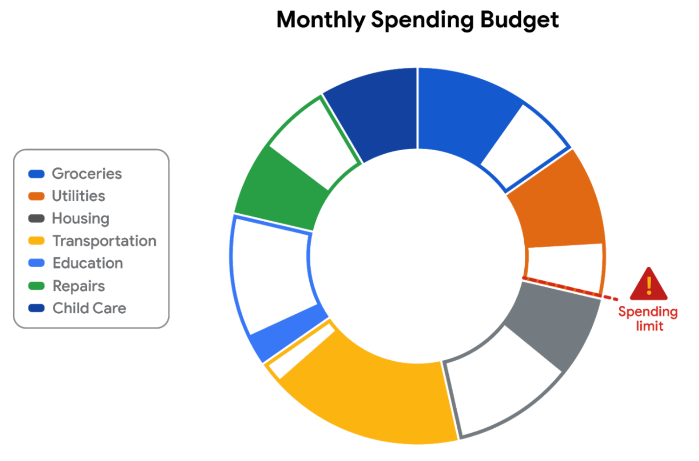

### **E​mpathize**

First, empathize by putting yourself in the shoes of a customer who has a checking account with the bank.

* Do the colors and labels make sense in the visualization?
* How easy is it to set or change a budget?
* When you click on a spending category in the donut chart, are the transactions in the category displayed?

What is the main purpose of the data visualization? If you answered that it was to help customers stay within budget or to save money, you are right! Saving money was a top customer need for the dashboard.

### **D​efine**

Now, imagine that you are helping dashboard designers define other things that customers might want to achieve besides saving money.

What other data visualizations might be needed?

* Track income (in addition to spending)
* Track other spending that doesn’t neatly fit into the set categories (this is sometimes called **discretionary spending**)
* Pay off debt

Can you think of anything else?

### **I​deate**

Next, ideate additional features for the dashboard and share them with the software development team.

* What new data visualizations would help customers?
* Would you recommend bar charts or line charts in addition to the standard donut chart?
* Would you recommend allowing users to create their own (custom) categories?

Can you think of anything else?

### **P​rototype**

Finally, developers can prototype the next version of the dashboard with new and improved data visualizations.

### **T​est**

Developers can close the cycle by having you (and others) test the prototype before it is sent to stakeholders for review and approval.

## Key takeaways

This design thinking example showed how important it is to:

* Understand the needs of users
* Generate new ideas for data visualizations
* Make incremental improvements to data visualizations over time

You can refer to the following articles for more information about design thinking:

* [Three Critical Aspects of Design Thinking for Big Data Solutions](https://dataconomy.com/2019/05/three-critical-aspects-of-design-thinking-for-big-data-solutions/)
* [Data and Design Thinking: Why Use Data in the Design Process?](https://www.enginess.io/insights/data-and-design-thinking)

Pro tips for highlighting key information

Headlines, subtitles, labels, and annotations help you turn your data visualizations into more meaningful displays. After all, you want to invite your audience into your presentation and keep them engaged. When you present a visualization, they should be able to process and understand the information you are trying to share in the first five seconds. This reading will teach you what you can do to engage your audience immediately.

If you already know what headlines, subtitles, labels and annotations do, go to the guidelines and style checks at the end of this reading. If you don’t, these next sections are for you.

**Headlines that pop**

A **headline** is a line of words printed in large letters at the top of a visualization to communicate what data is being presented. It is the attention grabber that makes your audience want to read more. Here are some examples:

* [Which Generation Controls the Senate?](https://i.redd.it/rw0vrjakuoc61.png): This headline immediately generates curiosity. Refer to the [subreddit post](https://www.reddit.com/r/dataisbeautiful/comments/l1yly6/oc_which_generation_controls_the_senate/) in the dataisbeautiful community, r/dataisbeautiful, on January 21, 2021.
* [Top 10 coffee producers](https://ichef.bbci.co.uk/news/976/cpsprodpb/65D8/production/_100827062_chart-globalcoffeeproduction-iskhe-nc.png): This headline immediately informs how many coffee producers are ranked. Read the full article: [bbc.com/news/business-43742686](https://www.bbc.com/news/business-43742686).

Check out the chart below. Can you identify what type of data is being represented? Without a headline, it can be hard to figure out what data is being presented. A graph like the one below could be anything from average rents in the tri-city area, to sales of competing products, or daily absences at the local elementary, middle, and high schools.

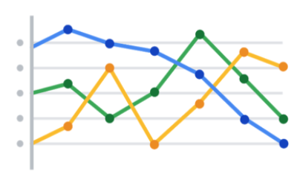

Turns out, this illustration is showing average rents in the tri-city area. So, let’s add a headline to make that clear to the audience. Adding the headline, “**Average Rents in the Tri-City Area**” above the line chart instantly informs the audience what it is comparing.

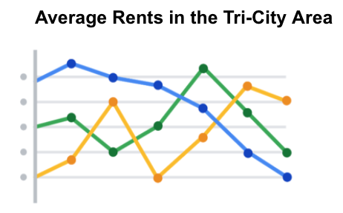

**Subtitles that clarify**

A **subtitle** supports the headline by adding more context and description. Adding a subtitle will help the audience better understand the details associated with your chart. Typically, the text for subtitles has a smaller font size than the headline.

In the average rents chart, it is unclear from the headline “**Average Rents in the Tri-City Area**”which cities are being described. There are tri-cities near San Diego, California (Oceanside, Vista, and Carlsbad), tri-cities in the San Francisco Bay Area (Fremont, Newark, and Union City), tri-cities in North Carolina (Raleigh, Durham, and Chapel Hill), and tri-cities in the United Arab Emirates (Dubai, Ajman, and Sharjah).

We are actually reporting the data for the tri-city area near San Diego. So adding “**Oceanside, Vista, and Carlsbad**” becomes the subtitle in this case. This subtitle enables the audience to quickly identify which cities the data reflects.

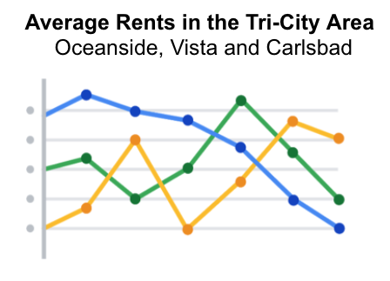

**Labels that identify**

A **label** in a visualization identifies data in relation to other data. Most commonly, labels in a chart identify what the x-axis and y-axis show. Always make sure you label your axes. We can add “**Months (January - June 2020)**” for the x-axis and “**Average Monthly Rents ($)**” for the y-axis in the average rents chart.

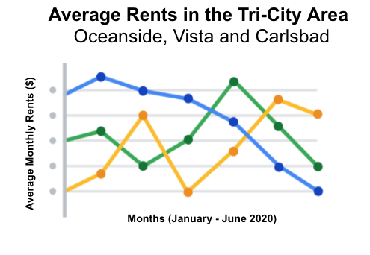

Data can also be labeled directly in a chart instead of through a chart legend. This makes it easier for the audience to understand data points without having to look up symbols or interpret the color coding in a legend.

We can add direct labels in the average rents chart. The audience can then identify the data for Oceanside in yellow, the data for Carlsbad in green, and the data for Vista in blue.

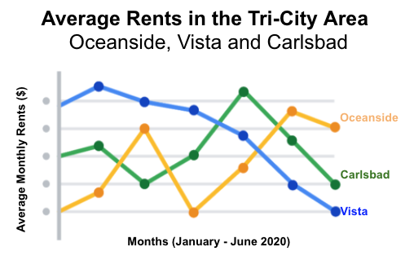

**Annotations that focus**

An **annotation** briefly explains data or helps focus the audience on a particular aspect of the data in a visualization.

Suppose in the average rents chart that we want the audience to pay attention to the rents at their highs. Annotating the data points representing the highest average rents will help people focus on those values for each city.

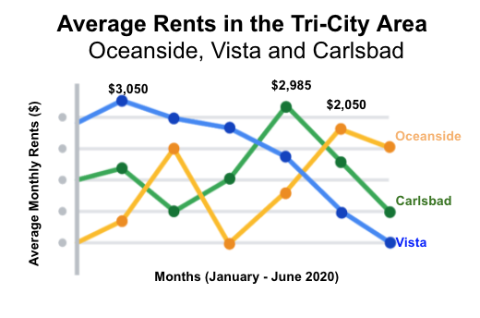

**Guidelines and pro tips**

Refer to the following table for recommended guidelines and style checks for headlines, subtitles, labels, and annotations in your data visualizations. Think of these guidelines as guardrails. Sometimes data visualizations can become too crowded or busy. When this happens, the audience can get confused or distracted by elements that aren’t really necessary. The guidelines will help keep your data visualizations simple, and the style checks will help make your data visualizations more elegant.

| **Visualization components** | **Guidelines** | **Style checks** |
| --- | --- | --- |
| Headlines | - **Content**: Briefly describe the data - **Length**: Usually the width of the data frame - **Position**: Above the data | - Use brief language - Don’t use all caps - Don’t use italic - Don’t use acronyms - Don't use abbreviations - Don’t use humor or sarcasm |
| Subtitles | - **Content**: Clarify context for the data - **Length**: Same as or shorter than headline - **Position**: Directly below the headline | - Use smaller font size than headline - Don’t use undefined words - Don’t use all caps, bold, or italic - Don’t use acronyms - Don't use abbreviations |
| Labels | - **Content**: Replace the need for legends - **Length**: Usually fewer than 30 characters - **Position**: Next to data or below or beside axes | - Use a few words only - Use thoughtful color-coding - Use callouts to point to the data - Don’t use all caps, bold, or italic |
| Annotations | - **Content**: Draw attention to certain data - **Length**: Varies, limited by open space - **Position**: Immediately next to data annotated | - Don’t use all caps, bold, or italic - Don't use rotated text - Don’t distract viewers from the data |

You want to be informative without getting too detailed. To meaningfully communicate the results of your data analysis, use the right visualization components with the right style. In other words, let simplicity and elegance work together to help your audience process the data you are sharing in five seconds or less.

# Designing a chart in 60 minutes

By now, you understand the principles of design and how to think like a designer. Among the many options of data visualization is creating a **chart**, which is a graphical representation of data.

Choosing to represent your data via a chart is usually the most simple and efficient method. Let’s go through the entire process of creating any type of chart in 60 minutes. The goal here is to develop a prototype or mock up of your chart that you can quickly present to an audience. This will also enable you to have a sense of whether or not the chart is communicating the information that you want.

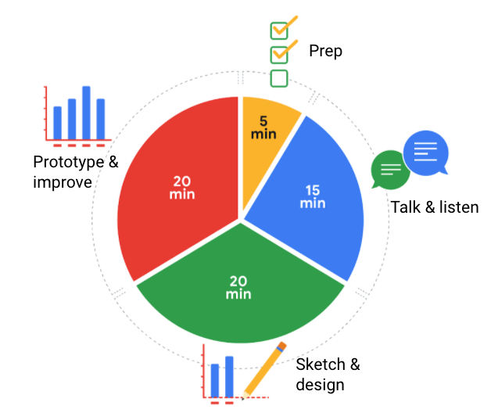5 minutes- prep 15 minutes- talk & listen 20 minutes- prototype & improve 20 minutes- sketch & design

Follow this high level 60-minute chart to guide your thinking whenever you begin working on a data visualization.

**Prep (5 min):** Create the mental and physical space necessary for an environment of comprehensive thinking. This means allowing yourself room to brainstorm how you want your data to appear while considering the amount and type of data that you have.

**Talk and listen (15 min):** Identify the object of your work by getting to the “ask behind the ask” and establishing expectations. Ask questions and really concentrate on feedback from stakeholders regarding your projects to help you hone how to lay out your data.

**Sketch and design (20 min):** Draft your approach to the problem. Define the timing and output of your work to get a clear and concise idea of what you are crafting.

**Prototype and improve (20 min):** Generate a visual solution and gauge its effectiveness at accurately communicating your data. Take your time and repeat the process until a final visual is produced. It is alright if you go through several visuals until you find the perfect fit.

## Key takeaway

This is a great overview you can use when you need to create a visualization in a short amount of time. As you become more experienced in data visualization, you will find yourself creating your own process. You will get a more detailed description of different visualization options in the next reading, including line charts, bar charts, scatter plots, and more. No matter what you choose, always remember to take the time to prep, identify your objective, take in feedback, design, and create.

## Hands-On Activity: Making your own visualization

**Total points**2

### 1.

**Question 1**



## Activity overview



Earlier in this course, you learned the importance of visualizing data with design thinking. In this activity, you will apply this knowledge and create your own visualization from a dataset.

By the time you complete this activity, you will be able to create and customize data visualizations using the Chart Editor in a spreadsheet. This will enable you to answer a business question with a shareable representation of data, which is important for presenting your findings in your career as a data analyst.



### **What you will need**

To get started, first access the example dataset.

Click the link to the example dataset to create a copy. If you don’t have a Google account, you may download the example dataset directly from the attachments below.

Link to example dataset: [Making your own visualization](https://docs.google.com/spreadsheets/d/1Zhm9WyrM4dmBav9Vc1VnCU82vLlESEaJGFgNcfTRsZk/template/preview)

OR

Download example dataset:

**Making your own visualization - example dataset**XLSX File

[Download file](https://d3c33hcgiwev3.cloudfront.net/NQchTAEVRoaHIUwBFbaG8w_83656977ed1b4900879d1c24ac1602d4_Making-your-own-visualization---example-dataset.xlsx?Expires=1648080000&Signature=MUvhhqs4Hi5bQfLT4rwKrfArAVmYxsaEwqpMFK5PqWOd8qprjE870x~tm13ijBghUHXK5sUGqiKGyxzIaY7jL6ErC4e457VD3YDlCC1bWoSi1TL~LI0GoXGDq-xYFBh6zevv5Xeqn2xA48OFwSOkTDvH22YKpWBjab1khoxDFS8_&Key-Pair-Id=APKAJLTNE6QMUY6HBC5A" \t "_blank)



### **The scenario**



You are a junior data analyst at a local company. In your current data analysis project, you’ve been exploring sales data for all of your company’s products, including the top products and sales trends for the last year. You need to present the results of this analysis to the company executives. Your goal for this presentation is to demonstrate how sales of the company’s products have changed over the last 12 months. Your findings about the two top-selling products include:

| **Product name** | **Units sold** | **Time period with highest sales** |
| --- | --- | --- |
| Product A | 2.5 million | 70% of total annual sales occur in October, November, and December |
| Product B | 1.9 million | Mostly consistent sales year-round, with a slight increase in November, December, and January |

Your audience is made up of the chief marketing officer (CMO) and marketing department vice presidents (VPs), not other data analysts or engineers. They will use the information you present to make decisions on how to allocate advertising dollars for each product for the coming year.

## Review the design thinking process



Now that you are familiar with the scenario, take a moment to review the steps of the **design thinking** process. Remember, design thinking is about keeping a user-centric focus. By understanding the needs of your audience, you can craft a data visualization that communicates your findings effectively. The steps of the Design Thinking process are:

* **Empathize**: Think about the emotions and needs of the target audience.
* **Define**: Understand the audience’s needs, problems, and insights.
* **Ideate**: Use your findings from the previous phases to begin to create data visualizations.
* **Prototype:** Start putting it all together. In this case, you can put your findings into  a presentation or dashboard.
* **Test**: Check that your prototype is effective. In this case, you can show your visualizations to team members before the presentation.

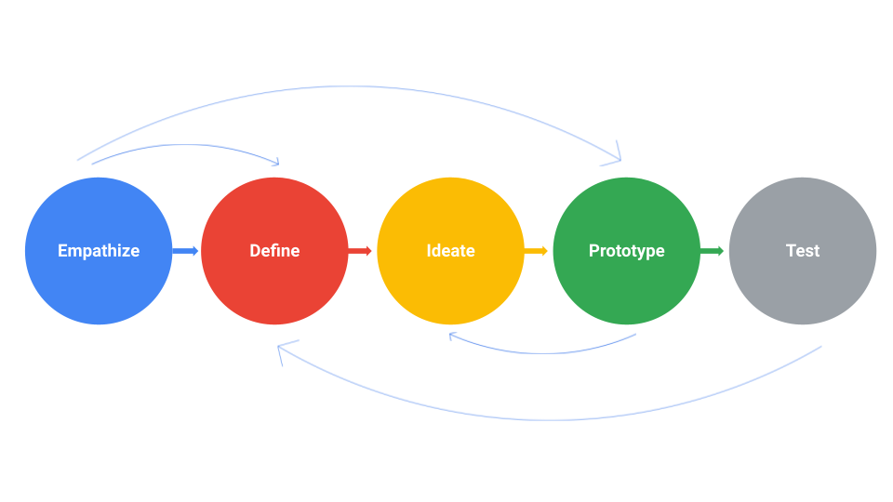

Take a moment to empathize with your audience’s needs. What takeaways are most important to them? Which data visualization would communicate that takeaway most effectively?

As you consider which kinds of data visualizations would be most useful, review the **decision tree** from earlier in this course. This will help you figure out what type of story you want to tell with your data.

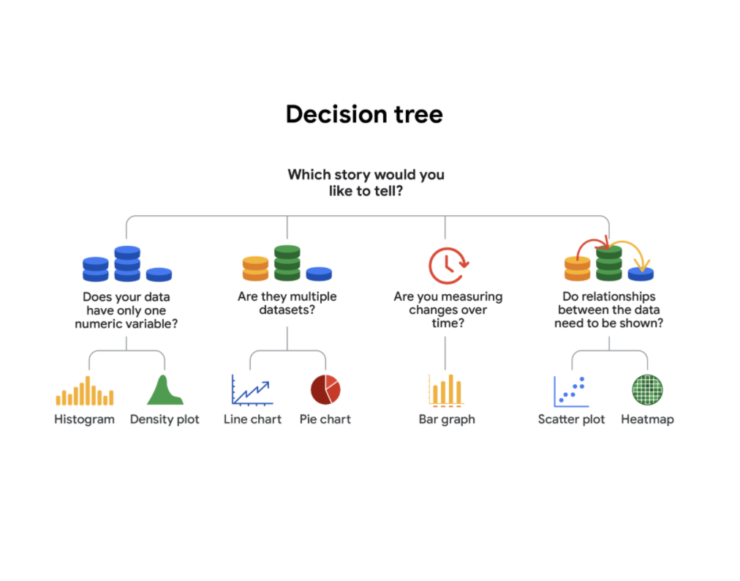-Does your data have only one numeric variable? Histogram or Density plot -Are there multiple data sets?  Line chart or pie chart -Are you measuring changes over time? Bar chart -Do relationships between the data need to be shown? Scatter plot or heatmap

## Create a prototype



Now, use spreadsheet software to try out different visualizations of the data.

1. Highlight all cells by clicking on cell **A1** and dragging to **M3.** This should highlight all the data and headers aside from the **Total** column.

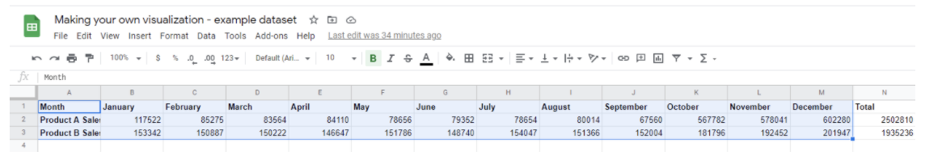

2. Click on the **Insert** tab and select **Chart.**

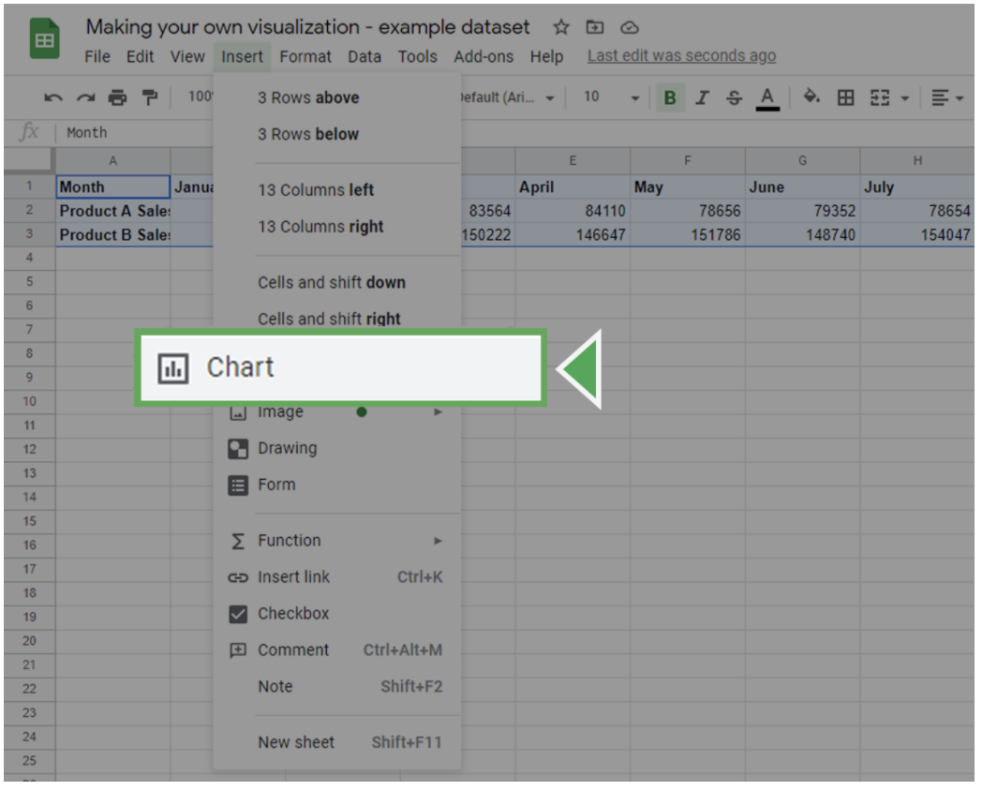

This will insert a chart object and bring up the **Chart editor** on the right side of the screen.

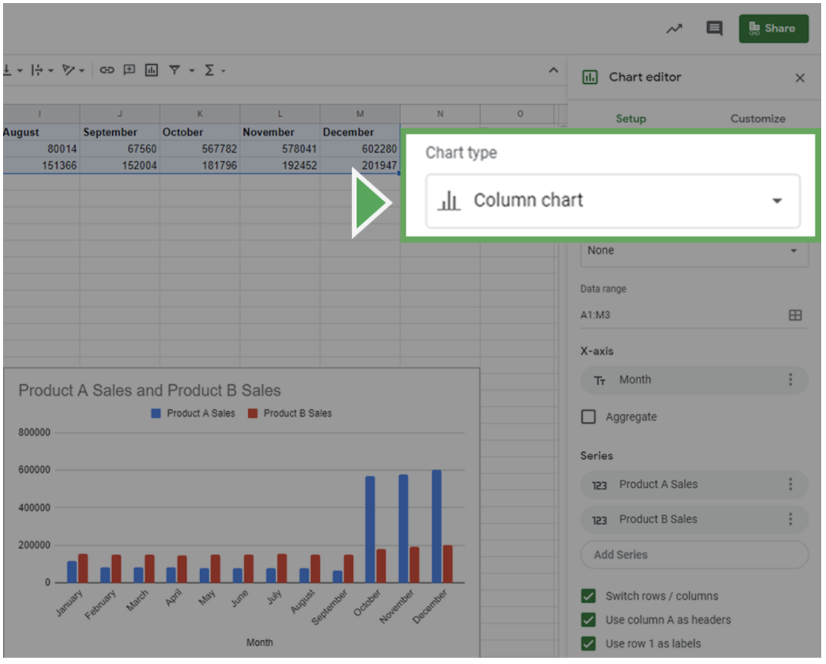

3. In the **Chart editor**, click on the **Setup** tab.

4. Click on the **Chart type** dropdown box. This will bring up the different kinds of charts you can create. Select the data visualization you think would be most useful during your design thinking process.

### **Customize your chart**



Now, customize your visualization by editing the titles, labels, and style.

Click on the **Customize** tab in the **Chart Editor**. Click on the **Chart & axis titles** dropdown to add an informative title or label your axes. Click the **Legend** dropdown to create a legend for your chart.

Once you decide on the style and labels, focus on the design elements of the chart. This is your chance to adjust elements such as color and font. For instance, you can change the color scheme of the chart in the **Chart Style** dropdown.

When creating data visualizations, **accessibility** is important. Set up your visualization in a way that is accessible and understandable by including highly contrasting colors.

Once you’re done customizing your chart, review your choices to ensure that your visualization is easy to understand.

* Do you think your audience will fully understand what they are observing within five seconds?
* Will they understand the key takeaway you’re trying to communicate after another five seconds?
* Did you use the most clear and communicative visualization style for your data?

If the answer to any of these questions is no, try different visualization styles and design choices. Experiment with colors, shapes, and chart types to find what makes it easier or harder to understand the message you are trying to convey.

**Visualization galleries**

One of the coolest features of Tableau Public is the **public gallery**, where you can explore what visualizations other people have created. In addition, you have the option to explore the data behind the visualizations, as well as download visualizations that you may want to explore in detail later on. You can find the gallery from the header on the home page, or use the search function, which appears as a magnifying glass icon, to explore data and vizzes about particular topics.



Here are a few useful links within Tableau Public:

* [**Public Gallery**](https://public.tableau.com/en-us/s/viz-gallery)**:** These are data visualizations created by other users that you can scroll through.
* [**Featured Gallery**](https://public.tableau.com/en-us/gallery/?tab=featured&type=featured)**:** This is a collection of featured data visualizations created by other users. This is a great source of inspiration.
* [**Viz of the Day**](https://public.tableau.com/en-us/gallery/?tab=viz-of-the-day&type=viz-of-the-day)**:** Tableau Public features a new data viz every day; check back for new visualizations daily!
* [**Google Career Certificates page on Tableau Public**](https://public.tableau.com/profile/grow.with.google#!/)**:** This gallery contains all of the visualizations created in the video lessons; you can explore these examples more here.
* [**Tableau Public resources page**](https://public.tableau.com/en-us/s/resources)**:** This links to the resources page, including some how-to videos and sample data.
* [**Tableau user forum**](https://community.tableau.com/s/)**:** Search for answers and connect with other users in the community on the forum page.

# Visualizations in spreadsheets and Tableau

This reading summarizes the seven primary chart types: column, line, pie, horizontal bar, area, scatter, and combo. Then, it describes how visualizations in spreadsheets compare to those in Tableau.

## Primary chart types in spreadsheets

In spreadsheets, **charts** are graphical representations of data from one or more sheets. Although there are many variations to choose from, we will focus on the most broadly applicable charts to give you a sense of what is possible in a spreadsheet. As you review these examples, keep in mind that these are meant to give you an overview of visualizations rather than a detailed tutorial. Another reading in this program will describe the applicable steps and process to create a chart more specifically. When you are in an application, you can always select **Help** from the menu bar for more information.

* To create a chart In Google Sheets, select the data cells, click **Insert** from the main menu, and then select **Chart**. You can set up and customize the chart in the dialog box on the right.
* To create a chart in Microsoft Excel, select the data cells, click **Insert** from the main menu, and then select the chart type. Tip: You can optionally click **Recommended Charts** to view Excel’s recommendations for the data you selected and then select the chart you like from those shown.

These are the primary chart types available:

* **Column (vertical bar)**: a column chart allows you to display and compare multiple categories of data by their values.

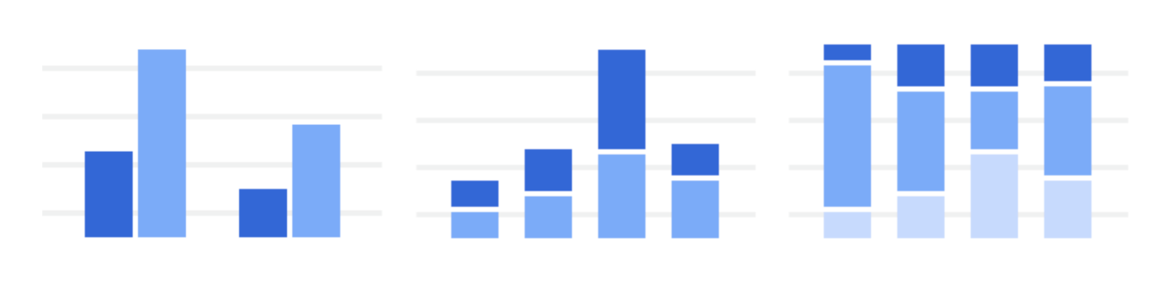

* **Line**: a line chart showcases trends in your data over a period of time. The last line chart example is a combo chart which can include a line chart. Refer to the description for the combo chart type.

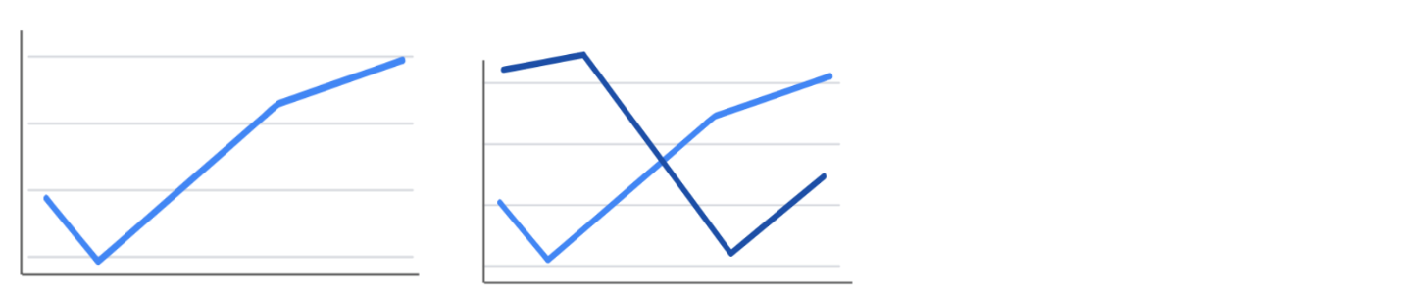

* **Pie**: a pie chart is an easy way to visualize what proportion of the whole each data point represents.

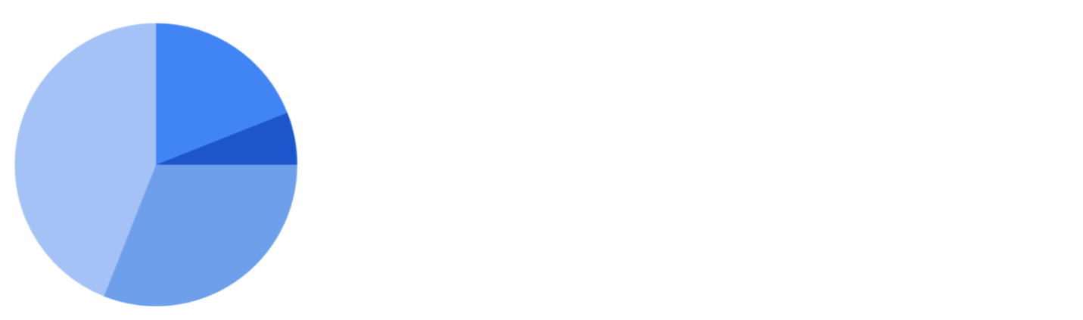

* **Horizontal bar**: a bar chart functions similarly to a column chart, but is flipped horizontally.

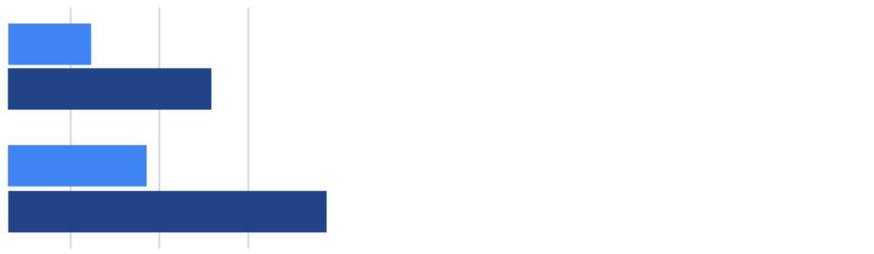

* **Area**: area charts allow you to track changes in value across multiple categories of data.

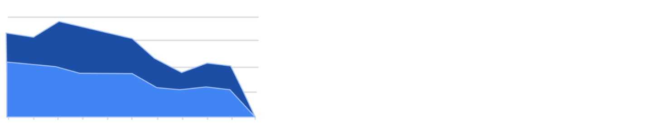

* **Scatter**: scatter plots are typically used to display trends in numeric data.

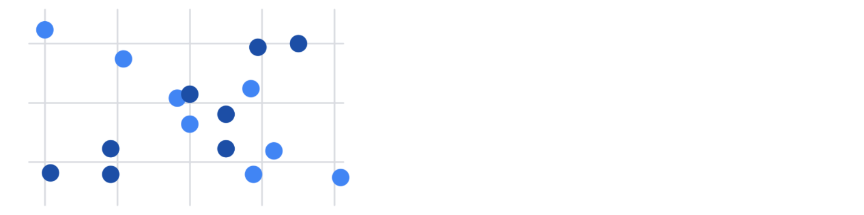

* **Combo**: combo charts use multiple visual markers like columns and lines to showcase different aspects of the data in one visualization. The example below is a combo chart that has a column and line chart together.

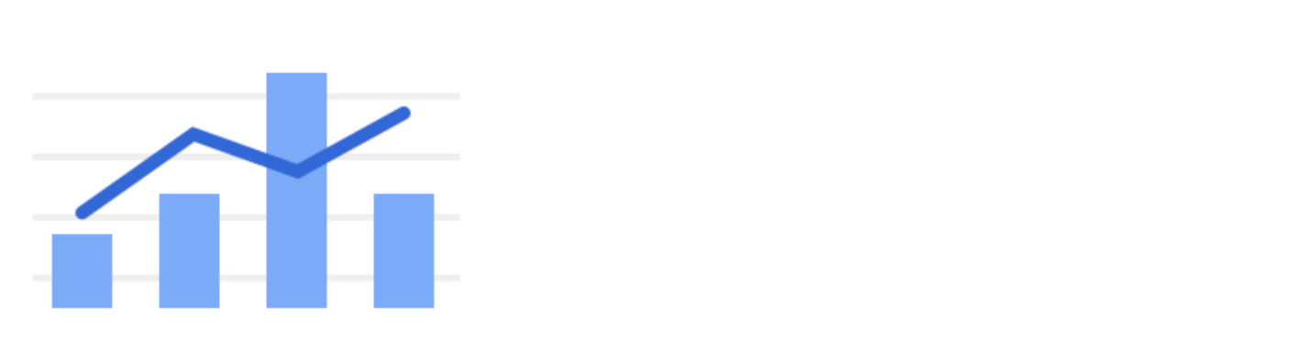

You can find more information about other charts here:

* [Types of charts and graphs in Google Sheets:](https://support.google.com/docs/answer/190718?hl=en) a Google Help Center page with a list of chart examples you can download.
* [Excel Charts](https://www.tutorialspoint.com/excel_charts/excel_charts_types.htm): a tutorial outlining all of the different chart types in Excel, including some subcategories.

## How visualizations differ in Tableau

As you have also learned, Tableau is an analytics platform that helps data analysts display and understand data. Most if not all of the charts that you can create in spreadsheets are available in Tableau. But, Tableau offers some distinct charts that aren’t available in spreadsheets. These are handy guides to help you select chart types in Tableau:

* [Which chart or graph is right for you?](http://www.tableau.com/sites/default/files/media/which_chart_v6_final_0.pdf) This presentation covers 13 of the most popular charts in Tableau.
* [The Ultimate Cheat Sheet on Tableau Charts](https://towardsdatascience.com/the-ultimate-cheat-sheet-on-tableau-charts-642bca94dde5). This blog describes 24 chart variations in Tableau and guidelines for use.

The following are visualizations that are more specialized in Tableau with links to examples or the steps to create them:

* **Highlight tables** appear like tables with conditional formatting. Review the [steps to build a highlight table](https://help.tableau.com/current/pro/desktop/en-us/buildexamples_highlight.htm).
* **Heat maps** show intensity or concentrations in the data. Review the [steps to build a heat map](https://help.tableau.com/current/pro/desktop/en-us/buildexamples_highlight.htm).
* **Density maps** show concentrations (like a population density map). Refer to [instructions to create a heat map for density](https://help.tableau.com/current/pro/desktop/en-us/maps_howto_heatmap.htm).
* **Gantt charts** show the duration of events or activities on a timeline. Review the [steps to build a Gantt chart](https://help.tableau.com/current/pro/desktop/en-us/buildexamples_gantt.htm).
* **Symbol maps** display a mark over a given longitude and latitude. Learn more from this [example of a symbol map](https://interworks.com/blog/ccapitula/2014/08/18/tableau-essentials-chart-types-symbol-map/).
* **Filled maps** are maps with areas colored based on a measurement or dimension. Explore an [example of a filled map](https://interworks.com/blog/ccapitula/2014/09/23/tableau-essentials-chart-types-filled-map/).
* **Circle views** show comparative strength in data. Learn more from this [example of a circle view](https://interworks.com/blog/ccapitula/2014/10/17/tableau-essentials-chart-types-circle-view/).
* **Box plots** also known as **box-and whiskers charts** show the distribution of values along a chart axis. Refer to the [steps to build a box plot](https://help.tableau.com/current/pro/desktop/en-us/buildexamples_boxplot.htm).
* **Bullet graphs** compare a primary measure with another and can be used instead of dial gauge charts. Review the [steps to build a bullet graph](https://help.tableau.com/current/pro/desktop/en-us/qs_bullet_graphs.htm).
* **Packed bubble charts** display data in clustered circles. Review the [steps to build a packed bubble chart](https://help.tableau.com/current/pro/desktop/en-us/buildexamples_bubbles.htm).

## Key takeaway

This reading described the chart types you can create in spreadsheets and introduced visualizations that are more unique to Tableau.

# Visualizations in spreadsheets and Tableau

This reading summarizes the seven primary chart types: column, line, pie, horizontal bar, area, scatter, and combo. Then, it describes how visualizations in spreadsheets compare to those in Tableau.

## Primary chart types in spreadsheets

In spreadsheets, **charts** are graphical representations of data from one or more sheets. Although there are many variations to choose from, we will focus on the most broadly applicable charts to give you a sense of what is possible in a spreadsheet. As you review these examples, keep in mind that these are meant to give you an overview of visualizations rather than a detailed tutorial. Another reading in this program will describe the applicable steps and process to create a chart more specifically. When you are in an application, you can always select **Help** from the menu bar for more information.

* To create a chart In Google Sheets, select the data cells, click **Insert** from the main menu, and then select **Chart**. You can set up and customize the chart in the dialog box on the right.
* To create a chart in Microsoft Excel, select the data cells, click **Insert** from the main menu, and then select the chart type. Tip: You can optionally click **Recommended Charts** to view Excel’s recommendations for the data you selected and then select the chart you like from those shown.

These are the primary chart types available:

* **Column (vertical bar)**: a column chart allows you to display and compare multiple categories of data by their values.



* **Line**: a line chart showcases trends in your data over a period of time. The last line chart example is a combo chart which can include a line chart. Refer to the description for the combo chart type.



* **Pie**: a pie chart is an easy way to visualize what proportion of the whole each data point represents.



* **Horizontal bar**: a bar chart functions similarly to a column chart, but is flipped horizontally.



* **Area**: area charts allow you to track changes in value across multiple categories of data.



* **Scatter**: scatter plots are typically used to display trends in numeric data.



* **Combo**: combo charts use multiple visual markers like columns and lines to showcase different aspects of the data in one visualization. The example below is a combo chart that has a column and line chart together.



You can find more information about other charts here:

* [Types of charts and graphs in Google Sheets:](https://support.google.com/docs/answer/190718?hl=en) a Google Help Center page with a list of chart examples you can download.
* [Excel Charts](https://www.tutorialspoint.com/excel_charts/excel_charts_types.htm): a tutorial outlining all of the different chart types in Excel, including some subcategories.

## How visualizations differ in Tableau

As you have also learned, Tableau is an analytics platform that helps data analysts display and understand data. Most if not all of the charts that you can create in spreadsheets are available in Tableau. But, Tableau offers some distinct charts that aren’t available in spreadsheets. These are handy guides to help you select chart types in Tableau:

* [Which chart or graph is right for you?](http://www.tableau.com/sites/default/files/media/which_chart_v6_final_0.pdf) This presentation covers 13 of the most popular charts in Tableau.
* [The Ultimate Cheat Sheet on Tableau Charts](https://towardsdatascience.com/the-ultimate-cheat-sheet-on-tableau-charts-642bca94dde5). This blog describes 24 chart variations in Tableau and guidelines for use.

The following are visualizations that are more specialized in Tableau with links to examples or the steps to create them:

* **Highlight tables** appear like tables with conditional formatting. Review the [steps to build a highlight table](https://help.tableau.com/current/pro/desktop/en-us/buildexamples_highlight.htm).
* **Heat maps** show intensity or concentrations in the data. Review the [steps to build a heat map](https://help.tableau.com/current/pro/desktop/en-us/buildexamples_highlight.htm).
* **Density maps** show concentrations (like a population density map). Refer to [instructions to create a heat map for density](https://help.tableau.com/current/pro/desktop/en-us/maps_howto_heatmap.htm).
* **Gantt charts** show the duration of events or activities on a timeline. Review the [steps to build a Gantt chart](https://help.tableau.com/current/pro/desktop/en-us/buildexamples_gantt.htm).
* **Symbol maps** display a mark over a given longitude and latitude. Learn more from this [example of a symbol map](https://interworks.com/blog/ccapitula/2014/08/18/tableau-essentials-chart-types-symbol-map/).
* **Filled maps** are maps with areas colored based on a measurement or dimension. Explore an [example of a filled map](https://interworks.com/blog/ccapitula/2014/09/23/tableau-essentials-chart-types-filled-map/).
* **Circle views** show comparative strength in data. Learn more from this [example of a circle view](https://interworks.com/blog/ccapitula/2014/10/17/tableau-essentials-chart-types-circle-view/).
* **Box plots** also known as **box-and whiskers charts** show the distribution of values along a chart axis. Refer to the [steps to build a box plot](https://help.tableau.com/current/pro/desktop/en-us/buildexamples_boxplot.htm).
* **Bullet graphs** compare a primary measure with another and can be used instead of dial gauge charts. Review the [steps to build a bullet graph](https://help.tableau.com/current/pro/desktop/en-us/qs_bullet_graphs.htm).
* **Packed bubble charts** display data in clustered circles. Review the [steps to build a packed bubble chart](https://help.tableau.com/current/pro/desktop/en-us/buildexamples_bubbles.htm).

## Key takeaway

This reading described the chart types you can create in spreadsheets and introduced visualizations that are more unique to Tableau.

## Self-Reflection: Selecting visuals and charts

**Total points**1

### 1.

**Question 1**



## Overview



Now that you have learned about different kinds of visualizations, you can pause for a moment and think about what you are learning. In this self-reflection, you will consider how to select the right visualization for your needs and respond to brief questions.

This self-reflection will help you develop insights into your own learning and prepare you to apply your knowledge of visualizations to your own projects. As you answer questions—and come up with questions of your own—you will consider concepts, practices, and principles to help refine your understanding and reinforce your learning. You’ve done the hard work, so make sure to get the most out of it: This reflection will help your knowledge stick!

## What makes an effective visualization?



The key to effective presentations is data visualizations that are clear and convincing. In turn, the key to effective visualizations is selecting the best way to depict your data.

You have learned about a few types of visualizations (e.g., bar graphs, pie charts) and what each type is best at emphasizing. Determining which type of visualization to use is essential to giving your presentation the impact it needs.

So far, you have considered a few rules about what makes a helpful data visualization:

* **Five-second rule:** A data visualization should be **clear, effective, and convincing** enough to be absorbed in five seconds or less.
* **Color contrast:** Graphs and charts should use a **diverging color palette** to show contrast between elements.
* **Conventions and expectations:** Visuals and their organization should align with **audience expectations** and **cultural conventions**. For example, if the majority of your audience associates green with a positive concept and red with a negative one, your visualization should reflect this.
* **Minimal labels:** Titles, axes, and annotations should use as **few labels** as it takes to make sense. Having too many labels makes your graph or chart too busy. It takes up too much space and prevents the labels from being shown clearly.

For a refresher, you can refer back to the readings from this section. Check out [Designing a chart in 60 minutes](https://www.coursera.org/learn/visualize-data/supplement/IcuWb/dac6m1l4r2-designing-a-chart-in-60-minutes), [The wonderful world of visualizations](https://www.coursera.org/learn/visualize-data/supplement/j9Wdl/dac6m1l4-the-wonderful-world-of-visualizations), and [Visualizations in spreadsheets and Tableau](https://www.coursera.org/learn/visualize-data/supplement/bDdpK/dac6m2l2r3-visualizations-in-spreadsheets).

## Hands-On Activity: Practice linking data in Tableau

**Total points**1

### 1.

**Question 1**



## Activity overview



The video you just watched showed you how to make and visualize JOINs in Tableau. Now, you can use the datasets and instructions in this activity to perform the JOINs yourself. Feel free to refer back to the previous video if you get stuck.

In earlier activities, you worked in Tableau to create a data visualization. In this activity, you will review a scenario, link different data sources in Tableau, and create visualizations using multiple datasets.

By the time you complete this activity, you will be able to make visualizations out of data from multiple sources. This will enable you to visualize comparisons and combinations of data, which will allow you to share more complex projects in your career as a data analyst.



### **What you will need**

Click the link to create a copy of the datasets and download them. If you don’t have a Google account, download the datasets directly from the attachments below.

Link to datasets: [CO2](https://docs.google.com/spreadsheets/d/1LwGHDgJkXSm8b0ziSDyC8pQGqjYVGpX9mAEVPs2KQgY/template/preview), [energy](https://docs.google.com/spreadsheets/d/1C3tnheC5Qd8deHaSMNjWLZPApLwaGQkpx-Sv-1mDwv0/template/preview), [total population](https://docs.google.com/spreadsheets/d/1yfbxSmFOUhH1FHoxYpOl3ir982HA_lsPchLAt60xbss/template/preview), and [gdp total](https://docs.google.com/spreadsheets/d/1WbrxXDLKxAxDpwNSAQg2PdIEbtnjGwGe3bPHyCN7GlM/template/preview)

OR

Download datasets:

**CO2**XLSX File

[Download file](https://d3c33hcgiwev3.cloudfront.net/L2hkvFNhSXeoZLxTYQl3nA_5566727b2d444172b56efc2ff36565ac_CO2.xlsx?Expires=1648080000&Signature=bl5G7MhbOKXcYVFHFHxMemqtrrnOn-Sh6b6oSbI13ER2K7HLFHHq2tViPPYDjurU8tXw3uIlbYq3QJU~QBo8dKPbMuF3yINSH5v4pHuqJdqIU73p0Po6kbiuXgEwiT~G0E2vckskdMOspw2VxDnIJgNyh5~LTIdvZetf7z9OdYI_&Key-Pair-Id=APKAJLTNE6QMUY6HBC5A" \t "_blank)

**Energy data**XLSX File

[Download file](https://d3c33hcgiwev3.cloudfront.net/HvJxDD-oQbSycQw_qMG0mQ_94f08b5298d94325abdb9d843618b58e_Energy-data.xlsx?Expires=1648080000&Signature=Y9k3irz7fA14X~O9GlqG0y1aL5~MUCQ6ATJuG8hRHR4~ZWmEn1ePDaqp3nX~cPpmDEohbYliJAqYht5R-lEpd6fOjxFfsgeB937AZCJHYw6GfKOCnmWN7qh9ZceRiab7~dunKvs6VJ6iWUrV4ukACOy9tH-S76fZQ-~~C3ETjjk_&Key-Pair-Id=APKAJLTNE6QMUY6HBC5A" \t "_blank)

**totalpopulation**XLSX File

[Download file](https://d3c33hcgiwev3.cloudfront.net/AFPt1QKBRbKT7dUCgYWy9A_e5063a3d2680444681fa33afc140fca2_totalpopulation.xlsx?Expires=1648080000&Signature=auWZOtzkuXBDpTB1EG3Rdj1GfLwKOcoXWsEW6xDkFGVfZbDFsvAZE0IgBT2eAuDglaP2TQJ4rvqpAs4tD2oxqIJ8AdDMjeTM6f4mhIKKdAwSCo-o6vfYymNIG66FzYyAFwYGyEj~k~Tedq4qBJM-XNamF18HO89ym6S20jRa5iw_&Key-Pair-Id=APKAJLTNE6QMUY6HBC5A" \t "_blank)

**gdptotal**XLSX File

[Download file](https://d3c33hcgiwev3.cloudfront.net/6lyds9u2TRqcnbPbth0aOQ_6869b3e9e1d04ba2bf9cd3d8312108af_gdptotal.xlsx?Expires=1648080000&Signature=ioZqi-fi8db~V5YaWS7-AutZbTp7iQEq237GLx3joO4ZL06Gyl75OD0JLu0~A0vIq0yqzBeGt9LhUAr4JH9o7JjXp9lOJ4Epxj-X2~fE3zF42QW1rM8w2ApqQKCE15SosGRSIotXTbjSQ2YFluLb5I13UOS~GmB-mhZejCPEJ6g_&Key-Pair-Id=APKAJLTNE6QMUY6HBC5A" \t "_blank)



## The scenario



Imagine you are working as a data analyst at a policy research institute. For your current project, you need to create a visualization that shows the CO2 emissions per capita for each country from 2000-2011. You need to provide a visual presentation that not only allows someone to visually compare CO2 emissions between countries from year to year, but also provides information about each county’s population, GDP, and energy use.

You already have a dataset that includes emissions for each country between the years 1960 - 2011. But, the information that you need on energy use, total population, and GDP you had to collect from a government website. Each dataset is in a separate file. Moreover, some of the information is missing for some countries.

Often you will work with datasets that are missing information. Whether or not you need to find this missing information will depend on your project. In this case, you will notice that the missing information is from the 1960s, 1970s, and 1980s.

Luckily, your project is only concerned with the data from 2000-2011. You need an efficient way to utilize some data from one source, and some data from other sources. Taking just the information that you need from each source and creating a new data source takes a lot of time.

Tableau allows you to link data from different sources, as well as import data from different formats. While you won’t be working with one in this assignment, Tableau allows you to use a Web Data Connector. This tool allows you to import the data you need directly from another site. Your visualizations will update when the data sources for your visualization are updated.

## Load the data



1. Log in to [Tableau Public](http://public.tableau.com/).

* **Note:** Tableau frequently updates its user interface. The latest changes may not be reflected in the screenshots, but the principles in this activity remain the same. Adapting to changes in software updates is an essential skill for data analysts, and we encourage you to practice troubleshooting. You can also reach out to your community of learners on the discussion forum for help.

2. Go to your profile and click **Create a Viz**.

3.  From the **Connect to Data** window, go to the **Files** tab and open the **CO2 dataset** you downloaded earlier.

4. From the **Data Source** tab on the bottom of the interface, go to the **Connections** header at the top of the left-side column.

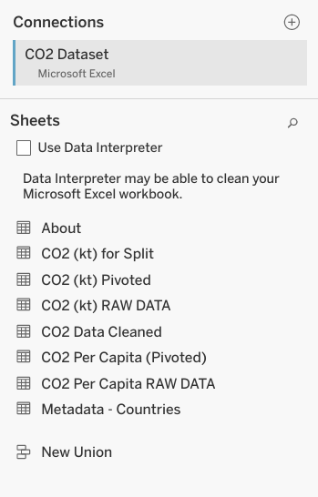

5. Click the **+** icon to add another data source. Start with the energy dataset.

6. Repeat step 5 for the other datasets, **gdptotal** and **totalpopulation**.

Now, you should have all four datasets loaded into Tableau. The datasets will be on the left-hand side of your screen under **Connections.**

**Note:** As you progress through the activity, make sure to save your progress by clicking File > Save or the Save icon. If you are asked to "Create an Extract," do so. It may take some time to create an extract of the data you are using in this activity, but it is essential to saving your progress.

You’ll notice that Tableau has already added one of the data sources into the area **Multiple Connections.** In the screenshot below, **Energy** is already loaded.

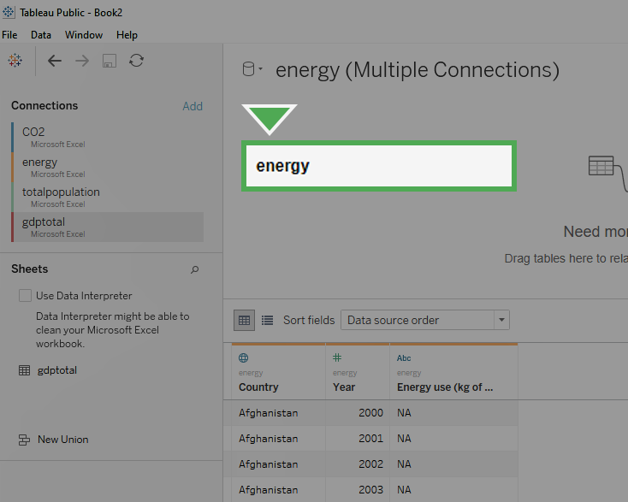

If one of the datasets has already been loaded in, you can remove it by dragging the box to the left-hand side (the grey area) of the screen. Click on the box labeled **Energy** in the center-top of the screen and drag it off to the left to delete it.

Once you remove the data from **Multiple Connections**, it should appear similar to the image below.

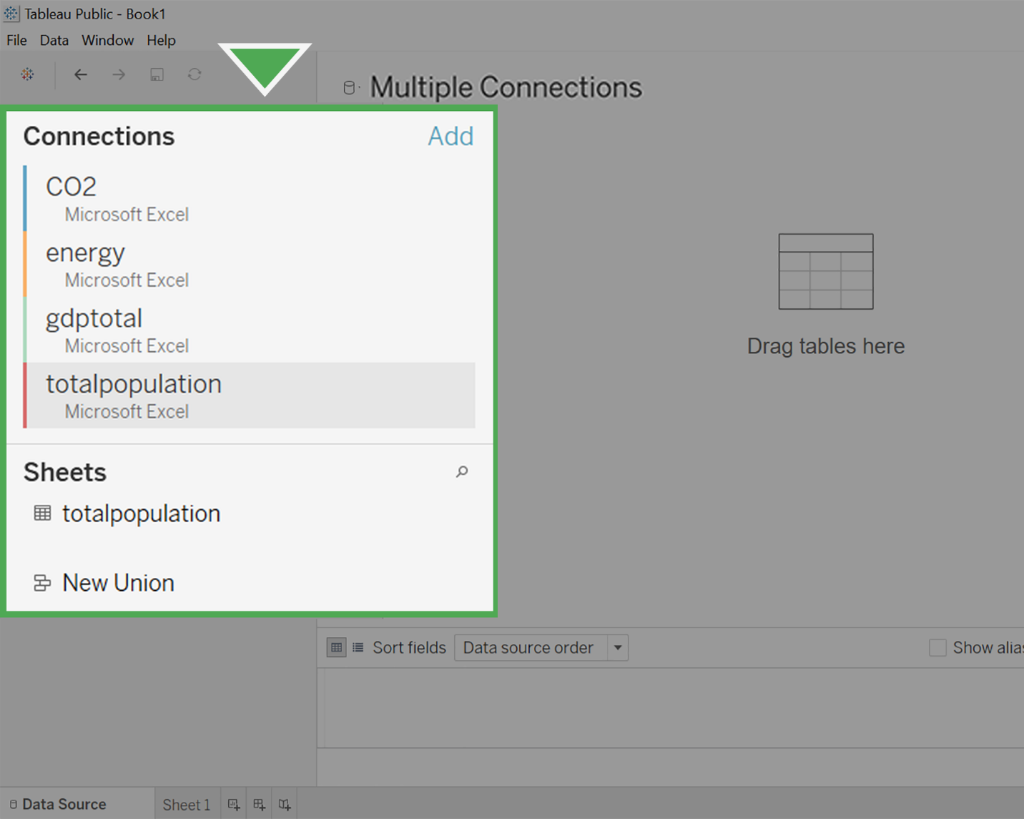

## Make connections with JOINs



Now, you’ll set up the connections between the different datasets by creating JOINs between them. You learned about JOINs in the previous course.

As a refresher: INNER JOINs and OUTER JOINs are types of relationships that can be used to combine data based on common columns of information.

In Tableau, you’ll notice that the former JOINs window has now become a multi-purpose Relationships window. By double-clicking your data tables, you can edit the JOINs instead of the relationships.

Follow these instructions to create JOINs in Tableau:

1. Clickon **CO2** under **Connections**.

2. Under **Sheets**, you will notice all the different sheets in the **CO2** dataset. Find **CO2 Data Cleaned** and double-click on it to load it.

3. Hover your cursor over the right side of the **CO2 Data Cleaned** box and clickon the **arrow**.

4. Select **Open** to open the **CO2 Data Cleaned** dataset. Make sure you complete this step. This allows you to change the physical table, which will allow you to create JOINs. Otherwise, you will only be able to edit Relationships. Usually, you could use either option to accomplish the same goal. But for the purposes of this activity, we specifically want to use JOINs.

Your screen should appear similar to the screenshot below.

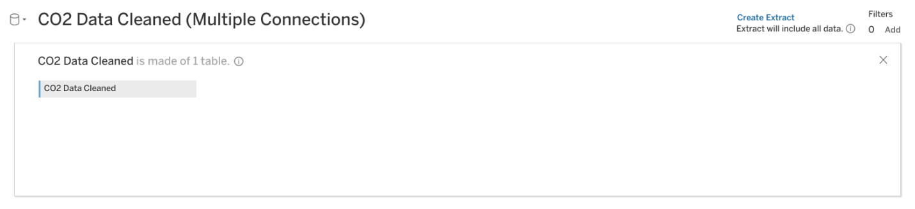

5. Clickon the **energy** dataset under **Connections.**

6. Drag the **energy** sheet across from the **CO2 Data Cleaned** box under **Multiple Connections.** A pop-up window for a Join will appear.

7. The popup window may automatically populate with **Year** from **CO2 Data Cleaned** and **Year1** from **Energy**. If not, put **Year** on the left side of the chart and **Year1** on the right side.

8. Clickon **Add new join clause** under **Year.** A dropdown menu will appear.

9. Select **Country Name** on the left side and **Country** on the right side**.**

10. Click the **X** to close the dropdown menu.

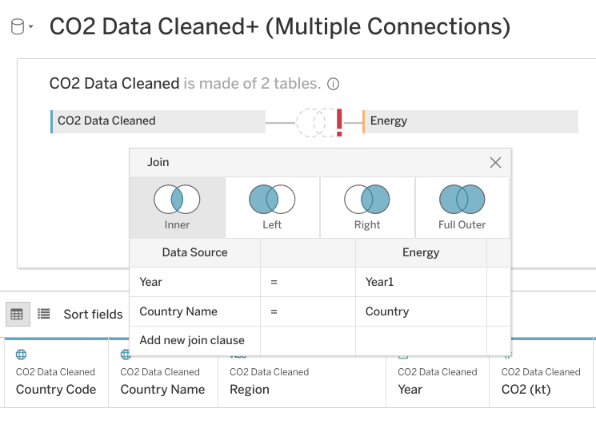

11. Click **Update now** to examine the dataset. You will notice that **Year** and **Year1** have a number sign above them. Change the data type to date for each of these columns.

12. In the column, **Year** click on the **#** (not the arrow next to it) and select **Date** from the available options.

After completing the first field, you will notice a red exclamation mark between **CO2 Data Cleaned** and **Energy**. This indicates that the columns you have joined are no longer of the same data type. One is formatted as date, and the other numeric.

You will also notice that after changing **Year** (CO2 Data Cleaned) to a Date type, the data preview pane will no longer display properly.

13. To fix this, go to the column list in the lower left of the screen.

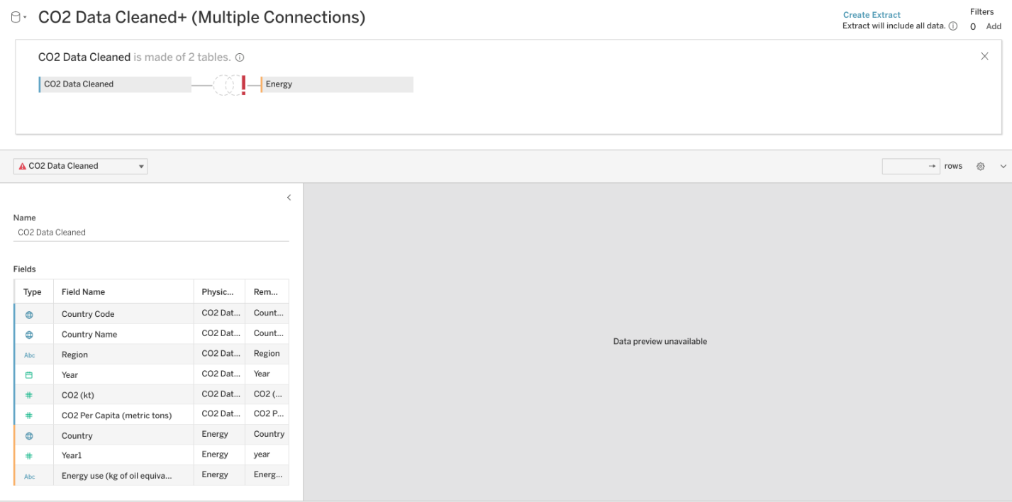

14. Select the **#** icon next to the **Year1** (Energy) column. Then, change the data type to Date.

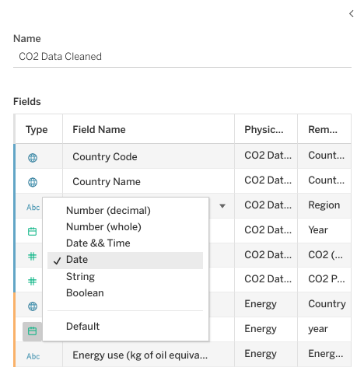

You may need to click **Update Now** in the preview pane to display the data properly. Make sure to repeat this step when you change more data types later on in this exercise.

The red exclamation mark will disappear. You might notice that all the years have been put into a month/day/year form with the default month and day as January 1st. This will not create any problems when creating a visualization, as you will filter the data by year.

### **Connect additional datasets**



Before adding any additional joins, the data type for **Year(Gdptotal)** needs to change.

A pop-up window will appear for the join. It might already be populated with **Year1** under **Datasource** and **Year(Gdptotal)** under **gdptotal.**

1. Click on **gdptotal** under **Connections**.

2. Under **Sheets**,dragthe **gdptotal** sheet into the white space underneath the **energy** box.

3. Scroll to the right until you find the column **Year(Gdptotal).** Click on **#** above it. A drop-down menu will appear.

4. Select **Date** from the drop-down menu.

If the data preview does not display properly, fix the date type in the lower left pane.

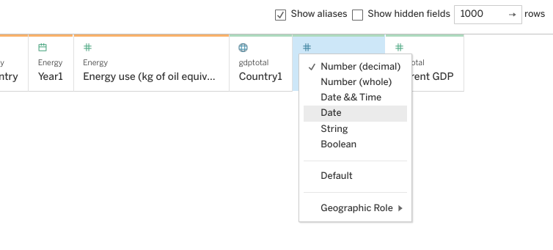

5. Click on the Venn diagram between energy and gdptotal. Click on **Add new join clause** under **year.** A drop-down menu will appear.

6. Under **CO2 Data Cleaned** clickon **Country Name**.

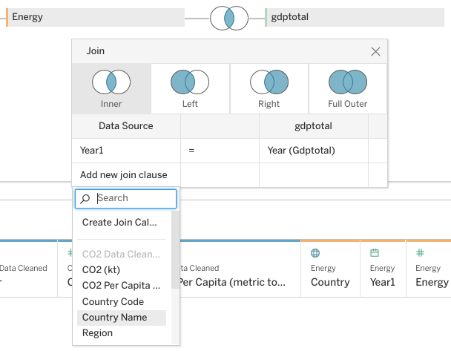

7. Clickon the empty field under **gdptotal** across from **Country Name.** A dropdown menu will appear.

8. Set the right side of the join statement to **Country1.**

9. Closethe Join pop-up by clicking on its **exit button**.

Now you are going to join **totalpopulation**, the last of the four datasets that you downloaded.

10. Click on **totalpopulation** under **Connections**.

11. Under **Sheets**, dragthe **totalpopulation** sheet into the white space to the right of the **energy** and **gdptotal** boxes.

A pop-up window will appear for the join. It should already be populated with **Year** under **Datasource** and **Year(totalpopulation)** under **totalpopulation.**

12. Scroll to the right until you find the **Year(totalpopulation)** column. Click on **#** above it. A drop-down menu will appear.

13. Select **Date** from the drop-down menu.

If the data preview does not display properly, fix the date type in the lower left pane.

14. Click on the Venn diagram to the left of totalpopulation. Click on **Add new join clause** under **Year.** A drop-down menu will appear.

15. Under **CO2 Data Cleaned** click **Country Name**.

16. Click on the empty field under **totalpopulation** across from **Country Name.** A dropdown menu will appear.

17. Click **Country (totalpopulation).**

18. Closethe Join pop-up by clickingon its **exit button**.

19. Click the Update button to view your data columns.

Congratulations! You have successfully joined four different sources of data.

You should take some time to study your dataset. The only years you should notice in your dataset are between 2000-2011. While your dataset **CO2** went from 1960-2011, and your other datasets went from 2000-2015, the intersection (the years they have in common) only includes 2000-2011. This is just the time span that you need.

If the dataset had gone beyond those dates, you would have filtered out the unneeded years in your visualization.

Reviewing the dataset, you may have noticed that some of your measurement values need to be changed. The data type for the column Energy use is listed as string data. You can tell this because of the Abc icon above the name. The column currentGDP is also formatted as type string.

20. Find the **Abc** icon above the **Energy use** column. Change it to **Number (decimal).**

21. Find the **Abc** icon above the **currentGDP** column. Change it to **Number (whole).**

If the data preview does not display properly, fix the date type in the lower left pane.

## Create a visualization



At the bottom of your screen, you will notice a tab labeled **Sheet 1.**

1. Clickon the tab **Sheet1.**

2. Drag **Country Name** under **CO2 Data Cleaned** into the **Detail** square.

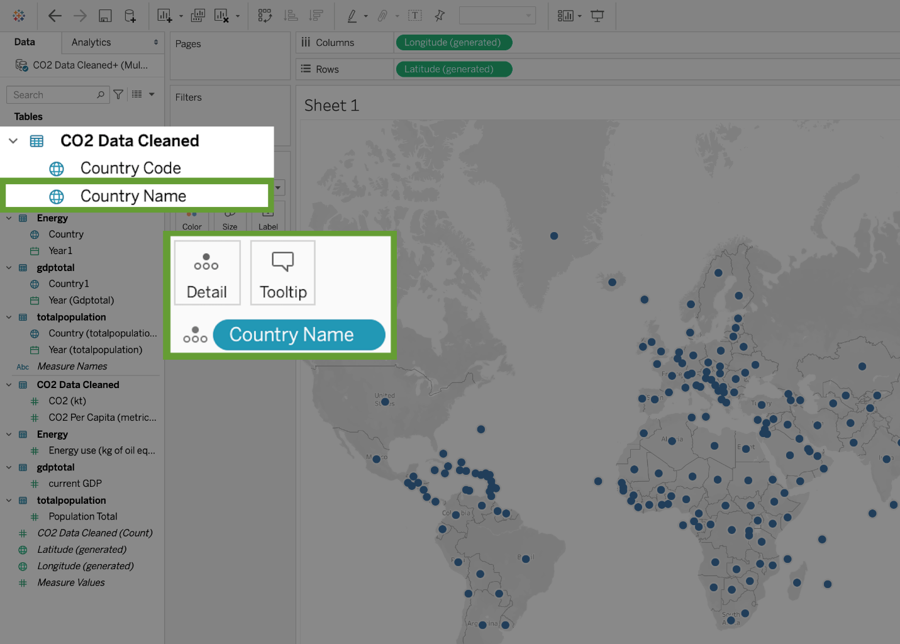

3. Drag **CO2 Per Capita** to **Color.**

4. Clickon **Color,** then **Edit Colors.**

5. Clickonthe **Palette** dropdown and change it from **Automatic** to **Red-Green diverging.**

6. Check the boxes for **Stepped Color** and **Reversed**. (Because green is generally viewed as positive for CO2 emissions, you want the colors to move towards red as emissions go up.)

7. Clickthe **Show** **Advanced** dropdown.

8. Checkthe **Start** and **End** boxes.

You might have noticed that the legend on the right-hand side of the screen shows **Sum(CO2 per capita)**. You need to change the **start** and **end** values in order to notice color contrasts showing red shades.

The lowest CO2 Per Capita emission for any year is 0.0396 and the largest is 61.9898.

9. Enter 0 into the **Start** field, and 62 into the **End** field. Click **OK**. Click the **X** button.

**Note:** These values are the highest and lowest emissions between 2000-2011. Your screen should now look like this:

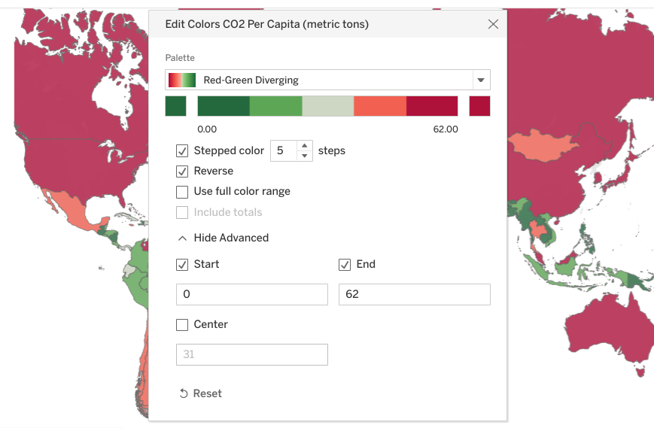

10. Drag **Year** from under **CO2 Data Cleaned** into the **Filters** area.

11. Clickon **Years, Next, All, OK.**

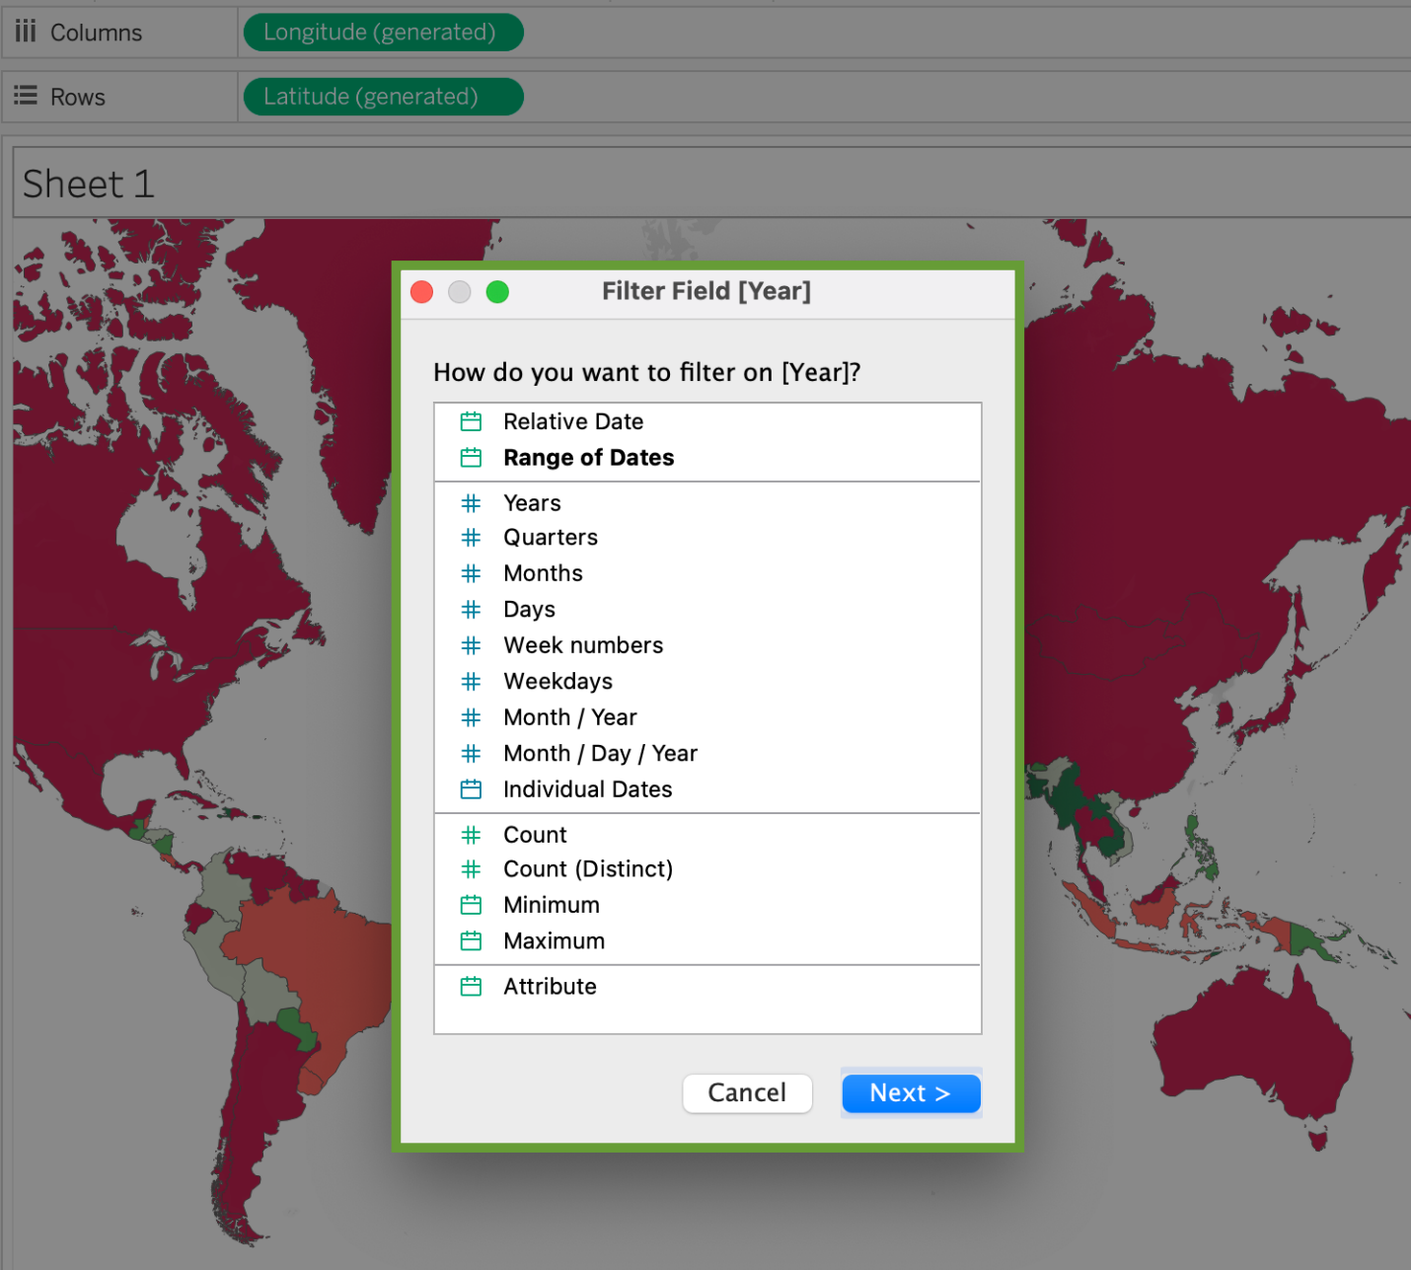

12. In the **Filters** box, right-click on **YEAR(Year)**

13. Select **Show Filter.** The filter will appear on the right side of the screen.

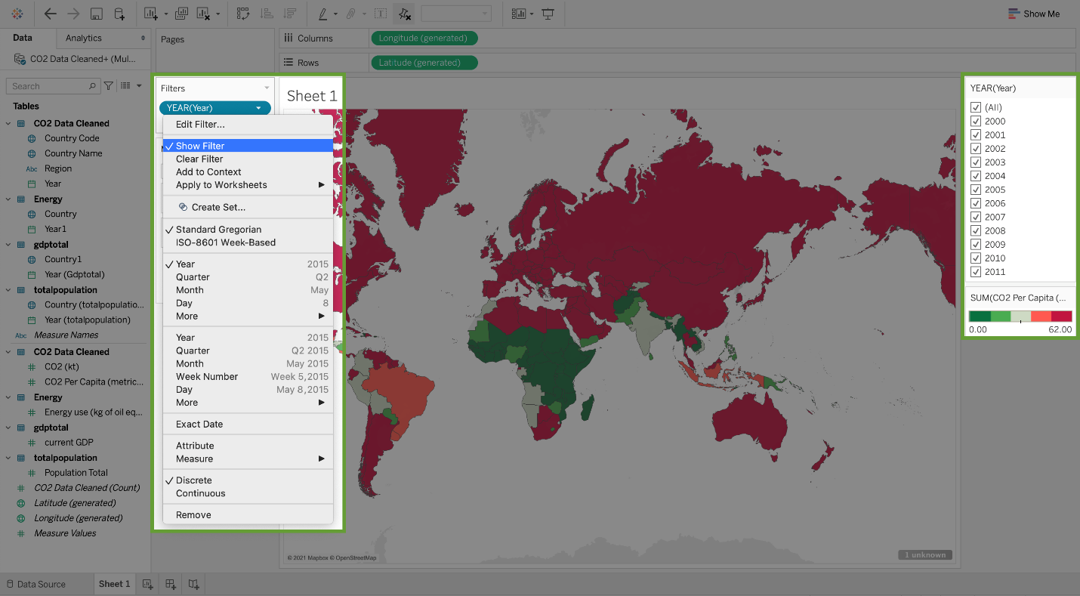

14. Click on the arrow to the right of **YEAR(Year)** on the far-right side of the screen.

15. Select **Single Value (dropdown)**. Now the areas are colored only for the values of each year. Use the checkboxes in the list to choose which years you want to include in the visualization. You can select only the years between 2000-2011 to view the emissions relevant to the scenario.

Congratulations! You've linked your data and made a comprehensive data visualization in Tableau.

# Tableau resources for combining multiple data sources

Now that you have some experience working with data in Tableau, you are ready to start doing more, including combining multiple data sources. This reading will provide you with some how-to guides for that, and other helpful resources you can use as you practice using Tableau on your own.

| **Resource** | **Description** |
| --- | --- |
| [**Set up data sources**](https://help.tableau.com/current/pro/desktop/en-us/datasource_prepare.htm) | This page links to other resources explaining how to **set up your data sources** and prepare them for analysis once you have connected them to your Tableau account. It specifically includes articles explaining how to join or blend data, and what a union is and how they work. This is a great starting point as you get ready to begin using and combining data sources. |
| [**Join your data**](https://help.tableau.com/current/pro/desktop/en-us/joining_tables.htm) | **Joining** refers to the process of combining data sources based on common fields. This article gives a more detailed explanation of the different joins, how to use them in Tableau, and an example join with a step-by-step guide. |
| [**Don’t be scared of relationships**](https://help.tableau.com/v2020.2/pro/desktop/en-us/datasource_dont_be_scared.htm) | **Relationships** allow you to combine multiple data sources in Tableau. This is a more flexible alternative to joins, and doesn’t force you to create one single table with your multiple data sources. This article will give you more insight into how relationships work. |
| [**How relationships differ from joins**](https://help.tableau.com/current/online/en-us/datasource_relationships_learnmorepage.htm) | This article goes into more detail about the differences between using **relationships and joins**, and guides you through the process of using relationships to combine data. |
| [**Blend your data**](https://help.tableau.com/current/pro/desktop/en-us/multiple_connections.htm) | **Data blending** is another method you can use to combine multiple data sources. Instead of truly combining the data, blends allow you to query and aggregate data from multiple sources. This resource goes into more detail about blending and includes a tutorial. |
| [**Combining multiple date fields**](https://kb.tableau.com/articles/howto/combining-start-and-end-dates-into-a-single-axis) | This resource provides examples that explain how to **combine date fields** when using four different methods of data combination in Tableau. |

These are just a few resources you can use. You can also find more information online or in the[Tableau community forums](https://community.tableau.com/s/).

# Effective data stories

In data analytics, **data storytelling** is communicating the meaning of a dataset with visuals and a narrative that is customized for a particular audience. In data journalism, journalists engage their audience of readers by combining visualizations, narrative, and context into data-driven articles. It turns out that data analysts and data journalists have a lot in common! As a junior data analyst, you might learn a few things about effective storytelling from data journalism. Read further to explore the role and work of a data journalist in telling a good story.

**Note:** This reading refers to an article published in The New Yorker. Non-subscribers may access several free articles each month. If you already reached your monthly limit on free articles, bookmark the article and come back to this reading later.

## Take a tour of a data-driven article



[Ben Wellington](https://www.newyorker.com/contributors/ben-wellington), a contributing writer for The New Yorker and a professor at the Pratt Institute, used New York City’s [open data portal](https://nycopendata.socrata.com/Social-Services/311-Service-Requests-from-2010-to-Present/erm2-nwe9?) to track down noise complaints from logged service requests. He analyzed the data to gain a more quantitative understanding of where the noise was coming from and which neighborhoods were the noisiest. Then, he presented his findings in the [Mapping New York's Noisiest Neighborhoods](https://www.newyorker.com/tech/annals-of-technology/mapping-new-york-noise-complaints) article.

First, click the link above to skim the article and familiarize yourself with the data visualizations. Then, join the bus tour of the data! You will be directed to three visualizations (tour stops) to observe how each visualization helped strengthen the overall storytelling in the article.

### **Tour stop 1: setting context**

Earlier in the training, you learned how context is important to understand data. **Context** is the condition in which something exists or happens. Based on the categorization of noise complaints, the data journalist set the context in the article by defining what people considered to be noise.

In the article, review the [combo table and bar chart](https://media.newyorker.com/photos/590965cfebe912338a3758c4/master/w_1600%2Cc_limit/Wellington-noise-ComplaintCounts.jpg) that categorizes the noise complaints. Evaluate the visualization:

* **How does the visualization help set the context?**  The combo table and bar chart is effective in summarizing the noise categories as percentages of the logged complaints. This helps set the context by answering the question, “what is noise?” Notice that the data journalist created a combo table and bar chart instead of a pie chart. With 11 noise categories, a list with a bar chart showing relative proportions is an elegant representation. A pie chart with 11 slices would have been harder to read.
* **How does the visualization help clarify the data?**  If you add the percentages in the categories in the combo table and bar chart, the total is ninety-eight percent. There is a difference of two percent that can’t be accounted for in the visualization. So, rather than clarifying the data, the visualization actually causes a little confusion. One lesson is to always make sure that your percentages add up correctly. Sometimes rounding decimal places up or down causes percentages to be off so they don’t add up to 100%.
* **Do you notice a data visualization best practice?** You learned that a companion table in Tableau shows data in a different way in case some in your audience prefer tables. It appears that the data journalist had the same idea by using a combo table and bar chart. **Note:** As a refresher, a companion table in Tableau is displayed right next to a visualization. A companion table displays the same data as the visualization, but in a table format. You may replay the [Getting Creative](https://www.coursera.org/learn/visualize-data/lecture/Eytgs/getting-creative) video which includes an example of a companion table.

### **Tour stop 2: analyzing variables**

After setting the context by identifying the noise categories, the data journalist describes his analysis of the noise data. One interesting analysis is the distribution of noise complaints versus the time of day.

In the article, review the [stacked area chart](https://media.newyorker.com/photos/590965cd1c7a8e33fb38d4ac/master/w_1600%2Cc_limit/Wellington-noise-ComplaintsHours.jpg) for the distribution of noise complaints by hour of the day. Evaluate the visualization:

* **How does the visualization perform against the five-second rule?**  Recall that the five-second rule states that you should understand what is being conveyed within the first five seconds of seeing a chart. We are guessing that this visualization performs quite well! The area charts for loud music and barking dogs help the audience understand that more of these types of noise complaints were made during late night and early morning hours (between 10:00 PM and 2:00 AM). Notice also that the color coding in the legend aligns with the colors in the chart. A chart legend normally has the largest category at the top, but the data journalist chose to order the legend so the largest category, “Loud music or party” appears at the bottom instead. How much time do you think this alignment saved readers?
* **How does the visualization help clarify the data?** Unlike the visualization from the previous tour stop, this visualization does a better job of clearly showing that all percentages add up to 100%.
* **Do you notice a data visualization best practice?** As a best practice, both the x-axis and y-axis should be labeled. But, the data journalist chose to include % or A.M. and P.M. with each tick on an axis. As a result, labeling the x-axis “Time of Day'' and the y-axis “Percentage of Noise Complaints” isn’t required. This demonstrates that a little creativity with labeling can help you achieve a cleaner chart.

### **Tour stop 3: drawing conclusions**

After describing how the data was analyzed, the data journalist shares which neighborhoods are the noisiest using a variety of visualizations: [combo table and bar chart](https://media.newyorker.com/photos/590965ceebe912338a3758c2/master/w_1600%2Cc_limit/Wellington-noise-ComplaintsNeighborhoods.jpg), [density map](https://media.newyorker.com/photos/590965cfc14b3c606c1067b0/master/w_1600%2Cc_limit/Wellington-noise-complete.jpg), and [neighborhood map](https://media.newyorker.com/photos/590965d0ebe912338a3758c8/master/w_1600%2Cc_limit/Wellington-noise-WilliamsburgDetail.jpg).

In the article, review the [neighborhood map](https://media.newyorker.com/photos/590965d0ebe912338a3758c8/master/w_1600%2Cc_limit/Wellington-noise-WilliamsburgDetail.jpg) for how close a noisy neighborhood is to a quiet neighborhood. Evaluate the visualization:

* **How does the visualization help make a point?**  The data journalist observed that one of the noisiest neighborhoods was right next to one of the quietest neighborhoods. The neighborhood map is effective in emphasizing this observation as a dark blue area versus a white area.
* **How does the visualization help clarify the data?** The visualization classifies the data by neighborhood and allows the audience to follow along when the journalist focuses specifically on the Williamsburg, East Williamsburg, and North Side/South Side neighborhoods.
* **Do you notice a data visualization best practice?** Each neighborhood is directly labeled so a legend isn’t necessary.

## End of the tour: being inspired

We hope you enjoyed your tour of a data journalist’s work! May this inspire your data storytelling to be as engaging as possible. For additional information about effective data storytelling, read these articles:

* [What is Data Storytelling?](https://www.nugit.co/what-is-data-storytelling/)
* [The Art of Storytelling in Analytics and Data Science | How to Create Data Stories?](https://www.analyticsvidhya.com/blog/2020/05/art-storytelling-analytics-data-science/)
* [Use Data and Analytics to Tell a Story](https://www.gartner.com/smarterwithgartner/use-data-and-analytics-to-tell-a-story/)
* [Tell a Meaningful Story With Data](https://www.thinkwithgoogle.com/marketing-resources/data-measurement/tell-meaningful-stories-with-data/)

# Learning Log: Tell a story with data



## Overview



You have learned about how data storytelling and visualizations can be powerful tools for communicating your data findings with your audience. Now, you’ll complete an entry in your learning log to reflect on both data storytelling and visualization. By the time you complete this entry, you will have a stronger understanding of how you can combine these concepts to communicate more effectively. This will help you as you start sharing your own visualizations and presentations as a data analyst.

## Data storytelling and visualization



Before you write your response in the learning log template linked below, take a moment to consider how data storytelling and visualization are used to communicate about data.

**Data storytelling** means communicating the meaning of a dataset with visuals and a narrative that are customized for a particular audience.

For example, some music-streaming companies send their customers a “year in review” email. In these emails, they tell their customers which artists and songs they were a top fan of. This way, the companies use their customers’ data to tell a story.

**Data visualization** is the representation and presentation of data to help with understanding. You can use graphs, charts, word clouds, and other visual depictions to help your audience see and clearly understand your data.

The effects of data storytelling and data visualization can be powerful. Data storytelling and data visualization can captivate your audience, make stories memorable, touch people’s hearts, and inspire people to take action.



### Access your learning log

To use the template for this course item, click the link below and select “Use Template.”

Link to learning log template: [Tell a story with data](https://docs.google.com/document/d/18supoxx2UXq0cyaxraOgNN-9wGmpHsvzsbZNrKnzMYw/template/preview?resourcekey=0-cpUrzO49CLgKtGJDGP2TJg)

OR

If you don’t have a Google account, you can download the template directly from the attachment below.

**Learning Log Template\_ Tell a story with data**DOCX File

[Download file](https://d3c33hcgiwev3.cloudfront.net/yEMewOdVTJeDHsDnVeyXOQ_5f6c59217d8e46f299544b9edfb631f1_Learning-Log-Template_-Tell-a-story-with-data.docx?Expires=1648080000&Signature=D~6XZaptVnC5nI7o1igN-4PuIrxo8qzTIgBg4Iy~0tYTJe3oumfckNwW-8C4RJJ4Iz5DPYntp5f9AUrPi0cZS99IuR6Tmag7bBtna9NJ1yfXPRrkDWcM6mMt6QBoALqAtjrwc523YnU~Wayr1w4lo5Q6FLIixVrQcLK31f9JQBY_&Key-Pair-Id=APKAJLTNE6QMUY6HBC5A" \t "_blank)



## Reflection



Now that you’ve thought more about data storytelling and visualization, take a moment to reflect on these concepts. In your learning log template, write 2-3 sentences (40-60 words) in response to each question below:

* What is the most interesting thing that you have learned in Week 3 so far?
* What aspects of data storytelling and visualization do you want to explore in more detail? Why are those aspects important or interesting to you?
* What stories related to your own life or society are you curious about telling by using data?
* If you could tell any story by using data, what would it be, and why?

When you’ve finished your entry in the learning log template, make sure to save the document so your response is somewhere accessible. This will help you continue applying data analysis to your everyday life. You will also be able to track your progress and growth as a data analyst.

# Live and static insights

Previously, you learned about data storytelling and interpreting your dataset through a narrative. In this reading, you will explore the difference between live and static insights to make your data even clearer.



## Live versus static

Identifying whether data is live or static depends on certain factors:

* How old is the data?
* How long until the insights are stale or no longer valid to make decisions?
* Does this data or analysis need updating on a regular basis to remain valuable?

**S​tatic data** involves providing screenshots or snapshots in presentations or building dashboards using snapshots of data. There are pros and cons to static data.

**PROS**

* Can tightly control a point-in-time narrative of the data and insight
* Allows for complex analysis to be explained in-depth to a larger audience

**CONS**

* Insight immediately begins to lose value and continues to do so the longer the data remains in a static state
* S​napshots can't keep up with the pace of data change

**L​ive data** means that you can build dashboards, reports, and views connected to automatically updated data.

**PROS**

* Dashboards can be built to be more dynamic and scalable
* Gives the most up-to-date data to the people who need it at the time when they need it
* Allows for up-to-date curated views into data with the ability to build a scalable “single source of truth” for various use cases
* Allows for immediate action to be taken on data that changes frequently
* Alleviates time/resources spent on processes for every analysis

**CONS**

* Can take engineering resources to keep pipelines live and scalable, which may be outside the scope of some companies' data resource allocation
* Without the ability to interpret data, you can lose control of the narrative, which can cause data chaos (i.e. teams coming to conflicting conclusions based on the same data)
* Can potentially cause a lack of trust if the data isn’t handled properly

## Key takeaways

Analysts need to familiarize themselves with the business and data so they can recommend when an updated static analysis is needed or should be refreshed. Also, this data insight will help you make the case for what sorts of analyses, visualizations, and additional data are recommended for the types of decisions that the business needs to make.

Keep this [customer survey spreadsheet](https://docs.google.com/spreadsheets/d/1DWIKPvtci3Gq6Qbz15SjjY6l4wbc_4I-CpVaFDPneDA/template/preview?resourcekey=0-OOpDEJqur_5qsHXNIt2Bqg) on hand as it will be useful for the next video.

## Hands-On Activity: Creating, filtering, and customizing charts

**Total points**2

### 1.

**Question 1**



## Activity overview



You have learned that you can create charts in spreadsheets and in Tableau, and that you can customize the information displayed in them using filters. Before working in Tableau, you will work with the spreadsheet chart editor.

By the time you complete this activity, you will be able to create a chart in a spreadsheet and customize it by using filters and applying different styles. This will enable you to use spreadsheets in another helpful way, which is important for using all the tools at your disposal in your career as a data analyst.



### **What you will need**

To get started, first access the sample data.

To use the data for this course item, click the link below and select “Use Template.”

Link to sample data: [Cosmetics Inc.](https://docs.google.com/spreadsheets/d/1qaSKSyfvXz3Zsu_RU7abK-eNScSyGSe2oXT1KgiaMXI/template/preview)

OR

If you don’t have a Google account, you can download the template directly from the attachment below.

**Cosmetics Inc.**XLSX File

[Download file](https://d3c33hcgiwev3.cloudfront.net/1CatA2d3QAqmrQNndzAKQg_420b4adfcdec47a0b0c67d6c5cea0641_Cosmetics-Inc..xlsx?Expires=1648080000&Signature=TjcavJ~Aj7xGyw1nHeRl-SclRMpdb17ENwNmrXTdKlvzQypYs6XuWqDy6z2qiUtPgNhcimcDk0KNM3hqrcrZl5PZoGCwjtPqISZQR2o8OXC6JgwiwuOUgU9Xh0ziLoNtIXKbmB1kY00L9X-05areiB2BelgHat6~4nO~MbXcq98_&Key-Pair-Id=APKAJLTNE6QMUY6HBC5A" \t "_blank)



## Creating a chart in a spreadsheet



**Important note:** The following steps are for Google Sheets but they can help guide you to similar features in Excel. Refer to the Additional resources section if you need more specific instructions for creating charts in Excel. 1. In the spreadsheet that you copied or downloaded, practice creating a chart by clicking the second tab named **Create your chart here**. This tab contains the total purchases calculated for each store from the first tab. All of the original data is preserved in the first tab so you can explore chart creation in the second tab without changing or deleting any of the original data.

2. Highlight cells **B3** through **C7** as the data for your chart.

3. From the main menu, click Insert, and select Chart.

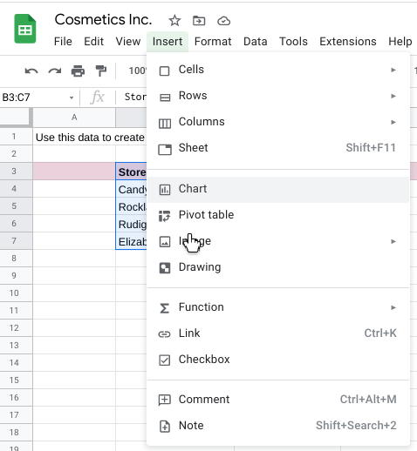

4. A chart is created automatically and a chart editor opens on the right so you can change the chart type. If a pie chart is displayed, click the **Chart type** drop-down and select a column chart so your chart looks like the one below.

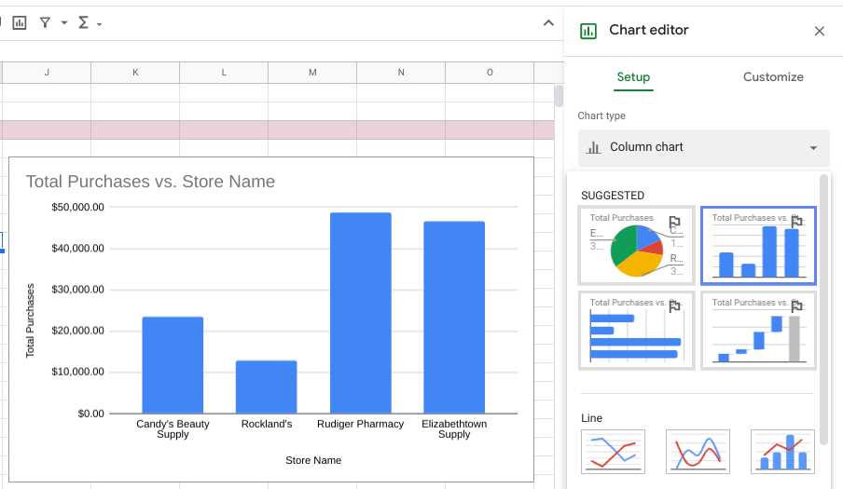

5.To filter the data shown in the column chart, make sure the **pink row 3** is highlighted and then click the **filter** **icon** in the toolbar. (The filter icon is the second icon from the right in the toolbar.) This adds a filter icon in each column of your data.

6. Click the filter icon for **Store Name** and uncheck **Candy's Beauty Supply**.

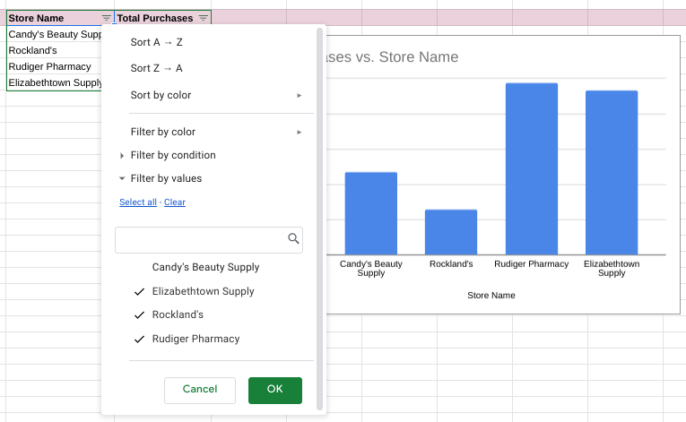

7.Click **OK** and your chart will automatically update to exclude the data for Candy's Beauty Supply, as shown below.

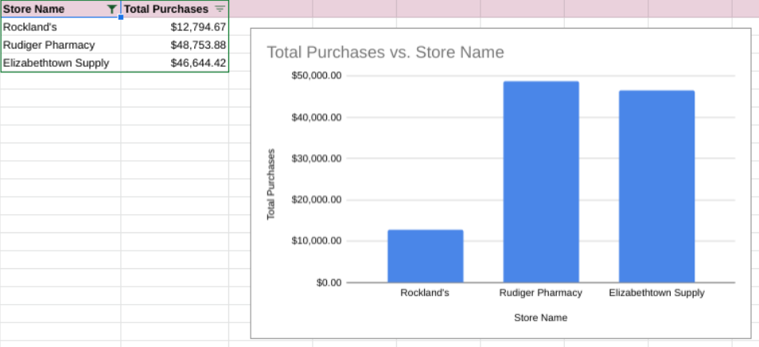

**Note:** To include the data for Candy's Beauty Supply again, simply click the filter icon for Store Name and click Candy's Beauty Supply to add the check mark back.

### **Applying Styles**



You can also apply different styles to the chart. For example, the default blue in the chart isn't the most appropriate for accessibility when the background is white.

1. Double-click the chart to open the chart editor.

2. Click **Series** in the chart editor to expand the options.

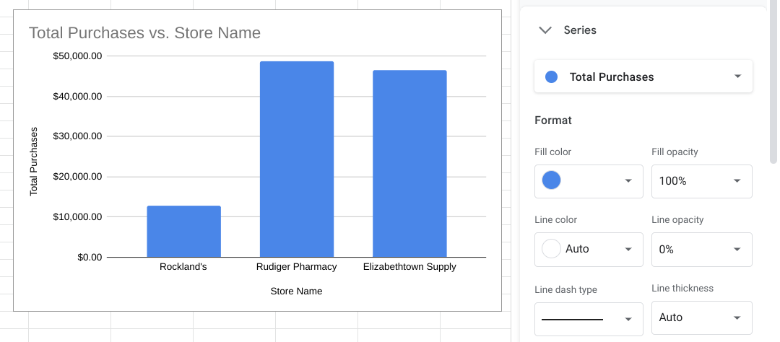

3.Under **Format**, click the drop-down for **Fill color**, and select **Custom**.

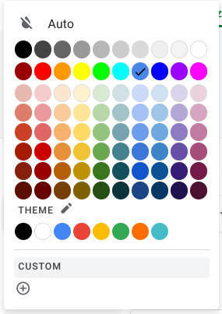

4.Change the **Hex value** for the color from **#4a86e8** to one of the blue hues recommended for use on white backgrounds for accessibility. The difference between the current color and these accessible colors may seem minimal, but a contrast ratio of 4.5:1 is important for people who cannot see the full color spectrum. Read through the [Carnegie Museums of Pittsburgh's accessibility guidelines](http://web-accessibility.carnegiemuseums.org/design/color/) to learn more about web accessibility guidelines.

* #0071bc
* #046b99
* #205493

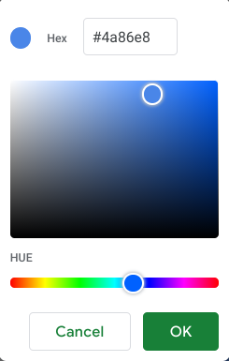

5.Click **OK** and the chart will automatically update with the newly assigned color.

## Additional resources



Here are a few more resources you can reference as you learn more about charts in spreadsheets:

* [Graphs in Google Sheets](https://www.datacamp.com/community/tutorials/graphs-in-spreadsheets): Not only does this resource contain a detailed example of chart creation in spreadsheets, but it also provides you with downloadable sample data you can use to practice. As you have learned throughout this course, practicing these skills helps you learn more about the tools you are using. This example data is a great way to start!
* [Add and edit a chart or graph in Google Sheets](https://support.google.com/docs/answer/63824): This article includes steps for creating, editing, and changing charts in Google Sheets with how-to videos. It also has a more in-depth guide to editing and customizing your chart after you have created it.
* [Create a Microsoft Excel chart from start to finish](https://support.microsoft.com/en-us/office/create-a-chart-from-start-to-finish-0baf399e-dd61-4e18-8a73-b3fd5d5680c2): This how-to guide from Microsoft’s support site includes instructions and a video tutorial for adding charts to Excel spreadsheets. This is a useful resource if you are working specifically with Excel spreadsheets. It also links to other useful articles about creating charts in Excel.
* [Microsoft Excel: Creating and modifying charts](https://guides.lib.umich.edu/c.php?g=283162&p=1886446): This is an explanation of Excel charts with downloadable handouts. This resource is especially useful because it has downloadable content that you can save to reference later when you start creating charts in your own spreadsheets.

## Hands-On Activity: Build a dashboard in Tableau

**Total points**1

### 1.

**Question 1**



## Activity overview



The video you just watched showed you how to create a dashboard in Tableau. Now, you can use the template, dataset, and instructions in this activity to create the visualization yourself. Feel free to refer back to the previous video if you get stuck.

In previous activities, you linked data sources and created data visualizations. Now, you’ll use what you learned about the process of data visualization to add data to a dashboard.

By the time you complete this activity, you will be able to create and use a dashboard to present data in an accessible and interactive way. This will enable you to communicate your work and display dynamic data in professional settings.

Note: You will need the Tableau Public Desktop app to import the Dashboards Starter Template in this activity. For more information on downloading the Tableau Public app, see the [Reading: Optional: Using Tableau Desktop](https://www.coursera.org/learn/visualize-data/supplement/bMjvq/optional-using-tableau-desktop). If you are unable to download the app to your device, use the two visualizations you created in the last Tableau activities as Sheet 1 and Sheet 2 of this activity.



### **What you will need**

A starter template with a few existing data sources and visualizations and a data set have been provided. Click the link to the folder containing the starter template and data set.

**If you are logged into your Google Account:**

Click and drag to highlight both the template and the data set. Then, right-click on the selected files and click Download.

**If you are not logged into your Google Account:**

To download both items, click the DOWNLOAD ALL button in the top right corner of the page. You do not need a Google account to download the files.

Download the starter template and data set: [Starter template and data set](https://drive.google.com/drive/folders/12Ajyz_h6C4TW5CJfwq70KCMwl0rVT-8U)



## Open the template and load the data



In a business context, data visualizations are most useful when they are presented in a dashboard-style format to stakeholders. Dashboards put all the pertinent information in the same place, making it easier to understand the important takeaways. Many dashboards are also constantly updating to reflect new data, and some are even interactive. No matter what style of dashboard you choose, they can help you deliver the work you’ve done when creating visualizations.

Now it's time to begin the activity. After you download the **Dashboards Starter Template**, find the file in your storage and open it in Tableau Public Desktop.

Upon opening the Tableau project template, your screen should look like this:

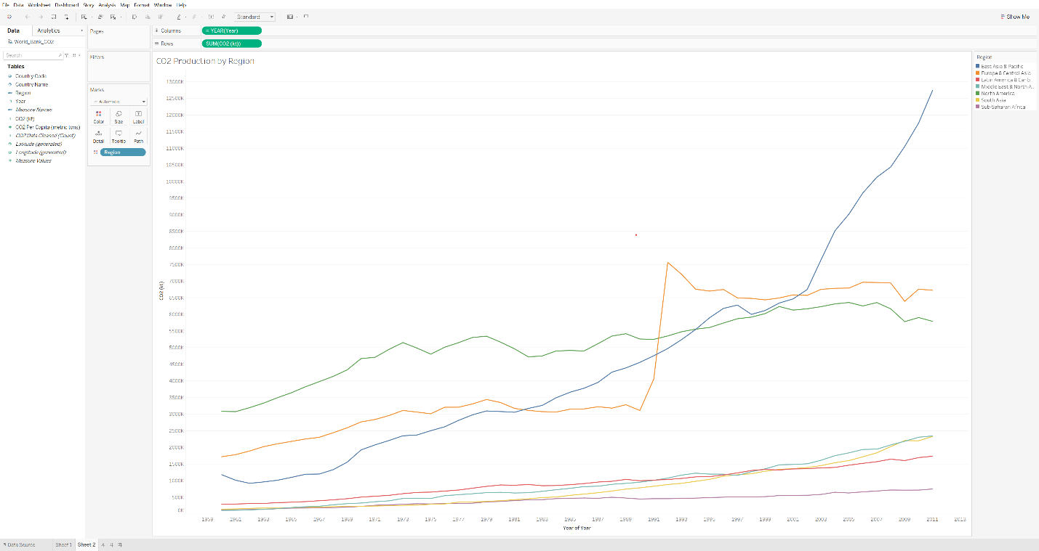there are multiple multi-colored lines each representing different data

The Dashboards Starter Template workbook allows you to explore and manipulate the visualizations found in two sheets: **Sheet 1** and **Sheet 2**. However, the Tableau workbook does not contain the actual dataset. Next, you will load the dataset.

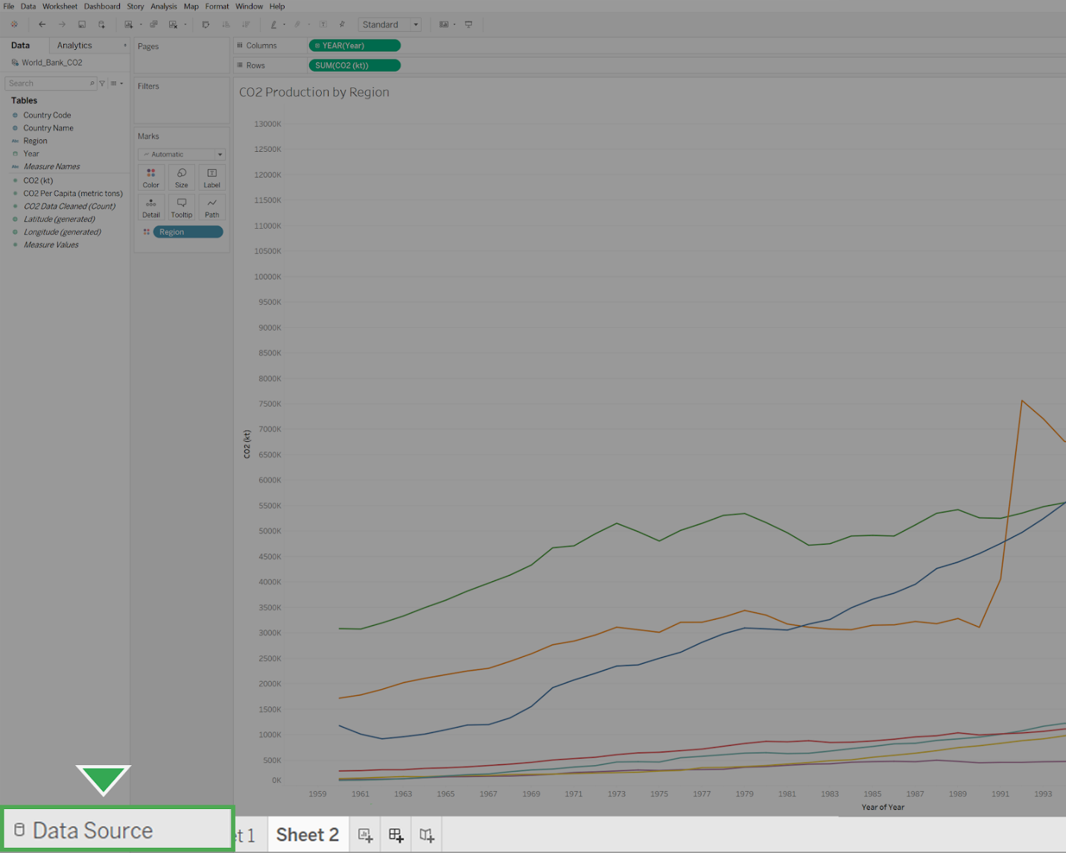

To load the actual dataset:

1. Click the **Data Source** tab in the bottom left-hand corner of the window. This will open the **Datasources** folder Tableau Public has created on your computer by default.

2. Navigateto the location on your computer where you downloaded the **World Bank CO2** dataset and open it.

3. Locate the **My Tableau Repository** folder on your computer. This is usually placed in the Documents folder of your local files. If you cannot find the folder, use the search bar in your computer’s file explorer.

4. Double-click the folder **My Tableau Repository**, then double-click the folder **Datasources**.

5. Drag your datasets for Tableau from where you downloaded them into the **Datasources** folder. This will help you keep track of your datasets for various projects and stay organized.

**Note:** As a best practice, you should always move your datasets for Tableau into the **Datasources** folder.

## Create a dashboard



The example project contains the **World Bank CO2** dataset, with two separate visualizations. Click **Sheet 1**. This visualization shows the average CO2 per capita of each country. Now, click **Sheet 2**. This visualization is a line chart of the CO2 production of each global region over time.

You will use these visualizations to create a dashboard. Click the **Add Dashboard** button, which is the middle button on the bottom row with a symbol that appears like a spreadsheet with a plus sign.

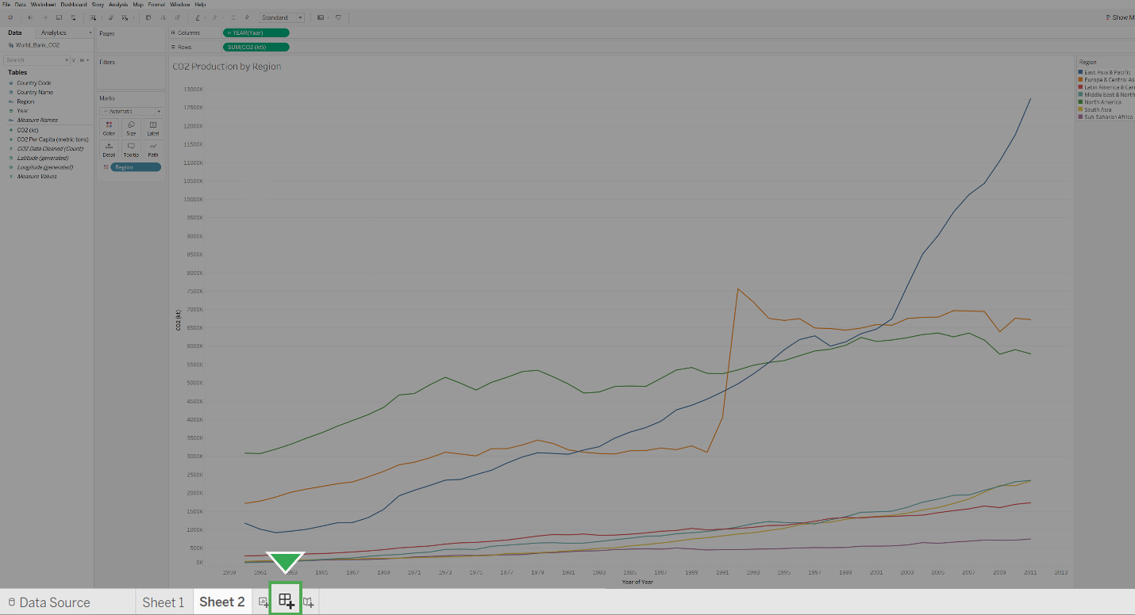

This will open a new dashboard. Your screen should appear like this:

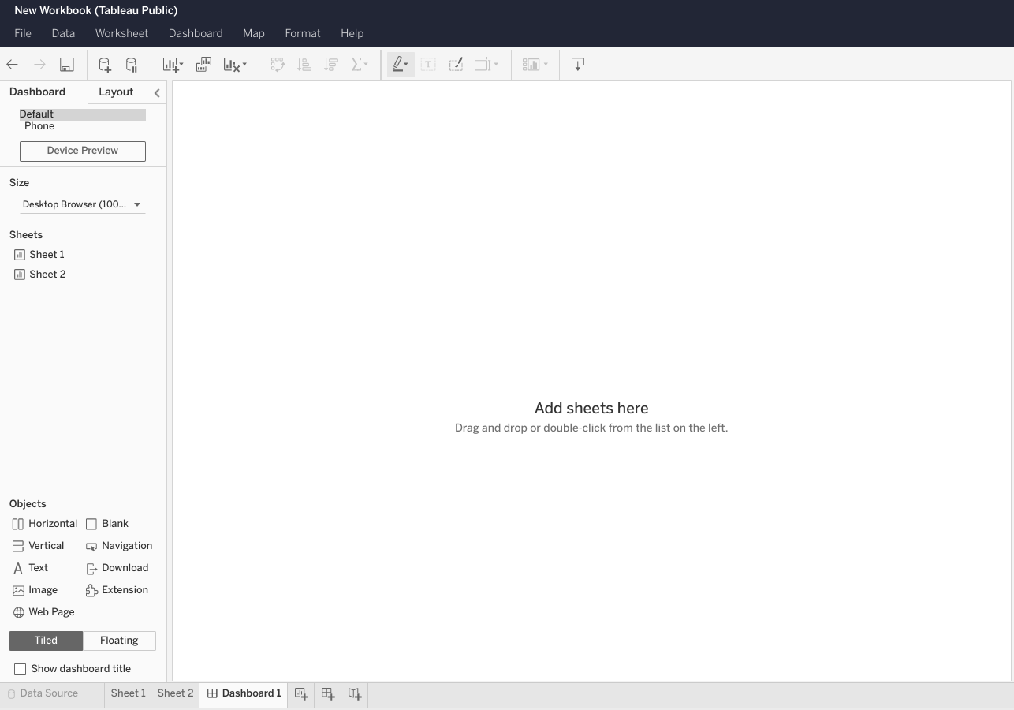

Now, you just need to add some visualizations to your dashboard.

## Add visualizations



To add visualizations, drag the appropriate sheets onto the dashboard in the layout that you prefer. In this case, you’ll add the map visualization from **Sheet 1** on top of the line graph from **Sheet 2**.

1. Start by finding **Sheet 1** in the Sheets section on the left side of the screen. Click and drag **Sheet 1** onto the area that says **Drop sheets here**. Your screen should appear like this:

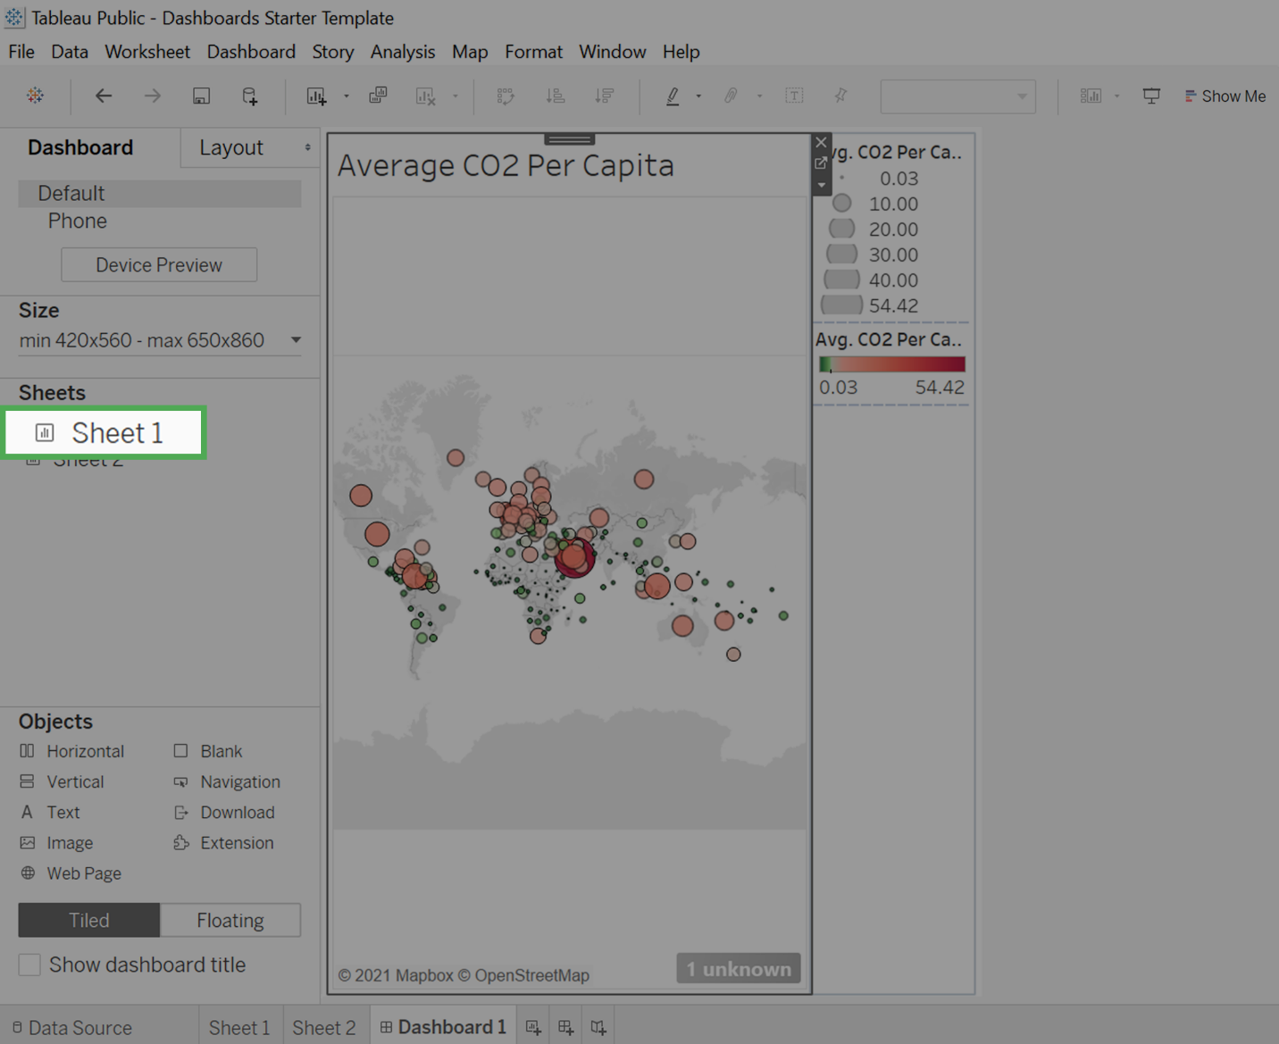

2. Click and drag **Sheet 2** onto the visualization. You’ll notice that the visualization adjusts to show the layout depending on where you drag the sheet. Place **Sheet 2** so that it takes up the bottom half.

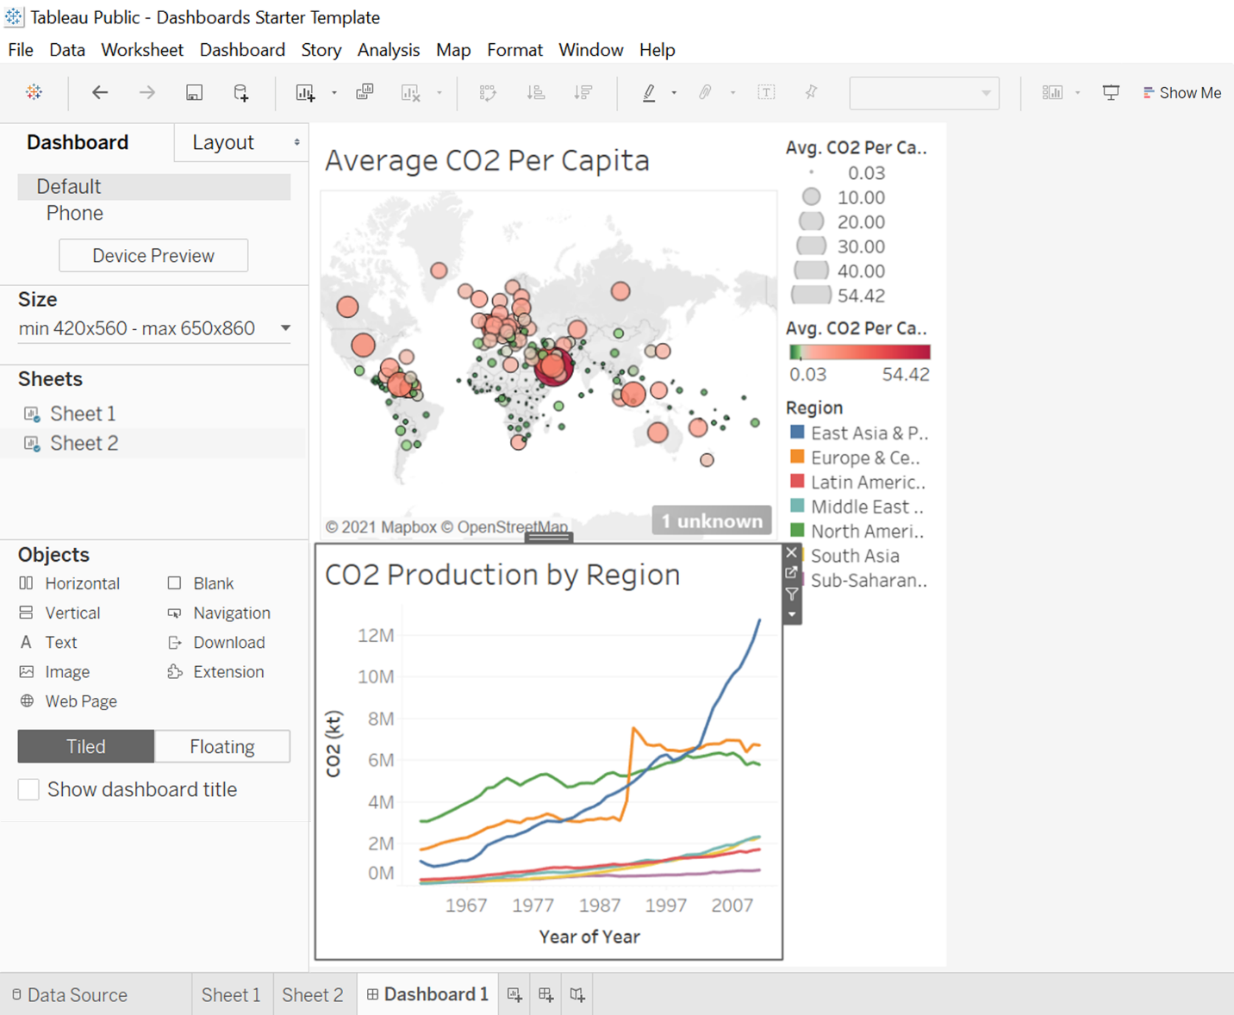

## Clean the dashboard



The dashboard currently contains three legends, but only two of them are needed. The topmost legend of grayscale values represents the CO2 Per Capita by size.

CO2 per capita is represented by size and color. As such, Tableau creates two legends. To simplify the visualization, your best choice is to delete the topmost legend that corresponds to size.

The relationship between small and large emissions can be interpreted by the relative sizes of the circles. However, the color representing the number of emissions per capita is not interpretable without the legend.

1. Delete the topmost legend. To do this, click it and then click the **X** attached to it to remove it from the dashboard.

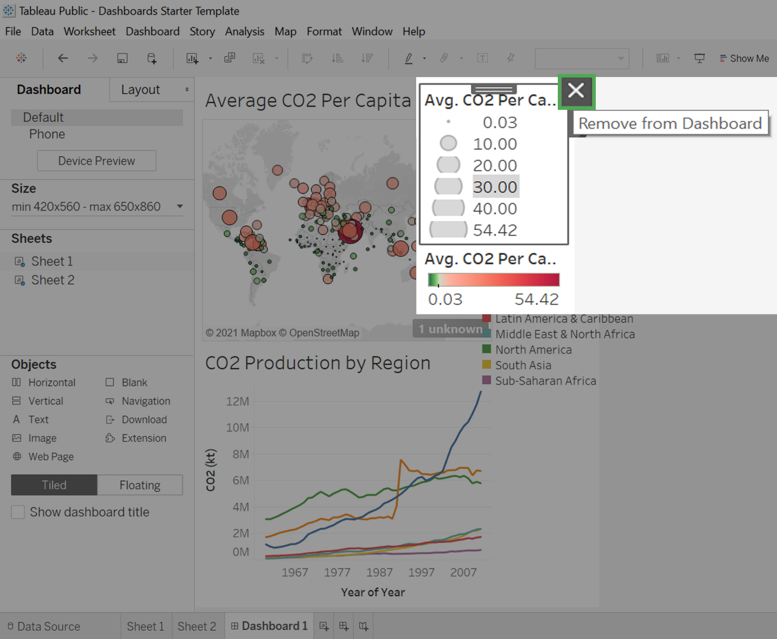

Now that it’s been removed, you’ll set the remaining legends to float.

2. Click on a legend.

3. Click the arrow pointing downwards for **More Options**. From there, select **Floating**.

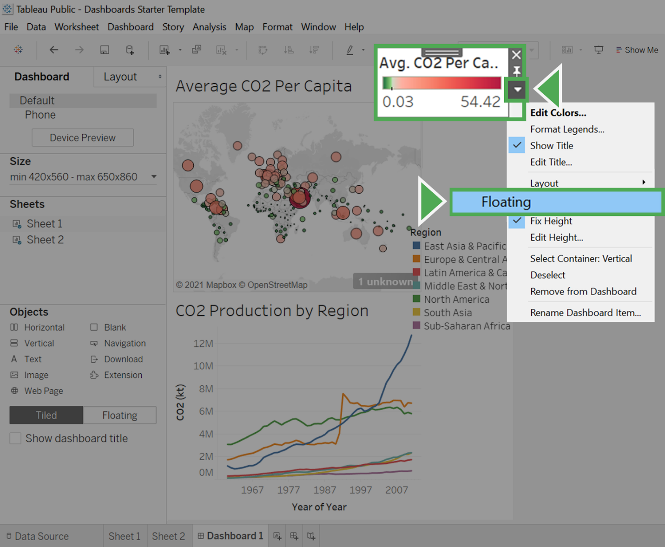

4. Drag the legend onto the top-right corner of the map visualization.

5. Repeat steps 2-4 and float the remaining legend onto the top-right corner of the bottom graph. Once you’ve done it, your dashboard should appear like this:

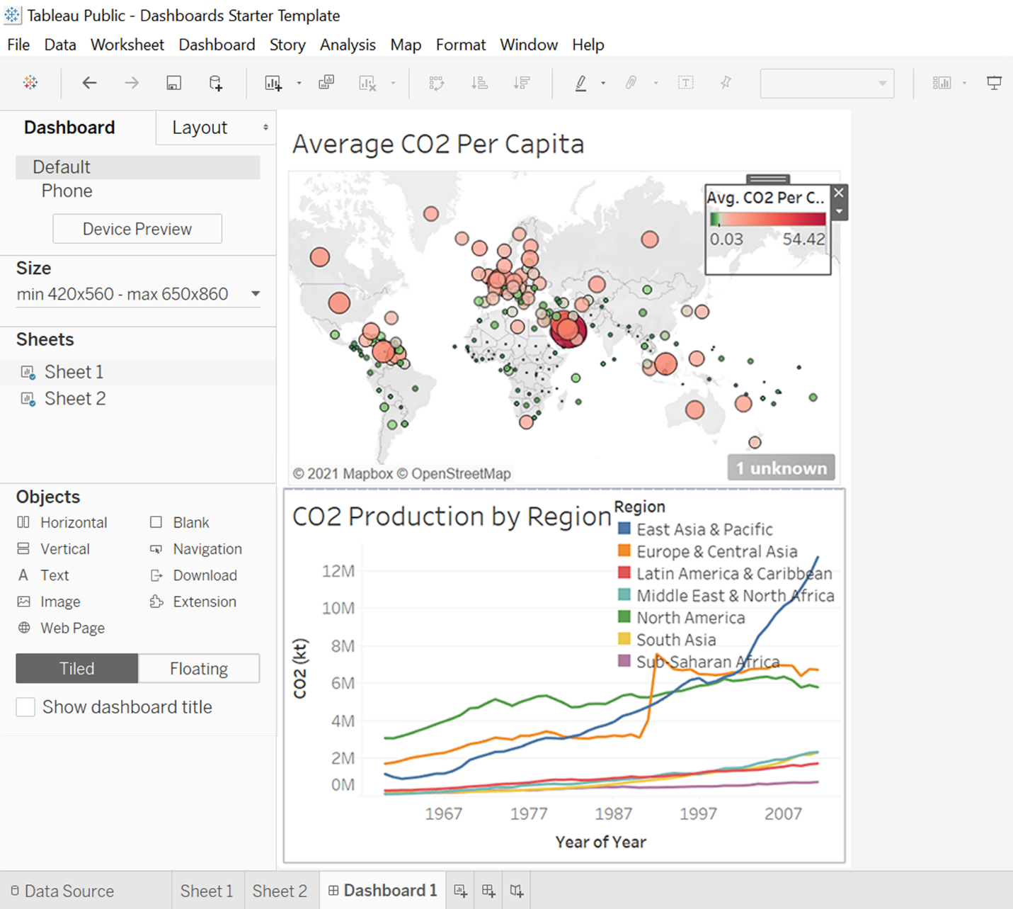

You’ve now created a basic dashboard. Tableau contains tons of other functionality that allows for dashboards that update in real-time or interactive dashboards and visualizations.

## Hands-On Activity: Practice presenting

**Total points**1

### 1.

**Question 1**



## Activity overview



Earlier in this course, you learned about what makes an effective presentation. In this activity, you will create screenshots of visualizations in the dashboard from your previous activity. Then, you'll add these jpegs to a new presentation, record yourself presenting, and evaluate your delivery and slides.

By the time you complete this activity, you will understand the steps involved in creating an effective presentation and reflect on how well you do when delivering a presentation yourself. This will enable you to successfully deliver presentations in the future, which is essential to your career as a data analyst.

## Create screenshots of your dashboard



Before you create your presentation, you need to capture screenshots from the Tableau dashboard you created in the previous activity, [Hands-On Activity: Create your first Tableau dashboard](https://www.coursera.org/learn/visualize-data/quiz/TT03O/hands-on-activity-creating-your-first-tableau-dashboard).

1. Go to Tableau Online and log in to your account. Retrieve the dashboard you created from the **Recents** page.

The way you capture screenshots will differ based on the operating system you are using. Here are some pointers on how to save your visualizations:

2. Click the **download icon** in the toolbar, then **Image** from the dropdown menu. This will save the visualization you created as a .png file, which you can insert into a slide presentation.

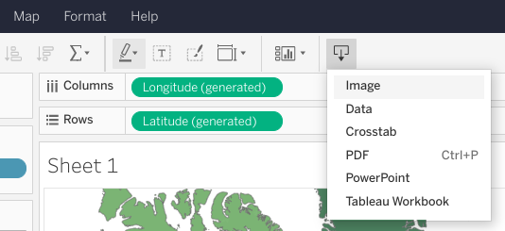

**OR**

3. Take a screenshot of each visualization using the command that corresponds to your operating system:

* Chromebook: Press **Ctrl** + **Show windows** icon (For non-Chrome OS keyboards, press **Ctrl** + **F5**).
* Mac: Press **Shift** + **Command** + **4.**
* Windows: Use the snipping tool—refer to this [Microsoft Support](https://support.microsoft.com/en-us/windows/use-snipping-tool-to-capture-screenshots-00246869-1843-655f-f220-97299b865f6b#take-screen-capture-print-screen=windows-7) page.

**Note:** If you do not find your computer or laptop listed above, please refer to your manufacturer’s reference guide or search online for a quick tutorial.

## Prepare a presentation



Now that you have your dashboard screenshots, it’s time to create your presentation.

To prepare your presentation, you should first consider your audience. In this activity, you will build a presentation for an audience of stakeholders. They aren’t closely involved in the project, but are curious about the analysis you have completed, the dashboard you have produced, and your key findings. Next, you can create your slides.

The first slide in your presentation should be a title slide, including the title of your presentation, your name, and the date of your presentation. Each of the next slides should have one or two of your dashboard screenshots. They should also include bullet points describing the context of your screenshots. Finally, you should include a closing slide with your final take-aways.

For this simple presentation, you only need a few simple slides. In future presentations, you will include more specific information and therefore need more slides.

Next, you can create your slides in presentation software.

### **Create your slides**



To create your slides, use whichever presentation software you feel comfortable with. If you’re unsure of which one to use or don’t own presentation software, use one of these free options:

* [Google Slides](https://www.google.com/slides/about/) (Google account required)
* [Microsoft 365](https://www.microsoft.com/en-us/microsoft-365/free-office-online-for-the-web) (Microsoft account required)
* [Prezi](https://prezi.com/) (login required)

### **Record yourself**



Use a smartphone, digital camera, or computer webcam to record a video of yourself presenting the visualizations you created. You can use [Screencastify](https://www.screencastify.com/) or a free trial of [Camtasia](https://www.techsmith.com/download/camtasia/) to record the slides of your presentation. Deliver your presentation in 2 to 3 minutes. Check that your lighting is bright enough and the focus of your lens captures a clear image. Then upload your file to your computer.

## Evaluating your presentation



Watch the video of your presentation. As you watch it, go through the following checklist. Each point is related to a best practice for presentations.

Do you:

* Use an attention-grabbing opening?
* Start with broad ideas and later talk about specific details?
* Speak in short sentences?
* Pause for five seconds after showing a data visualization?
* Pause intentionally at certain points?
* Keep the pitch of your voice level?
* Stand still and move with purpose?
* Maintain good posture?
* Look at your audience (or camera) while speaking?
* Keep your message concise?
* End by explaining why the data analysis matters?

### **Evaluate your slide deck**



Next, it’s time to evaluate your slide deck. Watch your video again. As you watch it, consider the following questions. Each question is related to a best practice for slide decks.

Do you:

* Include a good title and subtitle that describe what you’re about to present?
* Include the date of your presentation or the date when your slideshow was last updated?
* Use a font size that lets the audience easily read your slides?
* Showcase what business metrics you used?
* Include effective visuals (like charts and graphs)?

After you complete this checklist, save it for later. If your presentation did not check off every best practice, don’t worry. Later in this course, you will learn more presentation skills so you can rerecord and reevaluate this presentation.

Learning Log: Review a slide presentation



**Overview**



By now, you have started learning how to create effective slide presentations to share your findings. Now, you’ll complete an entry in your learning log to evaluate a slide presentation using what you have learned. By the time you complete this entry, you will have a stronger understanding of how to create an effective slide presentation using best practices from this course. This will help you evaluate your own work later on.

**Evaluate a series of slides**



Spend a few minutes going through the slide deck: [Turning revenue losses into profit opportunity](https://docs.google.com/presentation/d/1UaBTzTvy4yNdMM7zoqp7hoBh_efT2LikDvtZxVPPLBk/template/preview).

OR

Download the presentation:

**Positive and negative trends in annual sales**PPTX File

[Download file](https://d3c33hcgiwev3.cloudfront.net/GpCLT7PlQ_-Qi0-z5QP_vQ_d30dd028f35d467dac2c3d5979c0cef1_Positive-and-negative-trends-in-annual-sales.pptx?Expires=1648080000&Signature=GH5x8QNBjpeh-KniH5gAIKLbrydpddO9B9cWJpFz3GkOmmk~L-lGHBx-5f~TX8MboapfAU7-f1OFe1Ik3AnFJQnmjWYpQ3AWNpo~kfVroDngXoOGoFeSySWxZ0jr7EvwqQg8KGqPqysFVI6PRPNGcu7EwLyNH3OmmLROlU8eHQY_&Key-Pair-Id=APKAJLTNE6QMUY6HBC5A" \t "_blank)

This deck is incomplete and each slide might have room for improvement.

Use your knowledge of presentations to ask yourself: What do you like about each slide? How would you improve each slide? To help guide your review, consider the following best practices for slide decks:

* Include a title, subtitle, and date
* Use a logical sequence of slides
* Provide an agenda with a timeline
* Limit the amount of text on slides. Your audience should be able to scan each block of text on your slides within 5 seconds
* Start with the business task. Focus on the business task and frame the information in the context of the business task.
* Establish the initial hypothesis
* Show what business metrics you used
* Use visualizations
* Introduce the graphic by name
* Provide a title for each graph
* Go from the general to the specific
* Use speaker notes to help you remember talking points
* Include key takeaways

You can also make edits directly to the presentation to improve it.

**Complete the evaluation table**



Now that you have reviewed the deck by yourself, use the evaluation table in the learning log template linked below to record your thoughts about this table. The table will have a column for you to take notes on what worked well in each slide and what could be improved. It will appear like this in your template:

| **Slide #** | **What works well** | **What could be improved** |
| --- | --- | --- |
| 1 |  |  |
| 2 |  |  |
| 3 |  |  |
| 4 |  |  |
| 5 |  |  |
| 6 |  |  |
| 7 |  |  |

Once you have completed the evaluation table, you’ll have a chance to reflect on the overall presentation and how effective it is!



**Access your learning log**

To use the template for this course item, click the link below and select “Use Template.”

Link to learning log template: [Review a slide presentation](https://docs.google.com/document/d/1wI3bZIzHLnaiaGcI_uJXJ7XWxcf3sq-8MoFhjjxqMoU/template/preview)

OR

If you don’t have a Google account, you can download the template directly from the attachment below.

**Learning Log Template\_ Review a slide presentation**DOCX File

[Download file](https://d3c33hcgiwev3.cloudfront.net/WVrKn2WnQ3yayp9lpwN81g_21738ed89f43425e9a1b42599e444ef1_Learning-Log-Template_-Review-a-slide-presentation.docx?Expires=1648080000&Signature=GQFYpe4~tw5legYUgB0laL58pLGfBtFphhdRbI1ef2UXu39oBOg-HRpEGutPMgVTadbvGSdn7RZrUVK~M~ZD2ZIsvpTZn18F6zG-d4BJpZOlQj0bxDLycftdvwUJsCCgplBgw5Z~K0J2LB2vJiU~YL024w~n8A02xYoTtbQbuDU_&Key-Pair-Id=APKAJLTNE6QMUY6HBC5A" \t "_blank)



**Reflection**



Now that you’ve reviewed the slide presentation and completed the evaluation table, take a moment to reflect on the work you just did. In your learning log template, write 2-3 sentences (40-60 words) in response to each question below:

* How effective was the overall presentation?
* What would you do differently for this presentation? What would you do the same?
* How can you use presentation best practices to help you create your own slide decks in the future?

When you’ve finished your entry in the learning log template, make sure to save the document so your response is somewhere accessible. This will help you continue applying data analysis to your everyday life. You will also be able to track your progress and growth as a data analyst.

# Step-by-step critique of a presentation

This reading provides an orientation of two upcoming videos:

* **Connor: Messy example of a data presentation**
* **Connor: Good example of a data presentation**

To get the most out of these videos, you should watch them together (back to back). In the first video, Connor introduces a presentation that is confusing and hard to follow. In the second video, he returns to talk about what can be done to improve it and help the audience better understand the data and conclusions being shared.

## Messy data presentation

In the first video, watch and listen carefully for the specific reasons the “messy” presentation falls short. Here is a preview:

* No story or logical flow
* No titles
* Too much text
* Inconsistent format (no theme)
* No recommendation or conclusion at the end

### **Messy presentation: people don’t know where to focus their attention**

The main problem with the messy presentation is the lack of a logical flow. Notice also how the data visualizations are hard to understand and appear without any introduction or explanation. The audience has no sense of what they are looking at and why.  When people in the audience have to figure out what the data means without any help, they can end up being lost, confused, and unclear about any actions they need to take.

## Good data presentation

In the second video, numerous best practices are applied to create a better presentation on the same topic. This “good” presentation is so much easier to understand than the messy one! Here is a preview:

* Title and date the presentation was last updated
* Flow or table of contents
* Transition slides
* Visual introduction to the data (also used as a repeated theme)
* Animated bullet points
* Annotations on top of visuals
* Logic and progression
* Limitations to the data (caveats) - what the data can’t tell you

**Tip:** As you watch this video, take notes about what Connor suggests to create a good presentation. You can keep these notes in your journal. When you create your own presentations, refer back to your notes. This will help you to develop your own thinking about the quality of presentations.

### **Good presentation: people are logically guided through the data**

The good presentation logically guides the audience through the data – from the objectives at the beginning all the way to the conclusions at the end. Notice how the data visualizations are introduced using a common theme and are thoughtfully placed before each conclusion. A good presentation gives people in the audience the facts and data, helps them understand what the data means, and provides takeaways about how they can use their understanding to make a change or do some good.

## Up next

Get started with the messy vs. goodpresentation comparison by viewing the first video: [Connor: Messy example of a data presentation](https://www.coursera.org/learn/visualize-data/lecture/SYW63/connor-messy-example-of-a-data-presentation).

**Self-Reflection: Examples of great presentations**

**Total points**1

**1.**

**Question 1**



Overview



Now that you have been introduced to a few presentation tips, you can pause for a moment to consider what you are learning. In this self-reflection, you will explore examples of great presentations to help you develop your own ideas about how to design and deliver presentations. Then, you will consider your thoughts about what makes a good presentation and respond to brief questions.

This self-reflection will help you develop insights into your own learning and prepare you to apply your knowledge of presentation best practices to your own presentations. As you answer questions—and come up with questions of your own—you will refine your understanding and reinforce your learning. You’ve done the hard work, so make sure to get the most out of it: This reflection will help your knowledge stick!

Examples of great presentations



Next, you can consider a few exemplary presentations. Before you get started, review the quick recap of the McCandless method. Then check out the examples below of spoken presentations and slide deck presentations and consider what makes a presentation effective.

The McCandless Method



As you look at examples in the next section of this activity, ask yourself: How do these presentations use the McCandless method?

As a refresher, the McCandless method is a set of guidelines for presentations. It suggests that you start with broad, general ideas and then work your way into the details.

The steps of the McCandless method include:

1. Introduce the graphic by name

2. Answer obvious questions before they’re asked

3. State the insight of your graphic

4. Call out data to support that insight

5. Tell your audience why it matters

Examples of great spoken presentations



TED Talks are short, spoken messages with important ideas. Take some time to watch the three TED talks linked below, which were carefully selected as model examples of great presentations. As you watch the videos, ask yourself how they each show characteristics of an effective presentation:

1. [The 3 bones of networking](https://www.youtube.com/watch?v=4OTPJZnBP8s)
2. [Grit: The power of passion and perseverance](https://www.youtube.com/watch?v=H14bBuluwB8)
3. [Looking for a job? Highlight your ability, not your experience](https://www.youtube.com/watch?v=guXxy8LH2QM)

Examples of great slide deck presentations



Click on the following links to see excellent examples of slide deck presentations. As you view each deck, ask yourself which characteristics of the slide deck make the presentation so effective.

Guide: Sharing data findings in presentations

Use this guide to help make your presentation stand out as you tell your data story. Follow the recommended tips and slide sequence in this guide for a presentation that will truly impress your audience.

You can also **download this guide as a PDF**, so you can reference it in the future:

**Sharing your data findings in presentations \_ Tips and Tricks.pdf**PDF File

[Open file](https://d3c33hcgiwev3.cloudfront.net/_LwuiIoNSYq8LoiKDUmKxw_e8ff903b66b943ddaea3b8517fe8a3af_Sharing-your-data-findings-in-presentations-_-Tips-and-Tricks.pdf?Expires=1648080000&Signature=Y0TUuJD4W6DbFQmw5uSnzlRC7ZGDa4VGlOv-ZB-9JVCzCdOb3rBwHGPV1z-tECbOfNwJGXdeI0SytPSXBVJS3ABar28NN35QQeitC~XB5fIOYAFdeWuIc0zBzeALPXFGe69~9jaBK1AJb3iOrZ1x-iA5GnZ-leMm0SG2NBLmlts_&Key-Pair-Id=APKAJLTNE6QMUY6HBC5A" \t "_blank)

**Telling your data story (tips and tricks to present your data and results)**

Use the following tips and sample layout to build your own presentation.

**Tip 1: Know your flow**

Just like in any good story, a data story must have a good plot (theme and flow), good dialogue (talking points), and a great ending or big reveal (results and conclusions). One flow could be an overview of what was analyzed followed by resulting trends and potential areas for further exploration.

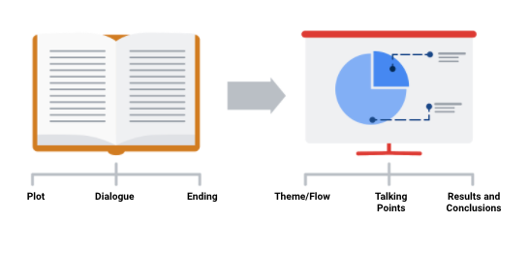

In order to develop the right flow for your presentation, keep your audience in mind. Ask yourself these two questions to help you define the overall flow and build out your presentation.

**Who is my audience?**

* If your intended audience is executives, board members, directors, or other C-level (C-Suite) executives, your storytelling should be kept at a high level. This audience will want to hear about your story but might not have time to hear the *entire* story. Executives tend to focus on endings that encourage improving, correcting, or inventing things. Keep your presentation brief and spend most of your time on your results and recommendations. Refer to an upcoming topic in this reading—Tip 3: end with your recommendations.
* If your intended audience is stakeholders and managers, they might have more time to learn about how you performed your analysis and they might ask more data-specific questions. Be prepared with talking points about the aspects of your analysis that led you to your final results and conclusions.
* If your intended audience is other analysts and individual contributors, you will have the most freedom—and perhaps the most time—to go more deeply into the data, processes, and results.

**What is the purpose of my presentation?**

* If the goal of your presentation is to request or recommend something at the end, like a sales pitch, you can have each slide work toward the recommendations at the end.
* If the goal of your presentation is to focus on the results of your analysis, each slide can help mark the path to the results. Be sure to include plenty of breadcrumbs (views of the data analysis steps) to demonstrate the path you took with the data.
* If the goal of your presentation is to provide a report on the data analysis, your slides should clearly summarize your data and key findings. In this case, it is alright to let the data be the star or speak for itself.

**Tip 2: Prepare talking points and limit text on slides**

As you create each slide in your presentation, prepare **talking points** (also called **speaker notes**) on what you will say.

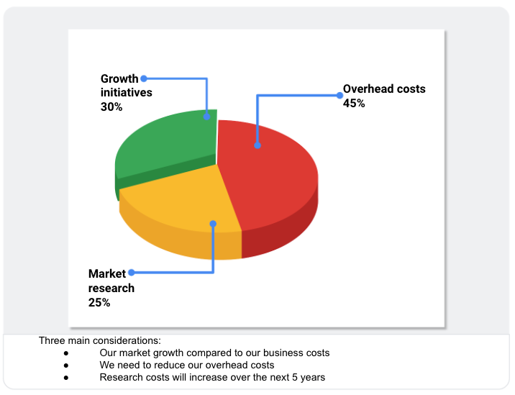

Don’t forget that you will be talking at the same time that your audience is reading your slides. If your slides start becoming more like documents, you should rethink what you will say so that you can remove some text from the slides. Make it easy for your audience to skim read the slides while still paying attention to what you are saying. In general, follow the five-second rule. Your audience should not be spending more than five seconds reading any block of text on a slide.

Knowing exactly what you will say when explaining each slide throughout your presentation also creates a natural flow to your story. Talking points help you avoid awkward pauses between topics. Slides that summarize data can also be repetitive (and boring). If you prepare a variety of interesting talking points about the data, you can keep your audience alert and paying attention to the data and its analysis.

**Tip 3: End with your recommendations**



When climbing a mountain, getting to the top is the goal. Making recommendations at the end of your presentation is like getting to the mountaintop.

* Useone slide for your recommendations at the end. Be clear and concise.
* If you are recommending that something be done, provide next steps and describe what you would consider a successful outcome.

**Tip 4: Allow enough time for the presentation and questions**



Assume that everyone in your audience is busy. Keep your presentation on topic and as short as possible by:

* Being aware of your timing. This applies to the total number of slides and the time you spend on each slide.
* Presenting your data efficiently. Make sure that every slide tells a unique and important part of your data story. If a slide isn’t that unique, you might think about combining the information on that slide with another slide.
* Saving enough time for questions at the end or allowing enough time to answer questions throughout your presentation.

**Putting it all together: Your slide deck layout**

In this section, we will describe how to put everything together in a sample slide deck layout.

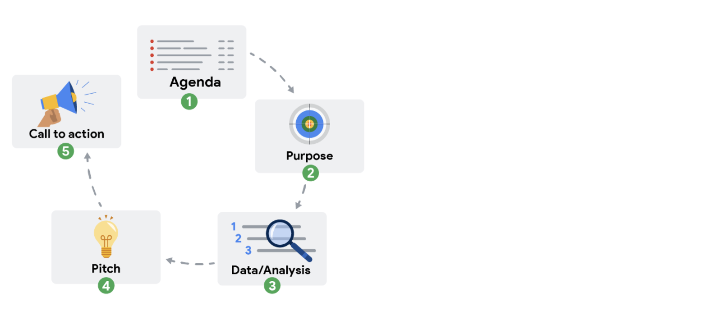

**First slide: Agenda**

Provide a high-level bulleted list of the topics you will cover and the amount of time you will spend on each. Every company’s norms are different, but in general, most presentations run from 30 minutes to an hour at most. Here is an example of a 30-minute agenda:

* Introductions (4 minutes)
* Project overview and goals (5 minutes)
* Data and analysis (10 minutes)
* Recommendations (3 minutes)
* Actionable steps (3 minutes)
* Questions (5 minutes)

**Second slide: Purpose**

Everyone might not be familiar with your project or know why it is important. They didn’t spend the last couple of weeks thinking about the analysis and results of your project like you did. This slide summarizes the purpose of the project and why it is important to the business for your audience.

Here is an example of a purpose statement:

*Service center consolidation is an important cost savings initiative. The aim of this project was to determine the impact of service center consolidation on customer response times.*

**Third slide: Data/analysis**

First, It really is possible to tell your data story in a single slide if you summarize the key things about your data and analysis. You may have supporting slides with additional data or information in an appendix at the end of the presentation.

But, if you choose to tell your story using more than one slide, keep the following in mind:

* Slides typically have a logical order (beginning, middle, and end) to fully build the story.
* Each slide should logically introduce the slide that follows it. Visual cues from the slides or verbal cues from your talking points should let the audience know when you will go on to the next slide.
* Remember not to use too much text on the slides. When in doubt, refer back to the second tip on preparing talking points and limiting the text on slides.
* The high-level information that people read from the slides shouldn’t be the same as the information you provide in your talking points. There should be a nice balance between the two to tell a good story. You don’t want to simply read or say the words on the slides.

For extra visuals on the slides, use animations. For example, you can:

* Fade in one bullet point at a time as you discuss each on a slide.
* Only display the visual that is relevant to what you are talking about (fade out non-relevant visuals).
* Use arrows or callouts to point to a specific area of a visual that you are using.

**Fourth slide: Recommendations**

If you have been telling your story well in the previous slides, the recommendations will be obvious to your audience. This is when you might get a lot of questions about how your data supports your recommendations. Be ready to communicate how your data backs up your conclusion or recommendations in different ways. Having multiple words to state the same thing also helps if someone is having difficulty with one particular explanation.

**Fifth slide: Call to action**

Sometimes the call to action can be combined with the recommendations slide. If there are multiple actions or activities recommended, a separate slide is best.

Recall our example of a purpose statement: *Service center consolidation is an important cost savings initiative. The aim of this project was to determine the impact of service center consolidation on customer response times.*

Suppose the data analysis showed that service center consolidation negatively impacted customer response times. A call to action might be to examine if processes need to change to bring customer response times back to what they were before the consolidation.

**Wrapping it up: Getting feedback**

After you present to your audience, think about how you told your data story and how you can get feedback for improvement. Consider asking your manager or another data analyst for candid thoughts about your storytelling and presentation overall. Feedback is great to help you improve. When you have to write a brand new data story (or a sequel to the one you already told), you will be ready to impress your audience even more!

Learning Log: Evaluate your presentation



**Overview**



Earlier in this course, you practiced creating, giving, and evaluating your own presentation for the [Hands-on Activity: Presenting practice](https://www.coursera.org/learn/visualize-data/quiz/uLhnv/hands-on-activity-presenting-practice). Now, you’ll complete an entry in your learning log revisiting that presentation and reflecting on how much your presentation skills have developed so far. By the time you complete this activity, you will have more experience presenting, evaluating, and receiving and applying presentation feedback. This will help you prepare for future presentations as a data analyst.

**Take two: Revisit your presentation**



For the hands-on activity, you recorded yourself presenting a data visualization dashboard that you created. You then evaluated your work. Now that you have more knowledge and practice under your belt, it’s time to try again!

* Re-record your presentation with the information you’ve learned during this course. Keep it as concise as possible so you can compare it to your previous version.
* Share the presentation with someone you know who might not be familiar with data analysis. Keep them in mind while you record your presentation, as it should be as simple and accessible as possible.
* Ask them for their feedback. Did they find it engaging? Did they truly understand the concept that you explained?
* If it would be helpful to receive feedback in a formal way, print out the checklist you used last time (provided below) and give it to your audience.

**Presentation Evaluation Checklist:**

* Do I use an attention-grabbing opening?
* Do I start with broad ideas and later talk about specific details?
* Do I speak in short sentences?
* Do I pause for five seconds after showing a data visualization?
* Do I pause intentionally at certain points?
* Do I keep the pitch of my sentences level?
* Do I stand still and move with purpose?
* Do I have good posture?
* Do I look at my audience (or camera) while speaking?
* Do I keep my message concise?
* Do I end by explaining to my audience why the data analysis matters?

Now, do the same for your **slide deck:**

* Do I include a good title and subtitle that describe what I’m about to present?
* Do I include the date of my presentation or the date when my slideshow was last updated?
* Does my font size let the audience easily read my slides?
* Do I showcase what business metrics I used?
* Do I include effective visuals (like charts and graphs)?

Once you have finished revising, recording, and sharing your presentation again, you’ll have a chance to reflect on your experience in the learning log template linked below.



**Access your learning log**

To use the template for this course item, click the link below and select “Use Template.”

Link to learning log template: [Evaluate your presentation](https://docs.google.com/document/d/1VLMyyR0jHg2hqCQAyWjCDi6_GxN9E-5xR05h9Pr_lnY/template/preview?resourcekey=0-jyB-80acoGEY4djkOHBjAg)

OR

If you don’t have a Google account, you can download the template directly from the attachment below.

**Learning Log Template\_ Evaluate your presentation**DOCX File

[Download file](https://d3c33hcgiwev3.cloudfront.net/7SHzMqkyR96h8zKpMpfeOg_ca0ecbd8296e4fb4b4e5afefd4715ef1_Learning-Log-Template_-Evaluate-your-presentation.docx?Expires=1648080000&Signature=Bn0A0v9GN~uVsGlDzfN6OQlHnp549besOdYn4sfUB4Dokfwr7rmNfwdOcT4aTe15eb6pfHuCaRUbdyf7~BWXaRiRe8IwsKjZeiAdtH7p-jBCbG3Bur6BVH-N~7qoPg~A3cuPeEQDHzla6TZ7vb-zkigPJlrWf17oJ3Xtl5l06UE_&Key-Pair-Id=APKAJLTNE6QMUY6HBC5A" \t "_blank)



**Reflection**



Now that you’ve finished rerecording your presentation and receiving feedback, take a moment to reflect on the process you just completed. In your learning log template, write 2-3 sentences (40-60 words) in response to each question below:

* What was your experience recording this presentation?
* How does this presentation experience differ from the last one you recorded? How does it differ from other presentations you delivered in the past?
* Did the feedback you received help you understand which skills you improved on? Did it help you realize which skills you still need to work on?

When you’ve finished your entry in the learning log template, make sure to save the document so your response is somewhere accessible. This will help you continue applying data analysis to your everyday life. You will also be able to track your progress and growth as a data analyst.

Preparing for the Q&A

When working on any project, it is important to understand from the beginning what stakeholders expect of you. This reading will be all about preparing questions to ask before planning your data gathering and presentations.

There are many things to consider before you begin asking and answering possible questions – like the objective, stakeholder expectations, and if there are any limitations. Make sure you have everything covered before you begin. The checklist below identifies ten tasks that you should engage in to be well prepared for your Q&A:

**Before the presentation**

1. Assemble and prepare your questions.
2. Discuss your presentation with your manager, other analysts, or other friendly contacts in your organization.
3. Ask a manager or other analysts what sort of questions were normally asked by your specific audience in the past.
4. Seek comments, feedback, and questions on the deck or the document of your analysis.
5. At least 24 hours ahead of the presentation, try and brainstorm tricky questions or unclear parts you may come across- this helps avoid surprises.
6. It never hurts to practice what you will be presenting, to account for any missing information or simply to calm your nerves.

**During the presentation**

1. Be prepared to respond to the things that you find and effectively and accurately explain your findings.
2. Address potential questions that may come up.
3. Avoid having a single question derail a presentation and propose following-up offline.
4. Put supplementary visualizations and content in the appendix to help answer questions.



**Practice makes perfect**

Preparing for a presentation or a meeting doesn’t have to be intimidating. If you invest time into knowing your audience, crafting your notes, doing necessary research and organizing your data, then there is very little reason why your audience will not be engaged, even impressed.

**Self-Reflection: Real-world objections**

**Total points**1

**1.**

**Question 1**



Overview



Now that you have learned about how to handle objections to your data, you can pause for a moment and think about what you are learning. In this self-reflection, you will consider your thoughts about how to respond to objections when giving a presentation and answer brief questions about your approach.

This self-reflection will help you develop insights into your own learning and prepare you to apply your knowledge of handling objections to real-world scenarios. As you answer questions—and come up with questions of your own—you will consider concepts, practices, and principles to help refine your understanding and reinforce your learning. You’ve done the hard work, so make sure to get the most out of it: This reflection will help your knowledge stick!

Respond to a business task



While delivering a presentation to an audience, your primary goal is to respond to a business task. A **business task** is a question or problem you use data to solve—and a presentation demonstrates how to solve it. Business tasks can have a variety of contexts and scopes, so the details of your presentation will depend on a lot of factors.

Sometimes, you may receive questions or objections about your presentation. This is normal, as your audience wants to understand your presentation as completely as possible. Responding to these questions and objections in a clear, concise, and polite manner is crucial to delivering an effective presentation.

Examples of objections



Consider the following situations where a data analyst delivers a presentation and receives an objection:

1. An analyst is presenting on the sales revenue of their company’s new product: an autonomous vacuum cleaning robot. The analyst shows the steps they took for each part of the analysis. They are confident that they have explained each step very thoroughly, but a stakeholder is confused when the presentation is over. They share a concern that the analysis may be incomplete.
2. An analyst is presenting on the effectiveness of a new drug treatment for heartburn. They use data from an external private company that describes how common heartburn is in the United States. After the presentation, they receive an objection from their stakeholder about the data collected. The stakeholder is concerned that the source of the data may not be reputable, and is unsure about the credentials of the data’s source company.
3. An analyst is presenting on the traffic patterns of a particular highway in their city. After extensive research and analysis, they conclude that Friday is the busiest day for commuters on that highway. One of the stakeholders, who commutes along that highway, disagrees and believes that Monday is the busiest day for traffic.